**UTILIZING AN AUTONOMOUS SURFACE VEHICLE FOR RIVER PLASTIC WASTE DETECTION**

ECE 4872: Final Semester ECE Senior Design

**Just Keep Swimming** Faculty Advisor: Dr. Michael West Corporate Sponsor: Ecolymer GmbH

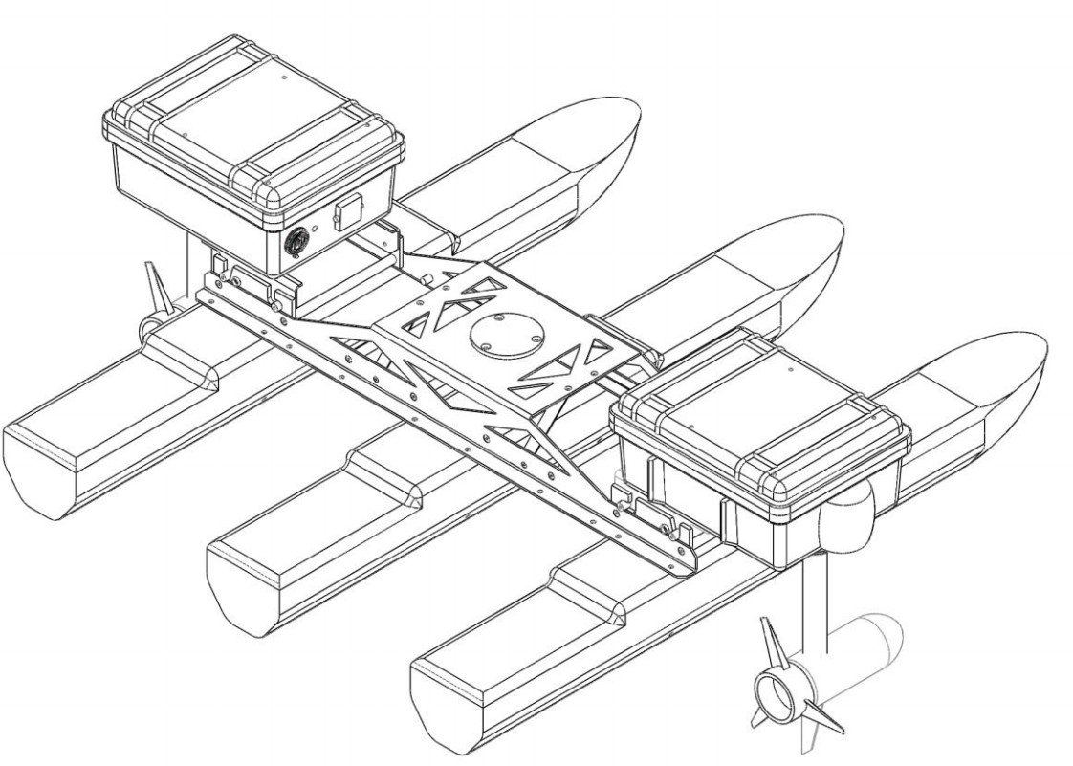

**Luis Pimentel**

*B.S. in Computer Engineering*

[lpimentel3@gatech.edu](mailto:lpimentel3@gatech.edu)

**Jin Bae**

*B.S. in Computer Engineering*

[hbae60@gatech.edu](mailto:hbae60@gatech.edu)

**Tan Tonge**

*B.S. in Electrical Engineering*

[ttonge@gatech.edu](mailto:ttonge@gatech.edu)

**Alexander Chanthaphaeng**

*B.S. in Electrical Engineering*

[asc31@gatech.edu](mailto:asc31@gatech.edu)

Georgia Institute of Technology

School of Electrical and Computer Engineering Atlanta, Georgia

Fall 2021

Submitted December 14, 2021

# Contents

Contents 1

Nomenclature 2

Executive Summary 3

1. Introduction 5
   1. Motivation 5
   2. Objective 5
   3. Background 6
2. Project Description and Goals 6
   1. Sponsor and Stakeholder Requirements 7
3. Technical Specifications and Verification 8
4. Design Approach and Details 9
   1. Hardware Design 9
      1. Existing Kingfisher M100 Hardware 9
      2. Hardware Modifications 11
   2. Perception Architecture 14
   3. Navigation Architecture 17
   4. Constraints, Alternatives, and Trade-offs 18
      1. Global, Economic, Environmental, and Ethical Factors 19
      2. Computation Aspects 20
   5. Engineering Analysis and Experiment 20
   6. Codes and Standards 23
5. Schedule, Tasks, and Milestones 25
   1. Gantt Chart 25
   2. PERT Analysis 25
6. Project Demonstration 26
7. Cost Analysis 29
8. Conclusion 31
9. Leadership Roles 33

References 34

A Expanded Gantt Chart 36

# Nomenclature

API — Application Programming Interface ASV — Autonomous Surface Vehicle CAD — Computer Aided Design

GPS — Global Positioning System IMU — Inertial Measurement Unit

MOOS-IvP — Mission Oriented Operating Suite Interval Programming PERT — Program Evaluation Review Technique

ROS — Robot Operating System ROV — Remotely Operated Vehicle USV — Unmanned Surface Vehicle

UTM — Universal Transverse Mercator System

# Executive Summary

The plastic pollution of water environments is an important problem that endangers marine animals and causes environmental issues. The goal of this project is to design a robotic Autonomous Surface Vehicle (ASV) that can collect trash within water environments such as rivers, lakes, and seas.

The last two teams from previous semesters worked on two subsystems that were intended to be part of the fully autonomous trash collecting robot. One team proposed a plastic detection system using the YOLOv2 object algorithm trained with a set of video taken under water and the other team built a GPS navigation module using MOOS-IvP.

The objective for our team was to integrate these two subsystems such that the robot is capable of operating without any human intervention. However, our team anticipated some challenges integrating the trash detection module with the navigation system that uses MOOS-IvP, especially the communication of data and implementing trash localization using MOOS.

This led to shifting from MOOS to Robot Operating System (ROS), which has over-the-network communication capabilities and extensively developed packages for trash localization and navigation. This was also partly due to the fact that Clearpath Robotics, the manufacturer of Kingfisher M100, provides ROS packages with the API to communicate with the motor drivers and that the team’s better familiarity with ROS. In order to transform the bounding boxes produced by the trash detection algorithm into 3D coordinates, the Go Pro camera adopted by the previous teams was not sufficient since the translation from 2D image to 3D coordinates requires a depth camera. This decision led to purchasing the ZED 2i stereo depth camera which comes with built-in ROS API to calculate the 3D location of the bounding boxes. The camera also comes with an embedded IMU, which could be used as a backup in case the main IMU on board of the Kingfisher becomes unusable.

The perception architecture was implemented through accessing the ZED image and point-cloud

data through the StereoLabs API from the ZED 2i camera. The camera image is processed through YOLOv2 to determine if plastic trash is present using the trash ICRA19 dataset. Upon detection of trash, the point- cloud is referenced by our custom localization software to determine the coordinate position of the trash relative to the vehicle.

The navigation architecture was implemented by using packages that perform state estimation, path planning, velocity control, and PID control. In addition, a custom driver was developed to set target waypoints and shift between patrol mode where the robot circles around predefined GPS coordinates looking for trash and pickup mode where the robot detects a trash and actually approaches its location. The localization was achieved by using IMU as a local source and GPS as a global source.

Our vehicle is intended to be a proof-of-concept focused on identifying and solving the limiting problems involved with operating the ASV. The key performance specifications for this will be the ability to identify trash underwater and navigate to it. The physical collection of the trash is outside the scope of our team’s project but are challenges to be tackled by other teams. We intent to demonstrate the successful operation of this vessel on a body of water with simulated placement of plastic trash throughout.

Given the goals of this project, we are leveraging existing platforms to reduce the development cost of the vehicle. We are not focusing on delivering the most cost-effective solution as this is a proof-of-concept but are avoiding expensive technologies that would unfeasible for a commercial solution. Next steps for future teams will include obstacle avoidance using an above water depth camera, obtaining and configuring a reliable IMU, and training the AI using a data set that is closer to the actual operation environment. Incorporating these improvements will allow the vessel to close in on reaching viability for deployment in the field.

# Introduction

Our team is requesting $1,073 to continue the development of a proof-of-concept autonomous surface vehicle (ASV) for robotics river plastic waste cleanup focusing on the limiting technologies involved in this challenge.

## Motivation

Conservation of the oceans, seas, and marine resources has such a large impact on human life that it has been identified as the United Nations Sustainable Development Goal 14.1 which challenges the world to ”prevent and significantly reduce marine pollution of all kinds, in particular from land-based activities” by 2025 [1]. The world’s oceans produce over half the world’s oxygen and contribute to significant climate regulation as well as having an economic impact of $282 billion in the U.S. alone [2].

If we are to prevent the pollution of these environments, we must tackle the problem at its source. River systems have a significant impact on this flow of waste as it is estimate that just 1000 rivers contribute 80% of global annual emissions up to the magnitude of 2.7 million metric tons per year with [3]. Simply implementing proper disposal methods to prevent the waste from entering rivers and oceans should fix this issue but it is found that 80 to 90% of plastic waste is improperly disposed of, primarily in low-to-middle- income income countries [4], and so we have to address the problem from a different angle.

## Objective

The intended use of the final form of this vehicle of is to be a fully automated river cleanup system that can be deployed at strategic sections of the most relevant rivers and waterways contributing to plastic waste. This has the potential to be used by governmental and private organizations interested in the conservation of the marine environment across the world.

Primarily product functionality for this project is the removal of plastic waste from waterways in an effective manner that creates significant reduction in their impact on the marine environment. The vehicle must be able to accomplish these goals while operating autonomously so that minimal human input is required, therefore decreasing its operating cost and allowing for deployability at a large scale.

Significant value for the intended users is expected to either reduce a company’s environmental impact through offsetting waste from their products or as a reactive measure for public and governmental organizations to eventually improve citizens health, economy, and quality of life due to the impact oceans have on all of us [2].

Autonomous vehicles are unproven in this space given the challenging environment of a moving river

which can include strong currents, vessel traffic, debris, and human interference. This poses a significant dilemma in correctly sensing the vehicles environment and navigating through it. Despite this, accurate operation is desirable as the vehicles behavior must be responsible and act with caution due to the lack of regulatory guidelines from this being a novel space.

## Background

Interest in the space of river clean-up is increasing with potential solutions being developed by multiple groups. The Ocean Cleanup has created a collection method called ”The Interceptor” which employs a stationary barrier to pull waste towards a solar powered barge with trash then being passed up by a conveyor belt into bins and has been deployed on rivers in Indonesia, Malaysia, and the Dominican Republic [3]. The Great Bubble Barrier, a Dutch startup, has installed a perforated tube laid across the bottom of a canal and then by pumping air through it creates an upward current which catches floating debris and carries them into a catchment pond [5]. Waterfront Partnership of Baltimore operates ”Mr. Trash Wheel”, a semi-autonomous trash interceptor that is placed at the end of a river with containment booms to funnel the trash into its gaping mouth where it is raked into a conveyor belt, which has collected over 1600 tons of debris [6].

# Project Description and Goals

The Kingfisher M100 [7] provided by Dr.West was identified as the proof-of-concept platform to eliminate development time on a USV when several suitable platforms such as this one already exist. We will be integrating the object identification methods performed by previous teams onto the USV by integrating a stereo vision camera to identify and locate the trash. We will then develop the navigation architecture stack to have the vehicle patrol a marine environment and drive to detected trash for collection by a future team.

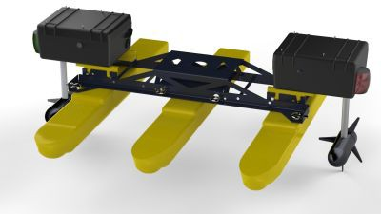

**Figure 1:** Kingfisher M100 base platform from Clearpath Robotics Inc. [7].

## Sponsor and Stakeholder Requirements

**Sponsor Description** Ecolymer has sponsored the development of this Senior Design project. Ecolymer is a worldwide plastic packaging producer based in Austria with around 20,800 employees at 178 locations across 46 countries leading to its place as a market leader for brands in the food, beverage, pharmaceutical, oil and lubricant, home, and beauty care industries. As a family-owned company, they are a aware that their social responsibility to their employees, customers, and the environment should characterize their way of thinking and working worldwide [8].

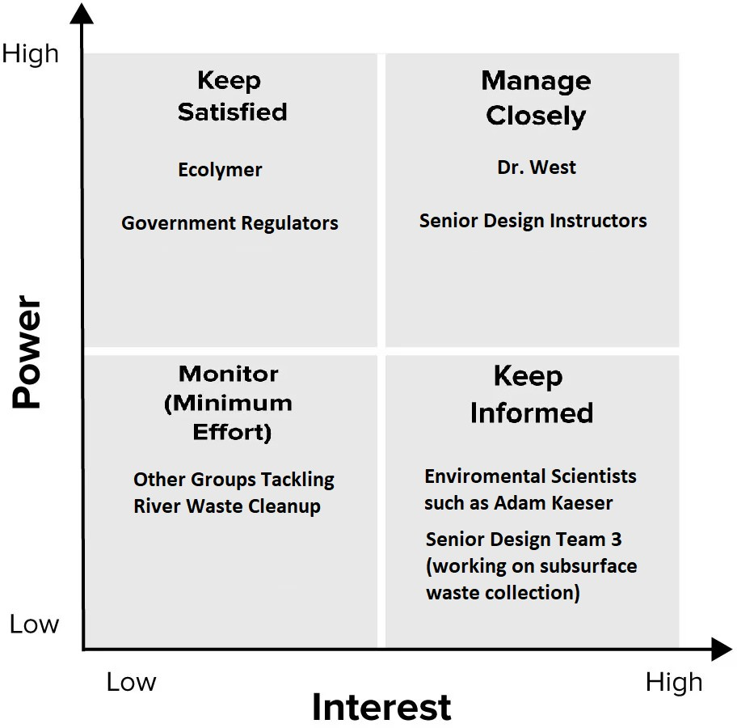

**Figure 2:** Stakeholder ”2x2” chart comparing interest and power in this project.

**Customer Needs** Ecolymer desires a fully automated river clean-up system that can be deployed in waterways to identify, collect, and dispose of plastic waste without interfering with river traffic or aquatic life. Once the garbage is collected, it can then either be re-purposed through recycling or it can be used locally to generate electricity through incineration. They are searching for a solution that is reasonably priced so that its deployment would be economically viable at a large scale. They are fairly flexible in our approach and methods to tackling this problem as they are primarily looking for a prototype system which proves the operational ability of the underlying technologies.

We must also strictly meet the requirements of the Senior Design instructors in our development process so that we are successful in the project deliverable associated with this course. These include the final report and Capstone Expo presentation. Finally, we have also made contact with some environmental scientists in our research for this project. Adam J. Kaeser, an aquatic ecologist with the U.S. Fish and Wildlife

Service, was particularly interested in our project and the impact it could have on the environmental mapping and habitat classification of inland waterways through sonar equipment in addition to the primary goals. We also expect to maintain communication with the other Senior Design team working on this problem but tackling it from the angle of subsurface waste collection by leveraging an ROV.

# Technical Specifications and Verification

In this section we detail the technical specifications that our robot should meet in order to be considered successfully operational. This is divided between Qualitative Specifications detailing the overall specifications and Quantitative Specifications detailing performance measures the robot must meet. We further divide the Qualitative Specifications between between Perception Specifications detailing the robot’s ability to detect and localize plastic and Navigation Specifications detailing the robot’s ability to navigate to estimated plastic locations.

|  |
| --- |
| **Qualitative Specifications** |
| Ability to detect trash objects using camera system and pre-trained trash detection model. |
| Ability to localize trash using bounding box and its corresponding depth values. |
| Ability to continuously estimate trash location as trash location drifts. |
| Ability to control the robot’s position and heading through ROS. |
| Ability to navigate robot from a starting point to a trash location. |

**Table 1:** Qualitative Design Specifications for Autonomous Operation.

|  |
| --- |
| **Quantitative Specifications** |
| **Perception Specifications** |
| Ability to detect all plastic within 3 meters with confidence *p ≥* 0*.*8 |
| Ability to estimate 100% of plastic locations within threshold *x ≤* 3 meters |
| Ability to estimate 60% of plastic locations within threshold 3 meters *≤ x ≤* 10 meters |
| Ability to estimate 20% of plastic locations within threshold 10 meters *≤ x ≤* 20 meters |
| Ability to continuously estimate trash location with drift in location of 1 meter |
| **Navigation Specifications** |
| Ability to navigate to 100% of plastic locations within threshold *x ≤* 3 meters |
| Ability to navigate to 60% of plastic locations within threshold 3 meters *≤ x ≤* 10 meters |
| Ability to navigate to 20% of plastic locations within threshold 10 meters *≤ x ≤* 20 meters |

**Table 2:** Qualitative Design Specifications for Autonomous Operation.

# Design Approach and Details

In this section, we detail the technical systems previously implemented by former teams for trash detection and collision-avoidance navigation. Furthermore, we detail our additions to these systems and our novel system for localizing the detected trash in the robot’s environment in order to autonomously navigate the Kingfisher to the trash’s location.

## Hardware Design

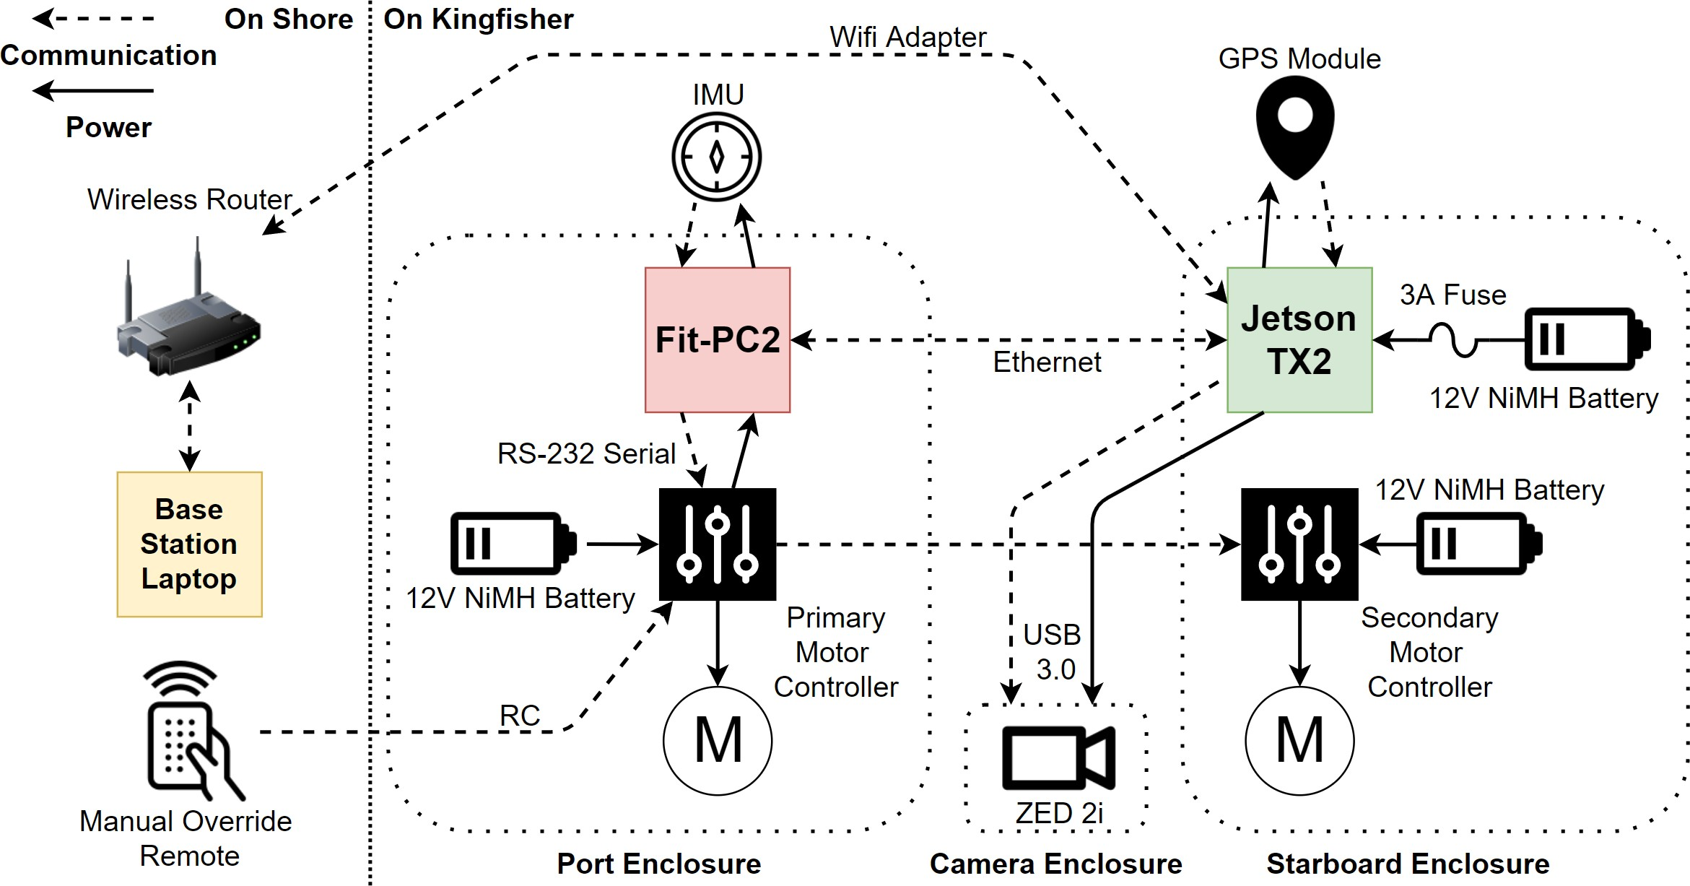

**Figure 3:** Hardware system architecture diagram showing components and wiring connections within each waterproof enclosure.

### Existing Kingfisher M100 Hardware

The stock Kingfisher M100 USV from Clearpath Robotics Inc. [7] supplied by Dr. West is comprised of two thruster modules and three pontoons connected by a main bent sheet steel frame. The thruster modules, as shown in Figure 4, each include a 200W-peak electric propeller motor, a waterproof enclosure, and a 14 Ah NiMH battery. The primary thruster module, on the port side, contains a Fit-PC2 [9], a miniature fan-less PC based on the Intel Atom CPU which communicates to the primary motor controller over a RS232 serial interface with a DE-9 connector. The secondary thruster module, on the starboard side, contains the secondary motor controller which is directed through the primary motor controller board. Included with the Kingfisher M100 is also a radio-controlled (RC) transmitter which can be used as a manual takeover with the primary motor controller having a radio receiver which blocks control from the Fit-PC2 and controls the motors based on radio channels when the takeover switch is enabled on the transmitter.

The Fit-PC2 is typically connected to a stock Inertial Measurement Unit (IMU) and GPS module but we had trouble integrating both of these into our final system. The stock IMU was determined to most likely be faulty and was worked around by using the IMU inside the ZED 2i camera but this yielded poor results. Using the GPS module with the included software on the Fit-PC2 resulted in significantly larger error than acceptable so we instead moved it to connect to the Jetson TX2 where we could use a more familiar ROS package to read more accurate data.

Additionally, in order to manage the NiMH batteries supplied by Dr. West, each battery was given an identification number and a log, shown in Figure 5, was created to record voltage of the batteries and keep track of charge status.

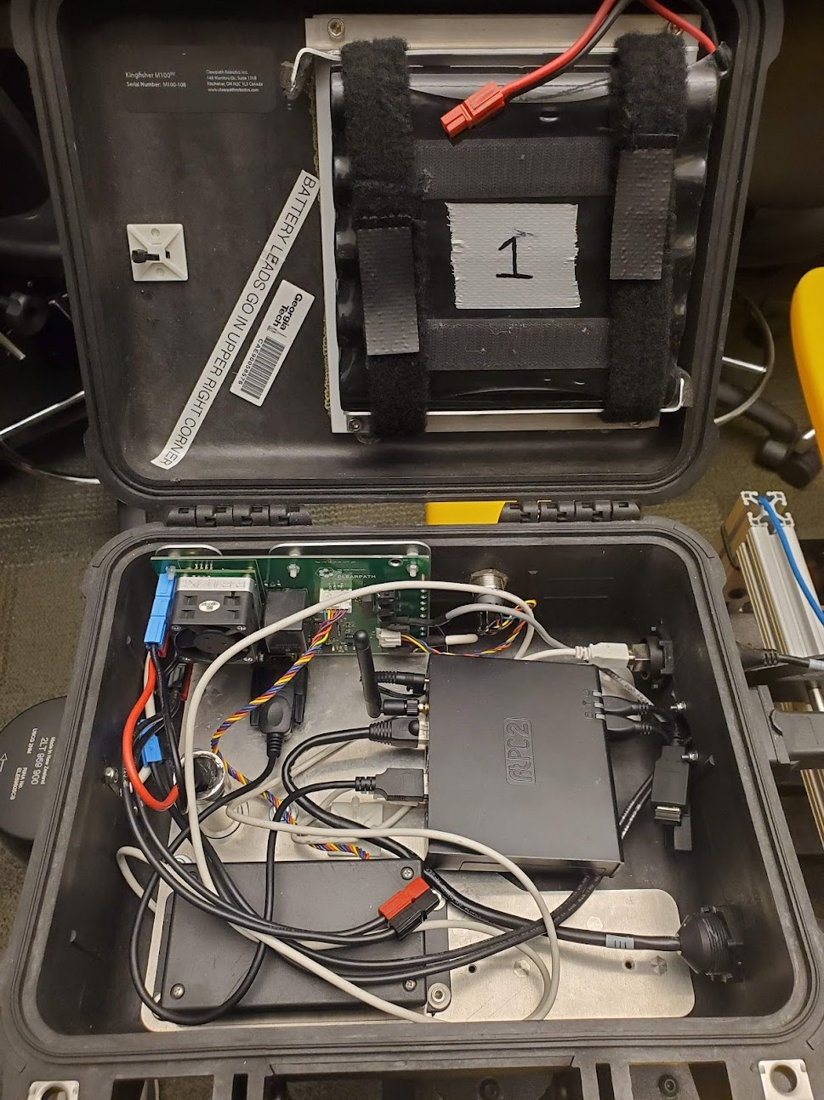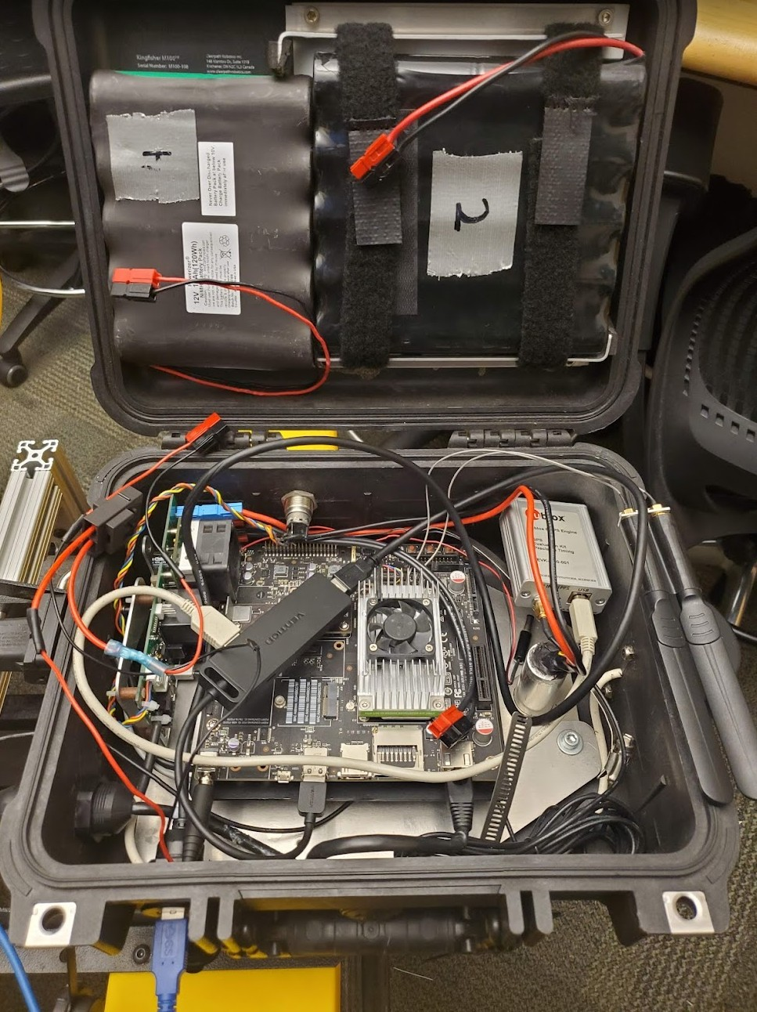

**Figure 4:** Internal layout of each Kingfisher M100 thruster module.

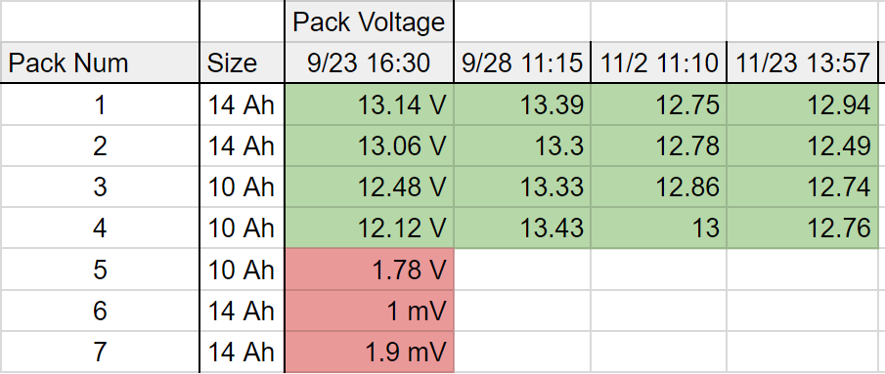

**Figure 5:** Battery catalog record including each battery pack identification number, capacity, and voltage at time of measurement.

### Hardware Modifications

**Stereo Camera** The ZED 2i stereo camera [10] from Stereolabs Inc. was identified as the primary per- ception sensor for the vehicle. This camera is designed for industrial applications of depth perception, environmental 3D mapping, and spatial analytics. Stereolabs provides an extensive software development toolkit enabling easy integration with ROS and OpenCV for our application. It features Dual 4M pixels sensors with 2-micron pixels with a weight of only 166 grams in a IP66-rated enclosure. The camera requires a USB 3.0 connection for data transfer and is rated to draw 380mA at 5V. Despite not designed for use un- derwater, there is a Stereolabs support article [11] referencing that it can be used underwater when properly calibrated inside a waterproof enclosure which is confirmed by the experimental setup described in [12].

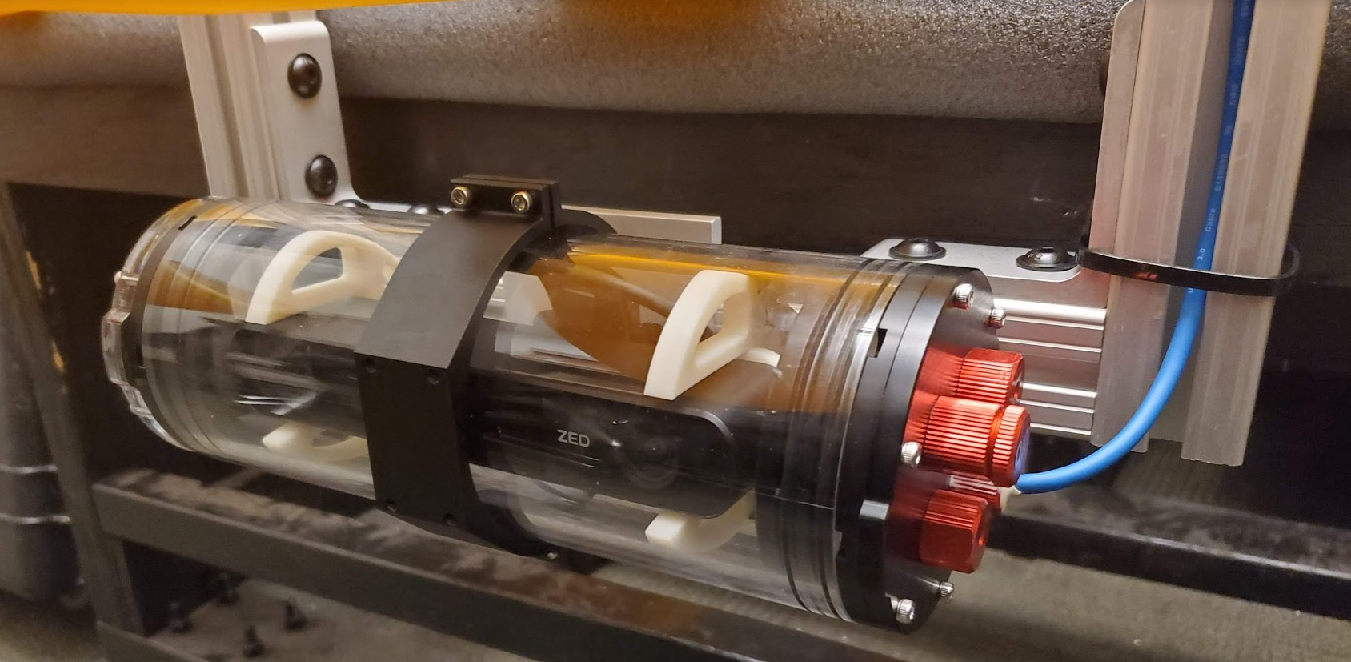

**Figure 6:** ZED 2i mounted within the BlueRobotics 3in Watertight Enclosure.

In order to properly protect the ZED 2i under the surface of the water, we selected the BlueRobotics Inc. 3in Series Watertight Enclosure for ROV/AUV [13]. This is comprised of a 8.75in cast acrylic tube, O-ring flanges, an acrylic end cap, and an aluminum end cap with 4 10mm holes. This provides an easy solution to place the ZED 2i camera down the length of the enclosure to allow for the camera field-of-view to see out the side of the clear acrylic as shown in Figure 6. The 4 holes are populated by a potted cable penetrator, a vent plug, and two blank stoppers. A custom mount, shown in Figure 7, was designed using AutoDesk Fusion 360 to hold the rectangular camera inside the cylindrical enclosure and was 3D printed with ABS plastic on a Stratasys Dimension Elite FDM printer. To pass through a data connection to the ZED 2i, a USB 3.0 Type-A extension cable was cut, potted with marine epoxy inside the cable penetrator, and soldered to a board-mount USB Type-A receptacle on the inside of the enclosure as shown in Figure

8. Delicate care was taken to ensure the SuperSpeed differential pairs were properly isolated and shielded

from each other to ensure full transfer rate. A Type-A to right-angle Type-C adapter is then used inside the

enclosure to connect the receptacle to the ZED 2i’s Type-C port.

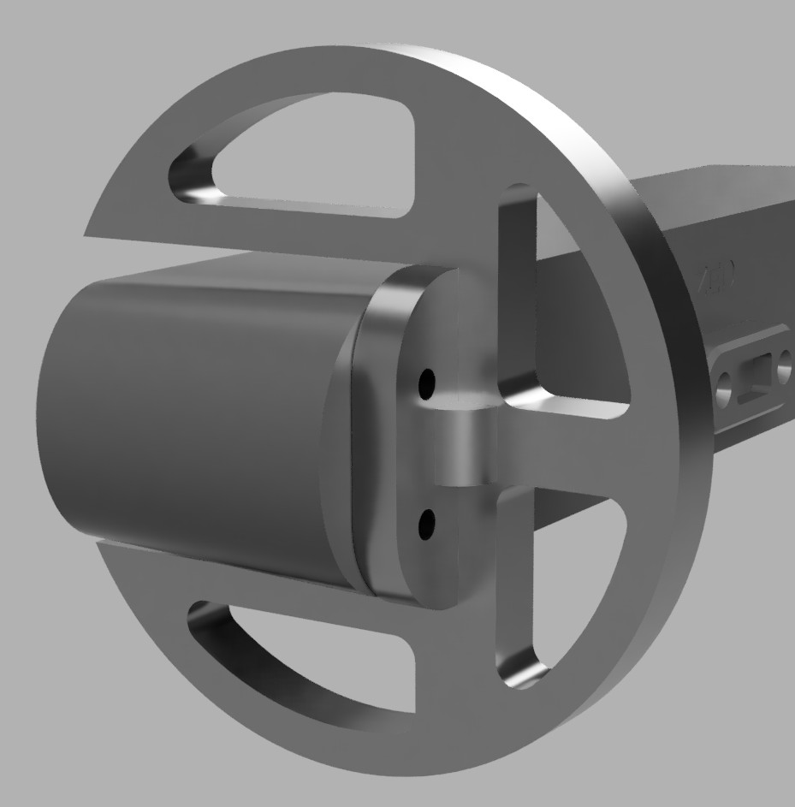

**Figure 7:** CAD model of the 3D printed camera mount

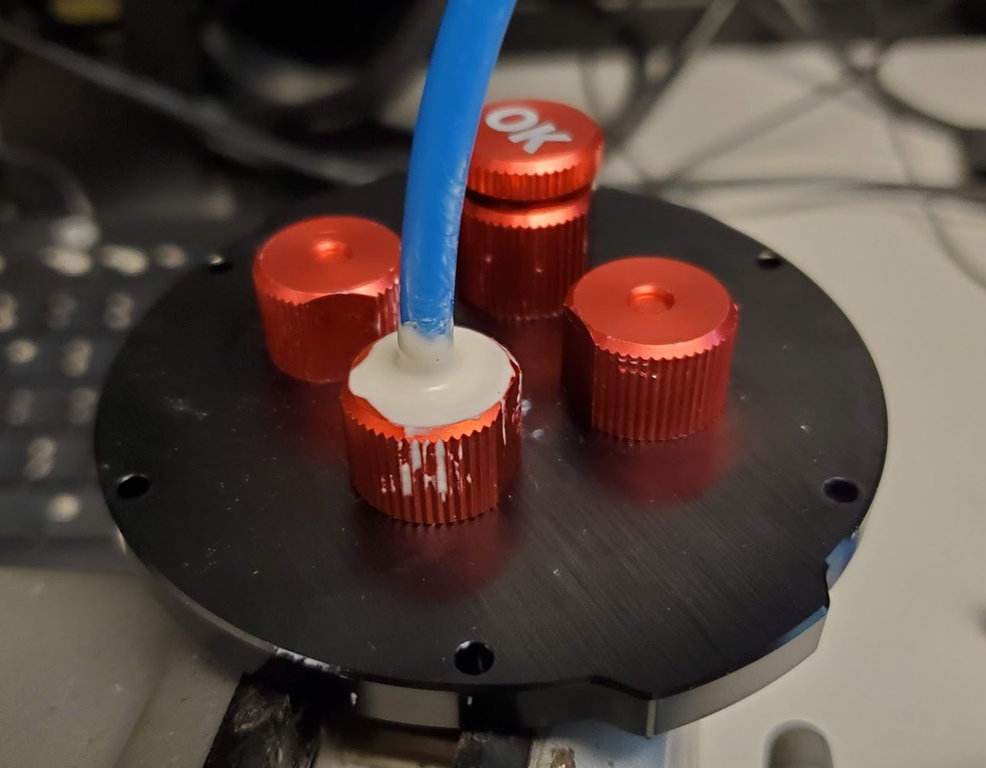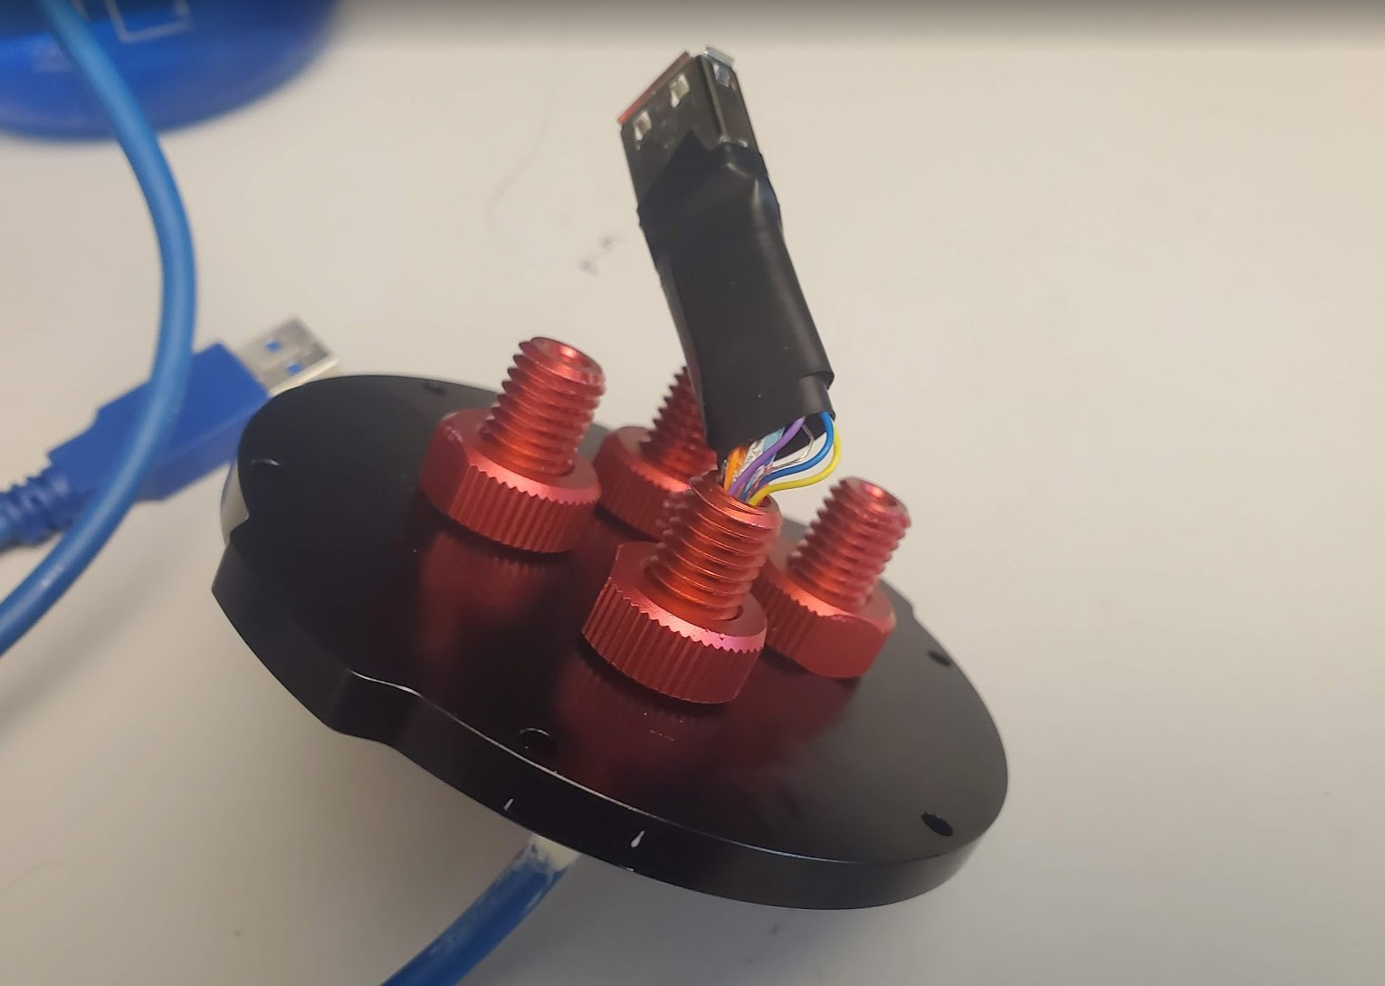

**Figure 8:** USB cable potted inside the waterproof penetrator and the Type-A receptacle soldered on the inside the enclosure to pass a USB 3.0 connection through the end-cap of the enclosure while maintaining the watertight seal.

To mount the camera inside the enclosure to the Kingfisher M100, a support frame was designed to place the enclosure under the surface of the water below the middle pontoon in a forward-facing position. This frame was designed using AutoDesk Fusion 360 from measurements of the Kingfisher M100 and trials testing the camera’s field of view to prevent conflict with the pontoon. 1.5in Aluminum T-slotted extrusion was identified as the easiest option to quickly design and assemble a sturdy frame. The extrusion, brackets, and fasteners were ordered from McMaster-Carr Supply Company in the specified lengths and quantities from the CAD model. The camera enclosure is held by a BlueRobotics 3in Enclosure Clamp around the center of the enclosure and mounted with M4 screws to a square aluminum mounting plate which is held to the T-slotted extrusion with end-feed fasteners. The support frame is held together with corner brackets

and attached to the main frame of the Kingfisher M100 through end-feed fasteners comprised of a 5/16in bolt and nut as well.

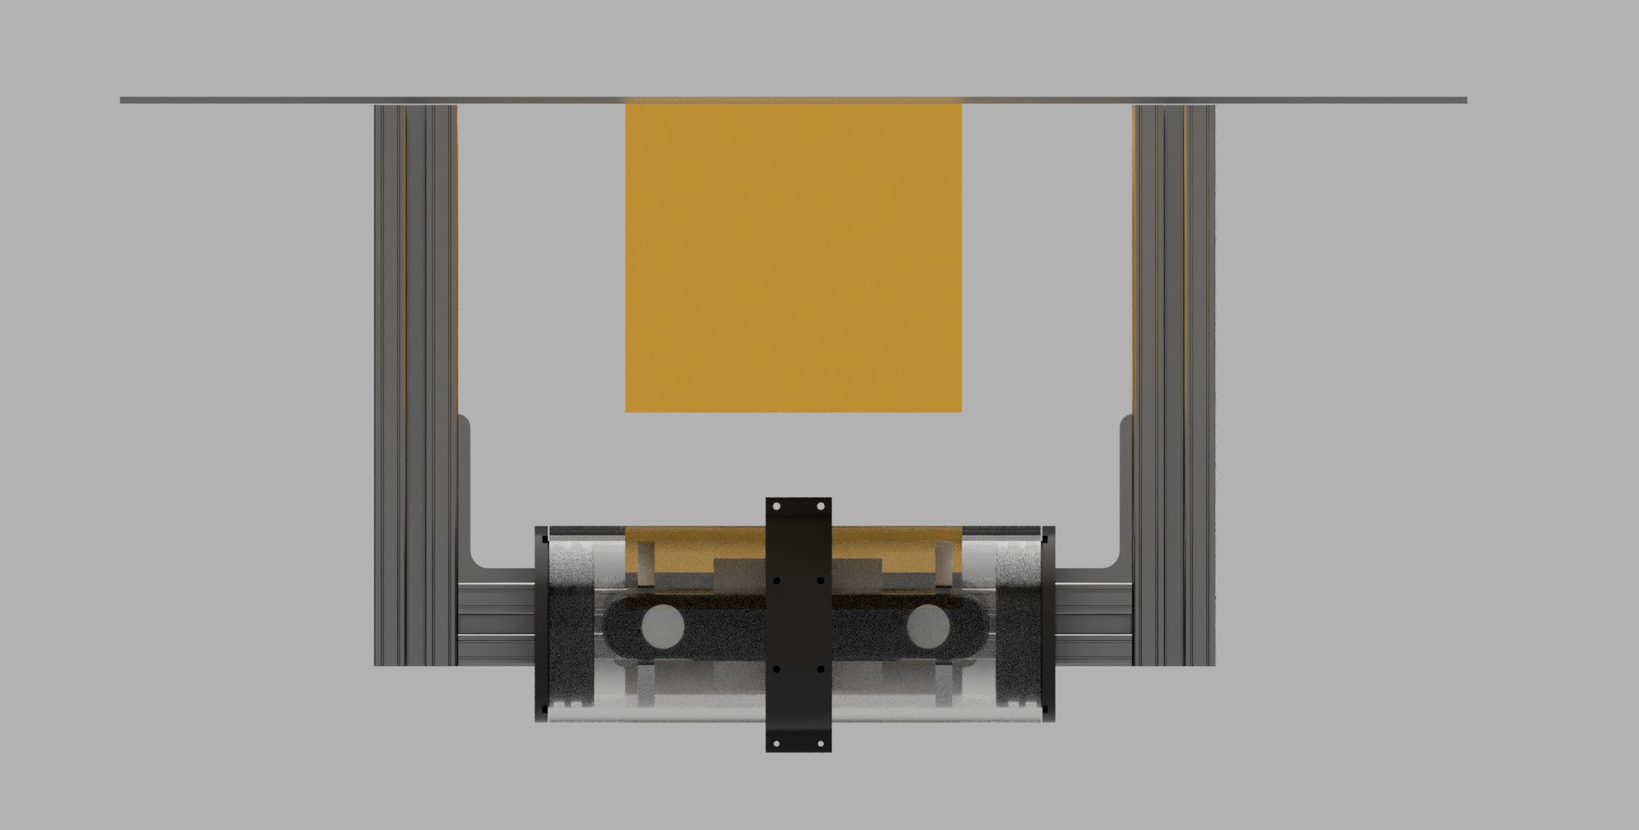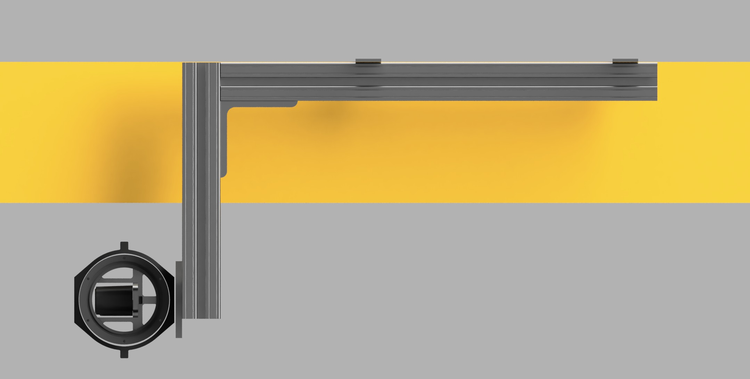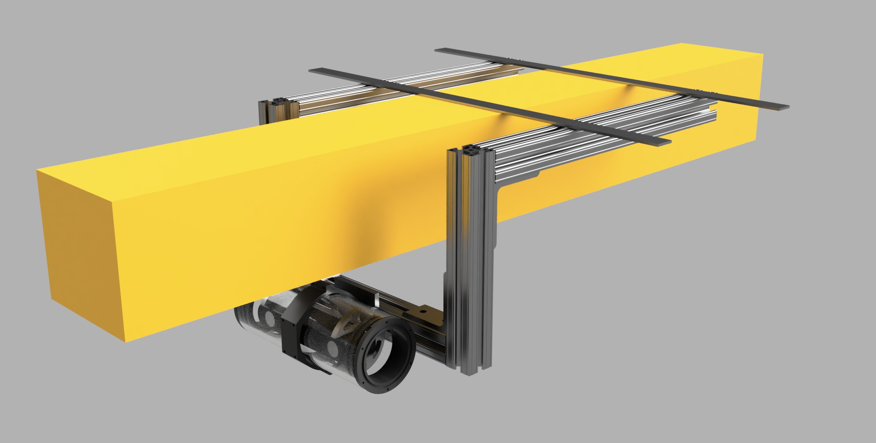

**Figure 9:** CAD model of the camera support frame

**Embedded Computing Board** A Jetson TX2 Developer Kit [14] was provided by Dr.West to use as the primary perception computer. The development kit features a Jetson TX2 compute module already integrated onto an ready-to-use mini-ITX carrier board with a fan and heatsink pre-installed [15]. The Jetson TX2 Developer Kit was placed inside the port Kingfisher M100 enclosure replacing the wireless router which was located there which is no longer needed as the carrier board is equipped with a 802.11ac Wi-Fi adapter.

The Jetson carrier board is powered through an independent circuit to prevent any interference from the drivetrain motors. This circuit is comprised of a 12V 10Ah NiMH battery connected with Anderson PowerPole PP30 connectors to 14 AWG wire which supplies power to the carrier board through a 2.5x5.5mm DC barrel jack connector. A 3A fast-blow automotive blade fuse is placed inside an inline fuse holder on the positive side of the circuit for protection of the Jetson. Despite the included AC adapter for the carrier board delivering at 19V, the Jetson carrier board contains power regulation circuitry which tolerates 5.5- 19.6V DC which allows for the decrease in voltage under discharge of the NiMH batteries as it draws 7.5W under typical load [16]. A battery over-discharge protection board was purchased to also place in this circuit which would include a relay to open when the battery became discharged below a specific voltage preventing damage to the cells. Unfortunately, it was accidentally broken during testing but since it was not deemed critical to the experimental phase of this project, it was not replaced and would be a beneficial improvement for a future team. Another future change could also be to place a voltage regulator between the battery and

Jetson carrier board to avoid any unintended consequences of the variation in battery voltage and provide better protection to the Jetson.

The Jetson is connected to the ZED 2i camera through a waterproof USB 3.0 pass-through connector added to the Kingfisher M100 port enclosure which provides a receptacle on the outside of the enclosure to plug in the USB 3.0 type-A cable potted into the camera enclosure which runs up the camera support frame and across the Kingfisher M100 frame to the port enclosure. The Jetson is also connected to the stock Kingfisher M100 GPS module through a USB adapter and to the FitPC-2 through an Ethernet connection over Cat 5 cable which passes between the two enclosures through waterproof connectors.

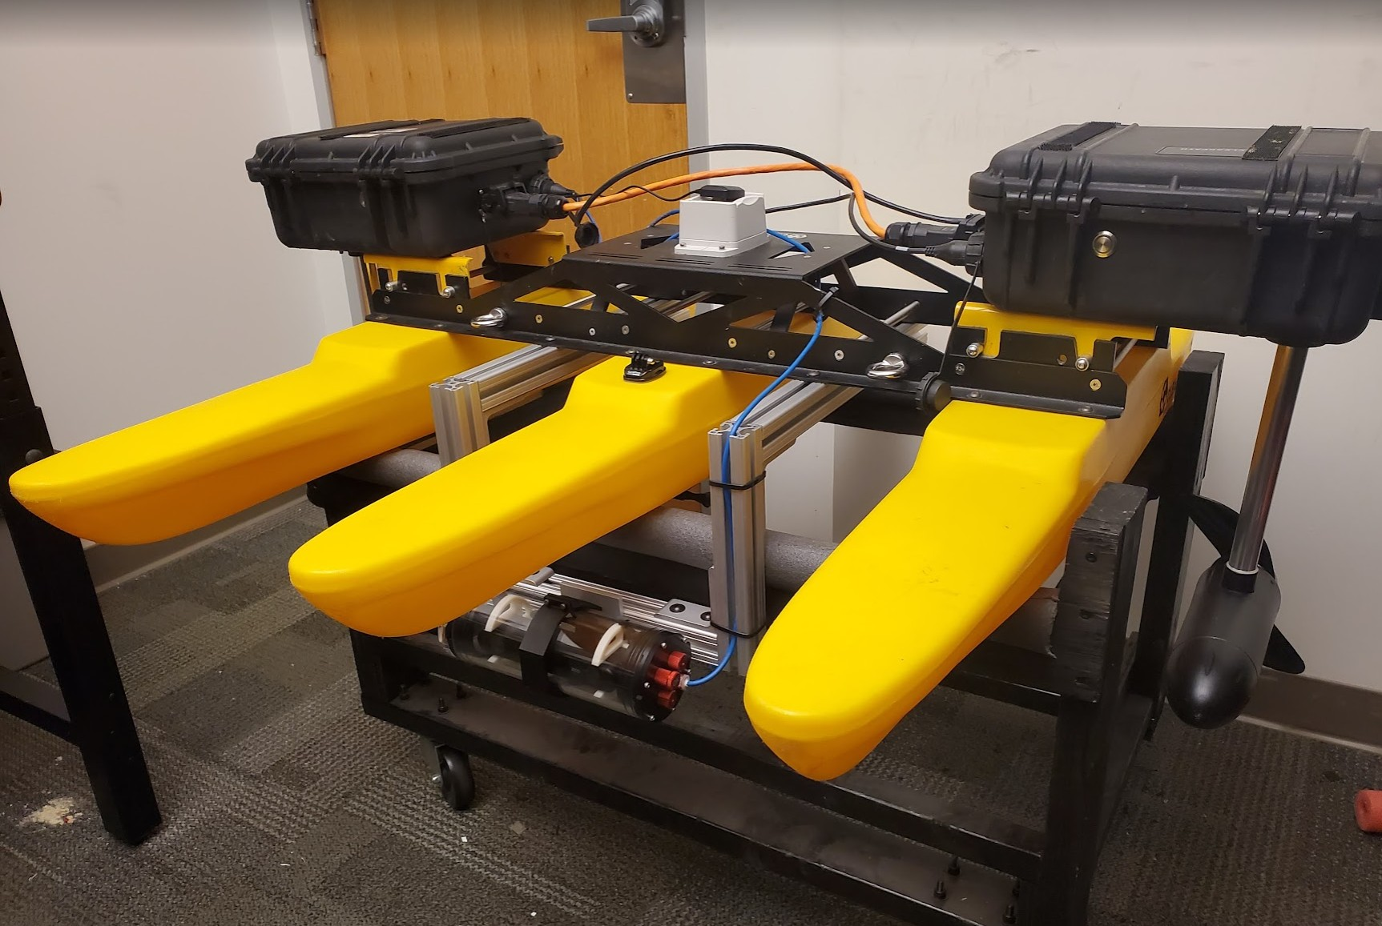

**Figure 10:** Final implementation of the ZED 2i mounted on the underside of the Kingfisher M100 inside the waterproof enclosure.

## Perception Architecture

In this section we detail the software architecture used for perception related tasks in accomplishing our goal of underwater plastic detection and localization. In this goal we seek to detect underwater plastic in the line of sight of the robot, localize it as to gets its position relative to the robot, and ultimately send these detected plastic locations to the navigation stack so that the robot can navigate to it. We provide a systems-level view of this architecture and offer details on specific software implementations and design considerations developed in this project.

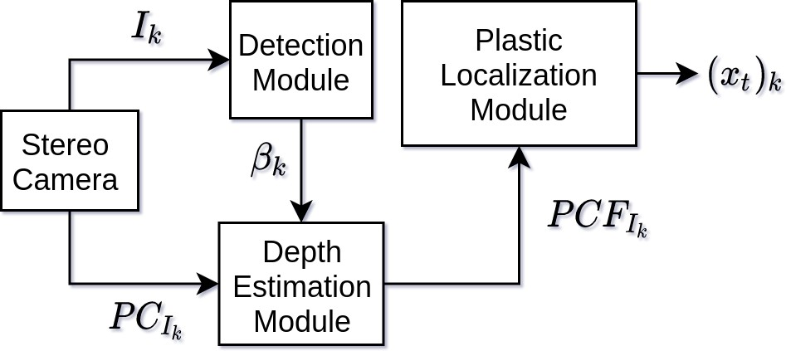

**Figure 11:** System level diagram of the perception architecture. *Ik*: Image from the stereo camera. *PCIk* : Point-cloud data at time. *βk*: Bounding boxes of detected objects in the image frame. *PCFIk* : Filtered point-cloud obtained by filtering only point-cloud points associated with detected objects. (*xt*)*k*: Calculated world position of detected objects.

**ZED Streamer** In order to obtain the necessary data for our perception architecture, our team developed software for interfacing with the ZED2i stereo camera in order to obtain a live camera feed from its image lens as well as 3D point-cloud data that is available through its stereo sensing capabilities. This sensor data is made available through usage of the StereoLabs APIs [17]. These APIs are simultaneously used within ROS [18] in order to communicate this data with other software components. Image data is available in the following (height *×* width) resolutions: VGA (672 *×* 376), HD720 (1280 *×* 720), HD1080 (1920 *×* 1080), or HD2K (2208 *×* 1242). Likewise, point-cloud data is also available at these resolutions where for each pixel a corresponding 3D point (xyz coordinate) in the world frame relative to the camera is produced. For our experiments we receive images at either VGA or HD720 resolution. We can receive these images a frame-rate of 30 FPS. However, obtaining a corresponding point-cloud at HD720 resolution proved difficult due to the large amount of data to process. This caused a significant delay in our communications between software modules that would not allow for real-time operation. Therefore, we operated mainly at VGA resolution as this was fast, did not experience delay, and was sufficient for our detection module. We were able to receive point-cloud data at 50 FPS without significant delay.

**Plastic Detection** The Fall of 2020 team proposed implementing a trash detection system with the ability to detect underwater plastic in a given image frame. To do this, a real-time object detection system called YOLOv2 [19] is utilized. This system uses a neural network architecture with an object detection model that has been trained on a ocean plastic waste data-set of over 5700 images [20] to detect three classes of objects: “plastic”, “marine-life”, and “remotely- operated vehicle (ROV)”. These objects can be identified by rectangular bounding boxes around the detected object. As seen in Figure 12. The corners of these

bounding are pixel coordinates in the image which can be used to process the sub-region of the image where the object is detected.

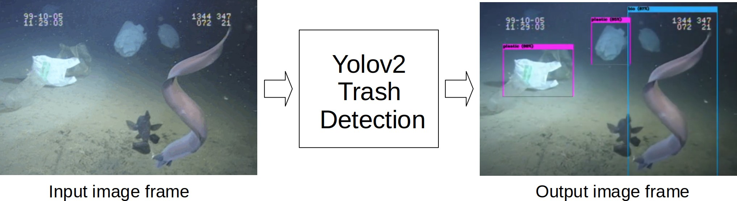

**Figure 12:** Input image frame to the YoloV2 detection system and corresponding output with bounding boxes around the detected objects. Input image is from the Trash-ICRA19 dataset.

In this section we detail our implementation of this system, corresponding to the **Detection Mod- ule** in Figure 11. In this module we implemented real-time object detection on a video stream from the ZED2i stereo camera. We process each image frame in the camera’s stream through our detection model. This outputs bounding boxes relative to the image frame of underwater plastic that is detected within that image frame. This software module is run on the Jetson TX2 on-board computer as this is directly connected to the ZED2i stereo camera. Again, we utilize ROS in this module to receive images from the ZED2i and communicate bounding boxes to other modules. In order to utilized the trash ICRA19 model, we utilize an OpenCV implementation of YOLOv2 based in Python [21]. We develop custom ROS messages that contain this information. This message consists of the pixel coordinates corresponding to the corners of the bounding box and the class of the detected object. Further, this has the ability to pass this information for multiple bounding boxes corresponding to multiple detected objects. Unfortunately, we were not able to utilize the Jetson’s TX2 GPU accelerations for processing an image frame through our network. By default, the necessary OpenCV version needed by the ZED SDK to work on the Jetson was OpenCV 4.1.1. However, to enable GPU acceleration with OpenCV’s YOLOv2 implementation, OpenCV 4.2 is required. Installing this on the Jetson proved difficult and could have effected the ZED SDK, therefore this was left as future work in order to move on to developing further software modules. We were able to achieve detection at 2.5 FPS, an acceptable rate to conduct experiments.

**Plastic Localization** In order to obtain the 3D locations of the detected underwater plastic, we utilize the point-cloud data obtained by the ZED2i. We do this by fusing this point-cloud data with the bounding boxes output by the detection module to filter out 3D points according to the bounding boxes. As the images

passed through the Detection Module are of the same resolution as our point-cloud data, we can sample points within the bounding boxes in the point-cloud frame. We developed multiple methods for extracting this information such as using the center of mass 3D point, or using many points within a defined radius around the center of mass, which are then averaged. This is done for every bounding box of every detected object. We then pass this information in a custom message to the Navigation Architecture with all of the estimated 3D locations of all detected plastic objects.

## Navigation Architecture

The navigation architecture of the robot relies on two sensors for localization. The IMU provides the change in pose that is precise and accurate over a short time but has a drift that introduces a constant error. The GPS provides a rough but accurate global coordinates that does not drift over time. These two sensor data are fed into the state estimation module which uses Extended Kalman Filter to calculate the best estimation of the robot’s location. The package used for Kalman filter is robot localization, which is the defacto official ROS package for state estimation.

Once the location of the robot is acquired, the driver module sets the next waypoint based on the driving mode. During normal operations, the driver would operate in the patrol mode where a list of GPS coordinates obtained from a preloaded CSV file are subsequently set as the current waypoint. This is for the robot to navigate inside a target area without accidentally colliding into a shore. If the perception module captures a trash and localizes it, the driver module then enters the trash collection mode and the location of the trash is set as the current waypoint. Once the trash waypoint is reached, the mode changes back to patrol mode and resumes where it left off.

In both driving modes, the waypoint is passed on to the path planner module which generates the most efficient path from the current location to the target waypoint. This is then passed onto the velocity controller which compares the current location and the given path and outputs a velocity command for the boat to follow. Finally, this velocity command is picked up by the PID controller, which compares the current velocity and the command velocity and adjusts the thrust of the motors on Kingfisher.

All of the packages other than robot localization and custom packages are part of the ROS navigation metapackage, which is a collection well developed packages for robot navigation, which is a defacto offical metapackage for implementing robot navigation.

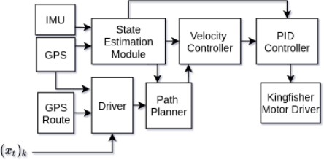

**Figure 13:** Navigation Architecture

## Constraints, Alternatives, and Trade-offs

Most significantly, we must consider the feasible time and scope of this project during a single semester as the final goal of an autonomous surface vehicle is quite extensive. Therefore, we are continuing this project from ideas developed in previous semesters and implementing them on the existing Kingfisher M100 platform to achieve the full goal. This will allow us to accomplish a reasonable goal without spending much time on mechanical design or the details of already completed work. Secondly, we are limited on the cost of sensors for environment perception. Given a larger budget, we could purchase expensive LIDAR or bathometry sensors that would allow for increased levels of underwater depth perception. Due to this we must develop smarter ways of sensing the robot’s environment to influence these navigation decisions.

The most significant trade-offs for the project are budget and the time and technical skills required for the implementation of the project. It would certainly increase the performance of the robot if expensive sensors are used for trash detection and localization. As for the skills and time required for the project, it is impossible to implement features such as underwater sonar due to the complexity of the task and the price of the components that are priced outside of the budget. The solution is to use hardware that is within the project budget and implement features within our skill-sets. For these reasons we choose to use the ZED2i stereo camera as it has both the capability to obtain images in the environment and provide 3D point-cloud information from its stereo-vision capabilities. Furthermore, this product is fully developed and has extensive resources and APIs that we can utilize to retrieve this information.

The following tables summarize comparisons between different sensors that were considered:

|  |  |  |  |  |  |
| --- | --- | --- | --- | --- | --- |
| Camera Comparison | | | | | |
| Camera | FOV (H/V) | Max-Resolution | Streaming | Waterproof | Price |
| ZED 2i | 110/70° | 4416x1242 | USB | No,IP66 | $449 |
| Low-Light HD USB Camera | 80/64° | 1920x1080 | USB | No | $99 |
| Blackfly S USB3 | N/A | 1440×1080 | USB | No | $335 |
| GoPro HERO4 | 122/94° | 4K | Wi-Fi | Yes | $399 |
| DTPod Underwater Camera | 360° | 1920x1080 | USB | Yes | $5198 |

**Table 3:** Camera sensor comparison of specifications considered.

|  |  |  |  |  |
| --- | --- | --- | --- | --- |
| Range Comparison | | | | |
| Sensor | FOV (degree) | Range (m) | Data Interface | Price |
| ZED 2i | 110/70° | 20 | USB 3.0 | $449 |
| Ping Sonar Altimeter and Echosounder | 30° | 30 | UART/Serial | $279 |
| Tritech Micron EchoSounder | 6° | 50 | UART/Serial | $1995 |
| Ping360 Scanning Imaging Sonar | 360° | 50 | UART/Serial | $1975 |

**Table 4:** Range sensor comparison of specifications considered.

### Global, Economic, Environmental, and Ethical Factors

Human activity results in about eight million tons of plastics entering the ocean every year [3]. When plastics enter the ocean, it does immeasurable damage not only to the ocean wild life but also to the global population that consume food harvested from the ocean. Apart from the usual publicly televised suffocation and entanglement of wild life, the ocean currents and winds degrade the plastics into smaller pieces until they are considered to be micro-plastics with lengths less than five millimeters [22]. Microplastics are consumed by many wild life that include sea harvests consumed by humans. This raises a serious health concern since there are rising studies that suggest toxicity and epidemiology related to micro-plastic [22]. This project is aimed at alleviating the global marine plastic crisis by exploiting the developing areas of robotics and artificial intelligence, thus positively contributing to the global health, environment, and sustainability, effectively automating the ethical dilemma of marine pollution.

There are potential concerns regarding the ethical aspects of the project. One concern is the

possibility of the ASV harming the wild life by accidentally injuring them with mechanical parts. As a

relevant example, at least 136 manatees in Florida were killed by boats in 2019 [23]. However, this problem is addressed in two parts in this project. Firstly, any sufficiently large objects, whether that be a marine animal or a rock, will be considered an obstacle by the obstacle avoidance system implemented with MOOS- ivp. Also, the YOLOv2 object detection system includes the ’marine-life’ class and makes the robot carry out conscious maneuvers not to engage with marine wild life. Another concern might be that the robot might get involved in a collision accident with other vehicles, but this is also addressed by adding the ’remotely-operated-vehicle’ class in the detection system.

This project is intended to provide a cheaper alternative to hiring laborers or relying on volunteers to reduce marine plastic. The cumulative development cost of the project prototype is expected to be expensive, but the mass production and mass deployment of these robots will likely prove to be cheaper and easier than relying on human labor. In addition, these robots will also be able to operate in environments that could be dangerous to humans, providing an ethical relief.

As for the political factors, the design of the robot abides by the codes and laws issued by the government of the region the robot is operating in which is discussed in the Codes and Standards section.

### Computation Aspects

The Kingfisher robot will carry an on-board Jetson TX2 for computation. This computer will interface with ZED2i camera to receive an image stream and 3D point-cloud data. This data will be utilized for plastic detection and localization. The range for this sensor is 0.1 - 20 meters and its performance is heavily dependent on the lighting conditions of the environment. GPS and IMU sensors will be used to localize the robot in its environment and for the path planning algorithm to generate a path from the robot’s location to potential trash targets. GPS performance can be heavily impacted by weather conditions.

The communication between our main software and the sensors will be done on a platform called Robot Operating System (ROS). ROS is a over-the-network middle-ware that allows different ROS software modules to communicate with each other through channels called topics and services. The manufacturers of devices frequently used for robotic applications provide their open source ROS packages that allow users to interface their devices with their software. In addition, many useful ROS robotics navigation packages such as the navigation stack and robot localization are available for use.

## Engineering Analysis and Experiment

**Hardware** Each hardware component was tested to prevent failure during system integration by ensuring reliable operation individually. Each electrical component was tested from independent power supplies before

being powered by the on-board battery packs. The Jetson was specifically tested with multiple battery packs at varying states-of-charge to ensure compatibility with the variation in voltage over discharge range. Each mounting component was designed using the computer aided design (CAD) program Autodesk Fusion 360 and vendor provided 3D models of the component to be mounted before being manufactured. This ensured a thorough design as the team was able to critique each iteration and accurate fitting with the required clearances was proven. The mounting components were not load stress tested using simulation tools as this is only intended to be a proof-of-concept and acceptable margins were allowed for. All structural components performed well during system testing under vehicle operation and did not compromise the buoyancy of the vehicle during full power. All watertight components were checked during the first perception testing with the seals in the camera enclosure and the potting of the USB cable showing no issues throughout our project during multiple hour-long test periods.

This video shows confirmation the vehicle is stable with the addition of the camera enclosure and

frame during manual driving: <https://photos.app.goo.gl/CqsX22rfPny41nRZ6>

**Perception** In order to test our Perception Architecture, our team conducted two rounds of testing and experiments at an indoor pool at Georgia Tech’s Campus Recreation Center. The purpose of the first test was to ensure that individual software modules detailed in Section 4.2 were fully functioning and that communication between these modules was successful. In our first round of testing we became familiar with the testing environment and operating procedures needed to run the perception architecture. These procedures are further detailed in our code-base.

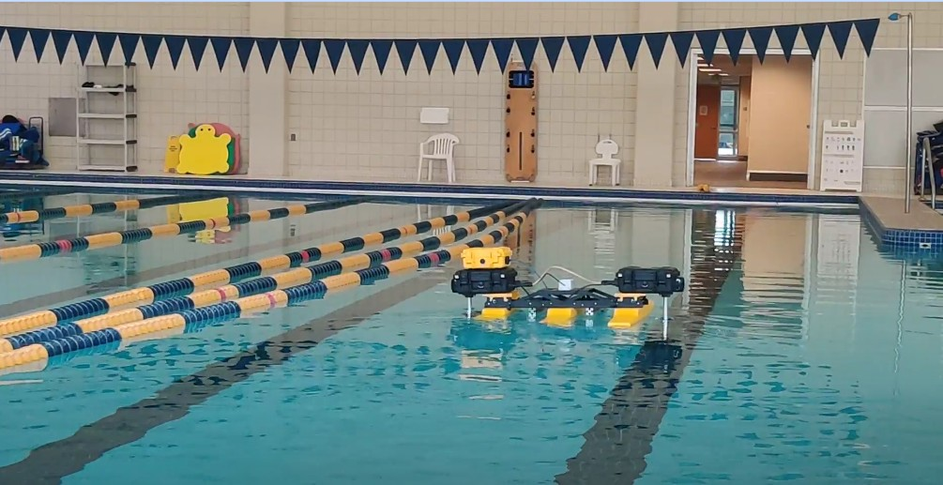

**Figure 14:** Kingfisher robot operating in the indoor pool used for experiments at the Georgia Tech Campus Recreation Center.

We were able to successfully receive image and point-cloud data from the ZED2i using our software

modules and view this data remotely from our laptops connected to the ROS network via Wi-Fi.

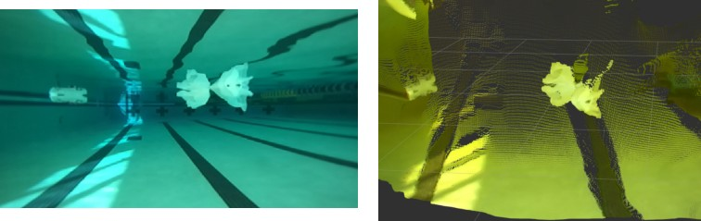

**Figure 15:** (Left) Image of below surface pool from underwater ZED2i camera with plastic placed in front. (right) Corresponding point-cloud produced by the scene in the image frame.

With this functioning, we were than able to run the detection module in order to verify that we were able to successfully detect plastic and output bounding boxes in real-time. From this first round of testing we were able to verify our qualitative specifications. In our second round of testing we followed the same procedures, however we set to test our Quantitative Specifications of estimating the detected plastic at various locations and conditions as detailed in Section 3.

**Navigation** To test out the navigation architecture, our team created a simulation environment by using Gazebo simulation environment and ROS plugins. The simulation adopted a hydrodynamics plugin to mimic the surface of water and the CAD model of the robot coupled with thrust plugin to simulate motor operations. The thrust plugin subscribes to the same topic as the actual motor driver and the sensor plugins provide the real time sensor data.

The perception module could not be tested using the simulation due to the fact that the simulation environment looks different from the real world where the data set used to train the AI were taken from. However, the role of the perception module could easily be implemented using the rviz user interface that publishes the location of the point clicked on the rviz map. This click interface served as the pseudo trash location and it was successfully picked up by the navigation module.

The navigation architecture worked very smoothly in the simulation environment and was able to switch between different driving modes based on the trash detection status and navigate to correct locations at any given time.

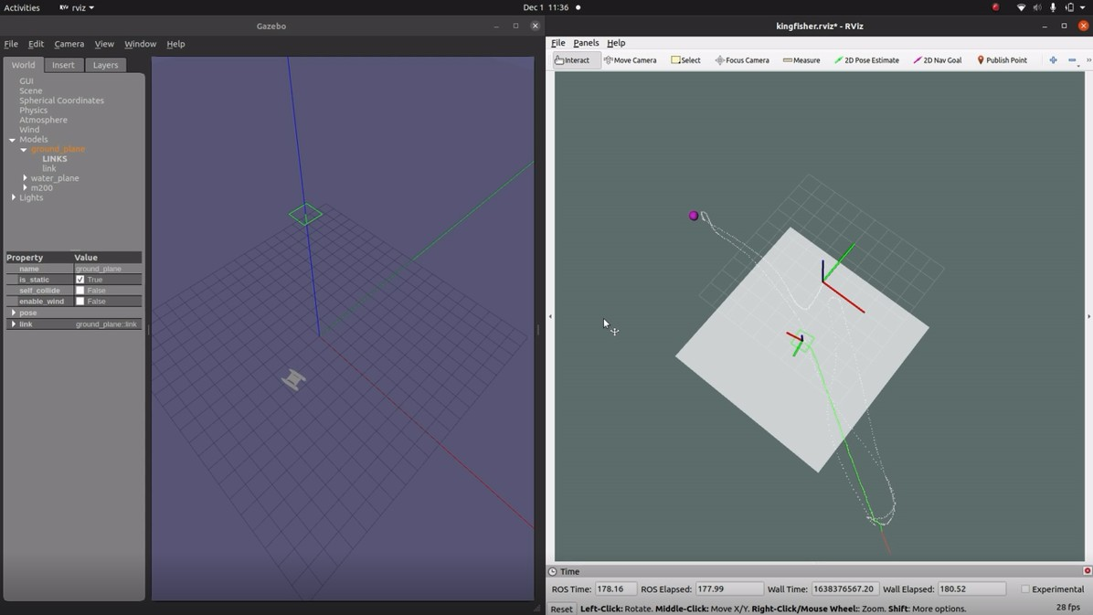

**Figure 16:** Navigation Simulation

## Codes and Standards

There are several standards that apply to our design based on the hardware already implemented.

* **COLREGS:** is a set of navigation and collision rules that require detection of other vessels and yielding to less maneuverable traffic. The river robot should be designed to avoid other moving objects within the local environment [24].
* **SOLAS (Safetly of Life at Sea):** sets safety standards in the construction, equipment, and operation of merchant ships. The river robot should be able to detect marine animals, and avoid killing, harming, or capturing an animal [25].
* **Interim Guidelines for MASS Trials:** sets rules to ensure that the trials of autonomous ships are conducted in a safe and secure manner without interrupting the environment. The robot should not have any features that could interrupt the livelihood of the animals like unnatural sudden lights and/or sounds [26].
* **ISO/CD 24161:** defines internationally recognized terminology for waste collection and transportation management which will be necessary for the final goal of autonomous waste collection [27].
* **GPS Standard Positioning Service (SPS) Performance Standard:** defines the level of performance the U.S. Government makes available to civilians without special authorization. It ensures compatibility of GPS with systems operated by civilians [28].
* **FCC Radio Spectrum Allocation:** determines which portions of the electromagnetic spectrum can be used for different radio frequency applications within the U.S., and therefore our robot must fall within these guidelines for manual control and communication during operation as a maritime vehicle [29].
* **IEEE 802.11a/b/g/n/ac:** allows for the WiFi connection at 5 GHz standard and 2.4 GHz standard at wider channels (80 and 160 MHz). The robot would need a connection from the Jetson to the base station WiFi antenna [30].

Many of these standards are not of much concern to our design as our project mostly relies on software implementation using existing hardware which should already be compliant to these specifications. As regulations regarding operations of autonomous vessels are not well developed yet, they are also not much of a concern, especially in rivers and with a small craft where the chance for damage is minimal. Therefore, during this project, we must strive to develop a system which operates responsibly in the environment using our best judgment.

# Schedule, Tasks, and Milestones

## Gantt Chart

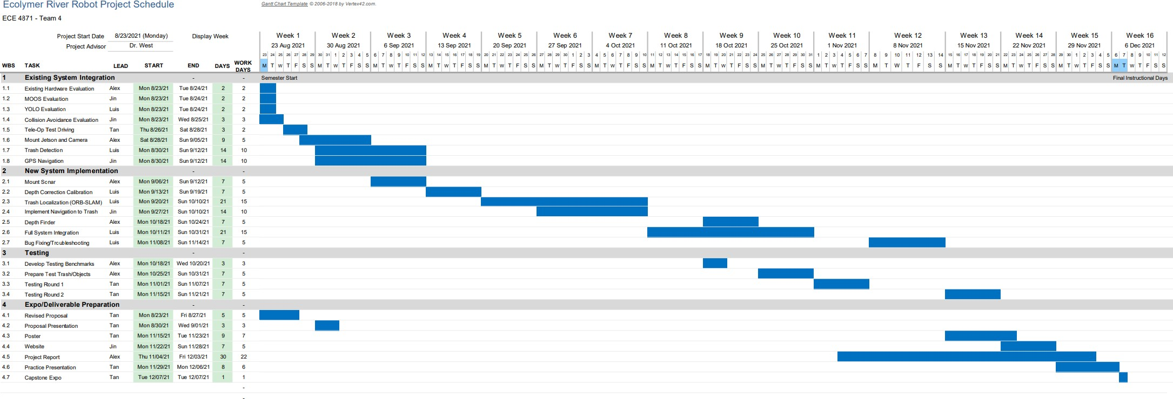

**Figure 17:** Gantt Chart for the Fall 2021 Semester. See Appendix A for expanded version.

## PERT Analysis

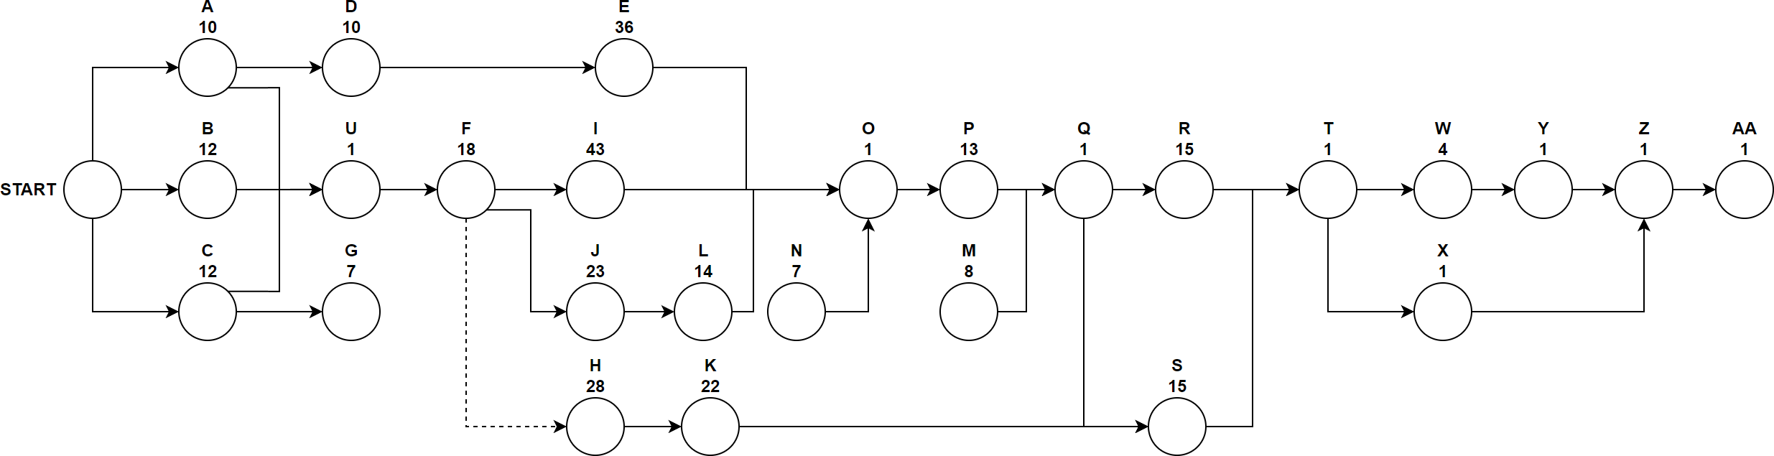

**Figure 18:** PERT Chart for the Fall 2021 Semester.

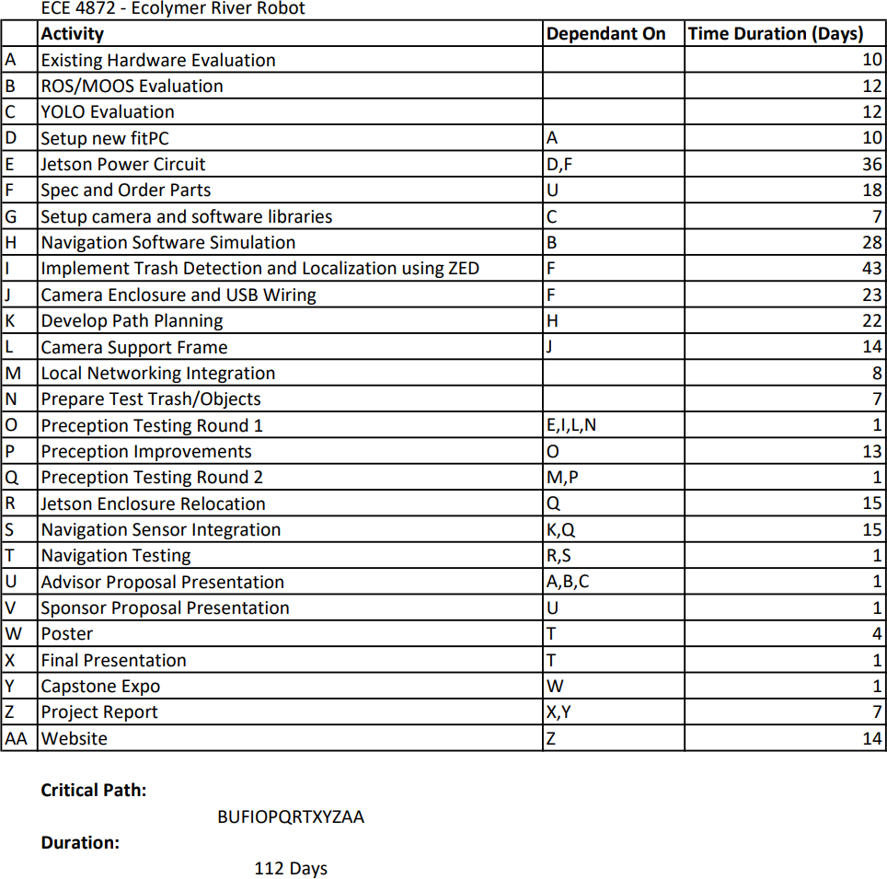

**Figure 19:** Table detailing PERT Analysis for the Fall 2021 Semester.

# Project Demonstration

**Perception Demonstration** We followed the same procedures detailed in Section 4.5 to conduct the experiments detailed in this demo. Plastic waste was placed in the pool in front of the robot and the full Perception Architecture was run. This allowed us to detect plastic and also estimate its 3D location. All of the data flowing between modules was recorded for later analysis and verification. The figures of this section display different frames taken from recordings of different runs.

We further measured different locations in the indoor-pool where we placed plastic according to the specifications we tried to meet. We were able to successfully detect all of the trash that was within 3 meters of the robot. However, as plastic was placed further from the robot, it was harder to detect all of the plastics in the image frame. This happened after roughly 5 meters. This was likely due to using a lower resolution image frame for detection, in order to meet necessary performance requirements. Furthermore, the lighting conditions of the pool were very reflecting, causing white blobs to appear near the surface of the water. Finally, the different patterns along the walls and floor of the pool made detection harder as

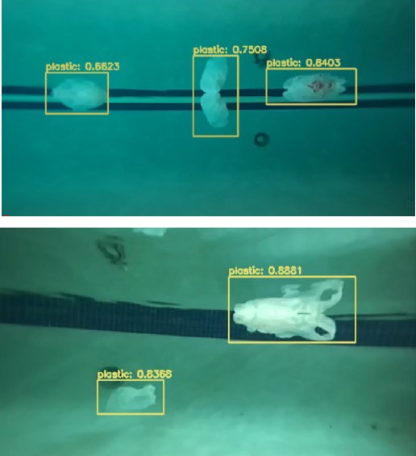

**Figure 20:** Image frames captured by the ZED2i camera with bounding boxes drawn on the image around detected plastic. Bounding boxes include the confidence level of the detection.

it sometimes identified these patterns as ROV. In order to test our specification of having the ability to continuously detect drifting trash locations we wrapped the plastic in a transparent string and moved it. Finally, confidence level measures were available by seeing the output of the Detection Module where where bounding boxes were drawn around the detected object.

|  |  |
| --- | --- |
| Ability to detect trash objects using camera system and pre-trained trash detection model. | Successful |
| Ability to localize trash using bounding box and its corresponding depth values. | Successful |
| Ability to continuously estimate trash location as trash location drifts. | Successful |
| Ability to detect plastic within 3 meters with confidence *p ≥* 0*.*8 | Successful |
| Ability to estimate 100% of plastic locations within threshold *x ≤* 3 meters | Successful |
| Ability to estimate 60% of plastic locations within threshold 3 meters *≤ x ≤* 10 meters | Partially Successful |
| Ability to estimate 20% of plastic locations within threshold 10 meters *≤ x ≤* 20 meters | Unsuccessful |

**Table 5:** Results of Quantitative and Qualitative Perception Specifications.

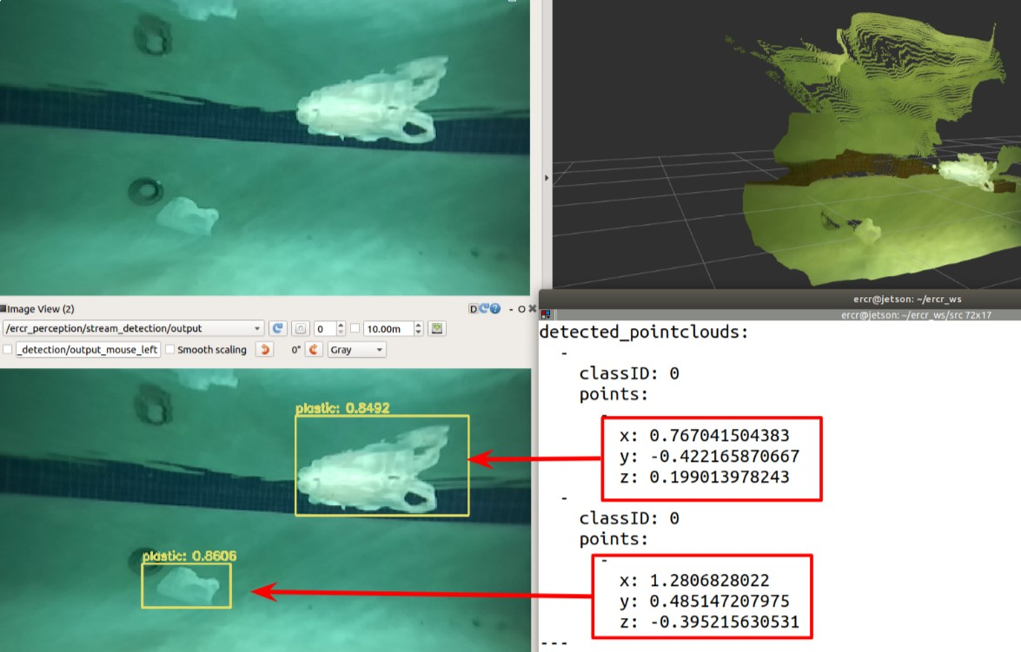

**Figure 21:** (Top Left) Image frame from the ZED2i passed to the Detection Module. (Top Right) Point- cloud data of this same image frame. (Bottom Left) Bounding boxes drawn on the detected plastic in the image frame. (Bottom Right) A message from the plastic localization module showing the estimated 3D locations of the two plastic images detected in the image frame.

An example of this demo can be seen in the following video: [https://drive.google.com/file/](https://drive.google.com/file/d/1RbXTxptkpuCll3MPNfoqoXthnh8a_TDz/view?usp=sharing) [d/1RbXTxptkpuCll3MPNfoqoXthnh8a_TDz/view?usp=sharing](https://drive.google.com/file/d/1RbXTxptkpuCll3MPNfoqoXthnh8a_TDz/view?usp=sharing)

**Navigation Demonstration** The final demonstration of the navigation software was delivered in the form of Gazebo simulation. The IMU on the Kingfisher was broken and could not be calibrated, therefore the robot could not obtain a usable position estimate and the whole navigation architecture could not be tested on the actual robot. However, all of the specification proposed during the initial presentation were met inside the simulation.

|  |  |
| --- | --- |
| Ability to control the robot’s position and heading through ROS | Successful |
| Ability to navigate robot from a starting point to a trash location | Successful |
| Ability to navigate to 100% of plastic locations within threshold *x ≤* 3 meters | Successful |
| Ability to navigate to 60% of plastic locations within threshold 3 meters *≤ x ≤* 10 meters | Successful |
| Ability to navigate to 20% of plastic locations within threshold 10 meters *≤ x ≤* 20 meters | Successful |

**Table 6:** Results of Quantitative and Qualitative Navigation Specifications.

# Cost Analysis

As this project is primarily a proof-of-concept in testing the technologies required for the final goal of full autonomy, cost effectiveness is not a large concern with much of the components already available for us to use. Regardless, this section explores a cost analysis to see the feasibility of the direct commercialization of this prototype as a product at the end of our project. Additionally, we must still be aware of the impact our choices could have on the price of a final product derived from our conceptual prototype.

Two hourly rates are required for the development cost and manufacturing cost of the product. Using the typical electrical engineer starting salary of $74,423/year [31] leads to an hourly cost *≈* $36 for development. Using the average engineering technician salary of $55,643/year [32] leads to an hourly cost *≈*

$27 for manufacturing.

The cost analysis was performed by identifying the cost associated with product research, develop- ment, and testing over the Fall 2021 semester, as shown in Table 7, which will them be distributed over an estimated number of units sold in five years. The part cost was identified in Table 8 through the available price of the required hardware components. It is notable that this is where the analysis is most inaccurate as multiple of the part choices here are dependant on hardware easily available to us for ease of development and would not be reflective of a true commercial product. Table 9 outlines the cost associated with individual manufacturing of the product where assembly is fairly simple but significant testing is required to ensure a high level of quality control. These results are combined in Table 10 to yield a unit selling price when considering overhead of 10% and adding an expected profit of 20%.

|  |  |  |  |  |
| --- | --- | --- | --- | --- |
| **Task** | **Hours/Week/Engineer** | **# of Engineers** | **Hours Over 16 Weeks** | **Total Cost** |
| Hardware | 2 | 2 | 64 | $2,304 |
| Software | 3 | 2 | 96 | $3,456 |
| Deliverables | 1 | 4 | 64 | $2,304 |
| Meetings | 2 | 4 | 128 | $4,608 |
| Testing | 2 | 4 | 128 | $4,608 |
| **Total Development Cost** | | | | $17,280 |

**Table 7:** Development Cost Estimation.

|  |  |  |  |
| --- | --- | --- | --- |
| **Part Name** | **Quantity** | **Price** | **Source** |
| Kingfisher M100 | 1 | $29,495 | [7] |
| NVIDIA Jetson TX2 | 1 | $400 | [15] |
| Zed 2i Stereo Camera | 1 | $499 | [33] |
| Blue Robotics Enclosure | 1 | $148 | [13] |
| Router | 1 | $79 | [34] |
| Enclosure Mounting | 1 | $97 | — |
| Cables and connectors | — | Estimating $200 | — |
| **Total Unit Part Cost** | | | $30,918 |

**Table 8:** Unit Part Cost Estimation.

|  |  |  |  |
| --- | --- | --- | --- |
| **Task** | **Hours** | **# of Technicians** | **Total Cost** |
| Fabricate  Assemble | 4  3 | 2  2 | $216  $162 |
| **Total Manufacturing Cost** | | | $378 |

**Table 9:** Manufacturing Cost Estimation.

|  |  |
| --- | --- |
| Development Cost  Estimated Units Sold Over 5 Years | $17,280  100 |
| Development Cost Per Unit Part Cost Per Unit  Manufacturing Cost Per Unit | $173  $30,918  $378 |
| **Total Cost Per Unit** | $31,469 |
| Expected Profit  Overhead | 20%  10% |
| **Unit Selling Price** | $40,910 |

**Table 10:** Suggested Selling Price Analysis.

# Conclusion

Coming into this project, our team knew that it would be a serious challenge due to the ambitious and open-ended nature of the problem. We recognized the task of a fully autonomous vehicle is particularly difficult especially in a river environment where there can be so many uncontrolled factors affecting the vehicle’s operation. We believe we did the best we could planning for the possibilities of our project during the Spring 2021 semester but the scope of work during the Fall 2021 semester still proved to be an undertaking. We are content with the final product we were able to achieve despite not quite not making it quite to the lofty goal of autonomous navigation established during the spring semester.

Nearly every stage of the project ran into problems and involved finding a creative solution to work through or around the issues which emerged. Many of these were created from having to interface with existing project hardware which was old, unsupported, or faulty. A few examples of this include: Previous Jetson power converter no longer working, USB cable potting issues, and hardware issues with IMU and GPS. Furthermore, working with many different pieces of software was difficult as different version of software were necessary. These issues did not allow us to implement GPU accelerated object detection on the Jetson and caused issues with compatibility of motor control packages on the FitPC.

The Perception Architecture developed in this project showed the underwater plastic detection and localization is a feasible task in developing a full solution for plastic removal in water environments. While several improvements detailed in this report could increase performance, we were able to achieve sufficient performance measures to run experiments and demonstrations this semester. Apart from IMU and GPS, the Navigation Architecture of this project surprisingly does not rely heavily on the nature of hardware. The software can be run on any computer connected to the network and the computation aspect of it does not require a heavy use of CPU or exploit CUDA cores on GPU. A functioning and well calibrated IMU will enable the navigation software to run smoothly on Kingfisher. However, adding the obstacle avoidance feature will require an additional depth camera placed above water unless future teams come up with a method to differentiate between a trash to be collected and an obstacle to be avoided. It is unlikely that the robot will collide into an object in the middle of a body of water and the GPS coordinates for patrol can be defined to avoid shore areas in advance, it will make the fully autonomous robot more reliable.

We recognize that there might some issues with our implementation of the camera vision which

would lead it to work significantly better in an ideal scenario than in reality but we are confident that we have developed a software structure from which a future group could continue the work and consider a different suite of sensor technologies. Despite the limitations of our current project, we were able to identify and make progress on a major limitation to prevent automatic plastic waste collection in such a difficult environment.

Our team was motivated by these obstacles as the eventual solution has the potential to make such a large impact in the future of many facets of our lives. We are excited to see the progress made by other groups in this field and hope our project is able to be continue by another team in the future as we believe it to be a very relevant issue. Regardless of the outcome, the challenge of river waste and marine pollution will have to be tackled eventually whether it is a preventative solution as we have proposed or a reactive solution after if starts impacting society on a global scale.

# Leadership Roles

|  |  |  |  |  |
| --- | --- | --- | --- | --- |
| **Leadership Roles** | | | | |
| Member | Luis Pimentel | Jin Bae | Tan Tonge | Alexander Chanthaphaeng |
| Roles | Perception Software Lead  Software Documentation | Navigation Software Lead  Webmaster | Project Manager  Expo Coordinator | Hardware Lead  Team Documentation |

**Table 11:** Leadership Roles for Fall 2021 Semester.

Leadership roles have been determined according to each team member’s skill set to best leverage the capabilities of our team, as shown in Table 11.

* **Project Manger** will be responsible for organizing meetings, communication with outside contacts, and schedule management.
* **Perception Software Lead** will be responsible for the primary development and final decisions relating to software for perception capabilities of the robot.
* **Navigation Software Lead** will be responsible for the primary development and final decisions relating to the software for navigation capabilities of the robot.
* **Hardware Lead** will be responsible for the implementation and fabrication needs relating to the hardware and sensors on the robot.
* **Software Documentation Coordinator** will be responsible for managing the Git Repository and technical documentation associated with the software algorithms.
* **Webmaster** will be primarily responsible for creating the team’s website upon the completion of the project.
* **Expo Coordinator** will be primarily responsible for the presentation poster and deliverables associ- ated with the Capstone Expo.
* **Team Documentation Coordinator** will be responsible for the deliverables associated with reim- bursement and documentation throughout the semester.

# References

1. “Sustainable development goal 14,” United Nations Department of Economic and Social Affairs. [Online]. Available: <https://sdgs.un.org/goals/goal14>
2. NOAA, “Why should we care about the ocean?” National Ocean Service. [Online]. Available: <https://oceanservice.noaa.gov/facts/why-care-about-ocean.html>
3. “River plastic emissions to the world’s oceans,” The Ocean Cleanup Technologies B.V. [Online].

Available: <https://theoceancleanup.com/sources>

1. H. Ritchie and M. Roser, “Plastic pollution,” *Our World in Data*, 2018, https://ourworldindata.org/plastic-pollution.
2. “The bubble barrier,” The Great Bubble Barrier. [Online]. Available: [https://thegreatbubblebarrier.](https://thegreatbubblebarrier.com/technology/) [com/technology/](https://thegreatbubblebarrier.com/technology/)
3. “Mr. trash wheel : A proven solution to ocean plastics,” Waterfront Partnership of Baltimore. [Online].

Available: <https://www.mrtrashwheel.com/>

1. “Kingfisher m100 user manual,” Clearpath Robotics, Inc. [Online]. Available: [https://oceanai.mit.edu/](https://oceanai.mit.edu/svn/moos-ivp-kfish/trunk/docs/kfish-m100-manual.pdf) [svn/moos-ivp-kfish/trunk/docs/kfish-m100-manual.pdf](https://oceanai.mit.edu/svn/moos-ivp-kfish/trunk/docs/kfish-m100-manual.pdf)
2. “Alpla group,” ALPLA. [Online]. Available: <https://www.alpla.com/en>
3. “fit-pc2 & fit-pc2i,” Compulab. [Online]. Available: <https://www.fit-pc.com/web/products/fit-pc2/>
4. “Zed 2i stereo camera,” [https://www.stereolabs.com/zed-2i/,](https://www.stereolabs.com/zed-2i/) Stereolabs Inc., accessed: 2021-12-12.
5. “Can i use the zed camera underwater?” [https://support.stereolabs.com/hc/en-us/articles/](https://support.stereolabs.com/hc/en-us/articles/4402812389399-Can-I-use-the-ZED-camera-underwater-) [4402812389399-Can-I-use-the-ZED-camera-underwater-](https://support.stereolabs.com/hc/en-us/articles/4402812389399-Can-I-use-the-ZED-camera-underwater-), Stereolabs Inc., accessed: 2021-12-12.
6. C. Wang, Q. Zhang, S. Lin, W. Li, X. Wang, Y. Bai, and Q. Tian, “Research and experiment of an underwater stereo vision system,” in *OCEANS 2019 - Marseille*, 2019, pp. 1–5.
7. “Watertight enclosure,” [https://bluerobotics.com/store/watertight-enclosures/3-series/wte3-asm-r1/,](https://bluerobotics.com/store/watertight-enclosures/3-series/wte3-asm-r1/) Blue Robotics Inc., accessed: 2021-12-12.
8. “Harness ai at the edge with the jetson tx2 developer kit,” NVIDIA Corporation. [Online]. Available: <https://developer.nvidia.com/embedded/jetson-tx2-developer-kit>
9. “Nvidia jetson tx2 developer kit,” Seeed Technology Co.,Ltd., 2021. [Online]. Available: <https://www.seeedstudio.com/NVIDIA-Jetson-TX2-Developer-Kit-p-4413.html>
10. “Jetson tx2,” Embedded Linux Wiki. [Online]. Available: [https://elinux.org/Jetson TX2](https://elinux.org/Jetson_TX2)
11. “Stereolabs api documentation,” StereoLabs, 2021. [Online]. Available: [https://www.stereolabs.com/](https://www.stereolabs.com/docs/api/) [docs/api/](https://www.stereolabs.com/docs/api/)
12. Stanford Artificial Intelligence Laboratory et al., “Robotic operating system.” [Online]. Available: [https://www.ros.org](https://www.ros.org/)
13. J. Redmon and A. Farhadi, “Yolo9000: better, faster, stronger,” in *Proceedings of the IEEE conference on computer vision and pattern recognition*, 2017, pp. 7263–7271.
14. M. S. Fulton, J. Hong, and J. Sattar, “Trash-icra19: A bounding box labeled dataset of underwater trash,” 2020, retrieved from the Data Repository for the University of Minnesota. [Online]. Available: [https://doi.org/10.13020/x0qn-y082.](https://doi.org/10.13020/x0qn-y082)
15. “Yolo - object detection,” OpenCV, 2021. [Online]. Available: [https://opencv-tutorial.readthedocs.io/](https://opencv-tutorial.readthedocs.io/en/latest/yolo/yolo.html) [en/latest/yolo/yolo.html](https://opencv-tutorial.readthedocs.io/en/latest/yolo/yolo.html)
16. M. Smith, D. C. Love, C. M. Rochman, and R. A. Neff, “Microplastics in seafood and the implications for human health,” *Current Environment Health Reports*, vol. 5, no. 3, pp. 375–386, 2018.
17. J. R. Platt and D. Kadaba, “The shocking number of florida manatees killed by boats last year,” The Revelator. [Online]. Available: <https://therevelator.org/2019-florida-manatees-killed/>
18. “Convention on the international regulations for preventing collisions at sea,” International Maritime Organization, 1972. [Online]. Available: [https://www.imo.org/en/About/Conventions/](https://www.imo.org/en/About/Conventions/Pages/COLREG.aspx) [Pages/COLREG.aspx](https://www.imo.org/en/About/Conventions/Pages/COLREG.aspx)
19. “International convention for the safety of life at sea,” International Maritime Or- ganization, 1974. [Online]. Available: [https://www.imo.org/en/About/Conventions/Pages/](https://www.imo.org/en/About/Conventions/Pages/International-Convention-for-the-Safety-of-Life-at-Sea-(SOLAS)%2C-1974.aspx) [International-Convention-for-the-Safety-of-Life-at-Sea-(SOLAS),-1974.aspx](https://www.imo.org/en/About/Conventions/Pages/International-Convention-for-the-Safety-of-Life-at-Sea-(SOLAS)%2C-1974.aspx)
20. R. Veal, “Interim guidelines for mass trials: Interim observations,” 2019. [Online]. Available: <https://eprints.soton.ac.uk/435582/>
21. “Iso/cd 24161,” International Organization of Standardization, 2021. [Online]. Available: [www.iso.org/](http://www.iso.org/standard/77957.html) [standard/77957.html](http://www.iso.org/standard/77957.html)
22. “Global positioning system standard positioning service performance standard,” Department of Defense, 2020. [Online]. Available: <https://www.gps.gov/policy/>
23. “Radio spectrum allocation,” Federal Communications Commission, 2021. [Online]. Available: [www.fcc.gov/engineering-technology/policy-and-rules-division/general/radio-spectrum-allocation](http://www.fcc.gov/engineering-technology/policy-and-rules-division/general/radio-spectrum-allocation)
24. “What are ieee 802.11 standards? : 802.11a/b/g/n/ac/ax,” IEEE, 2020. [Online]. Available: <https://www.signalboosters.com/blog/ieee-802.11-standards-explained-802.11abgnacax/>
25. “Entry level electrical engineer salaries in united states,” Glassdoor, Inc., 2021. [Online]. Available: [https://www.glassdoor.com/Salaries/entry-level-electrical-engineer-salary-SRCH KO0,31.htm](https://www.glassdoor.com/Salaries/entry-level-electrical-engineer-salary-SRCH_KO0%2C31.htm)
26. “Engineering technician salaries in united states,” Glassdoor, Inc., 2021. [Online]. Available: [https://www.glassdoor.com/Salaries/us-engineering-technician-salary-SRCH IL.0,2 IN1 KO3,25.htm](https://www.glassdoor.com/Salaries/us-engineering-technician-salary-SRCH_IL.0%2C2_IN1_KO3%2C25.htm)
27. “Zed 2i stereo camera,” Stereo Labs, 2021. [Online]. Available: [https://store.stereolabs.com/products/](https://store.stereolabs.com/products/zed-2i) [zed-2i](https://store.stereolabs.com/products/zed-2i)
28. “Speedefy ac2100 smart wifi router - dual band gigabit wireless router for home gam- ing, 4x4 mu-mimo, 7x6dbi external antennas for strong signal, parental control, support ipv6 (model k7),” [https://www.amazon.com/gp/product/B08C341JN6/ref=ppx yo dt b asin title o08 s00?](https://www.amazon.com/gp/product/B08C341JN6/ref%3Dppx_yo_dt_b_asin_title_o08_s00?ie=UTF8&psc=1) [ie=UTF8&psc=1,](https://www.amazon.com/gp/product/B08C341JN6/ref%3Dppx_yo_dt_b_asin_title_o08_s00?ie=UTF8&psc=1) Amazon, accessed: 2021-12-12.

# A Expanded Gantt Chart

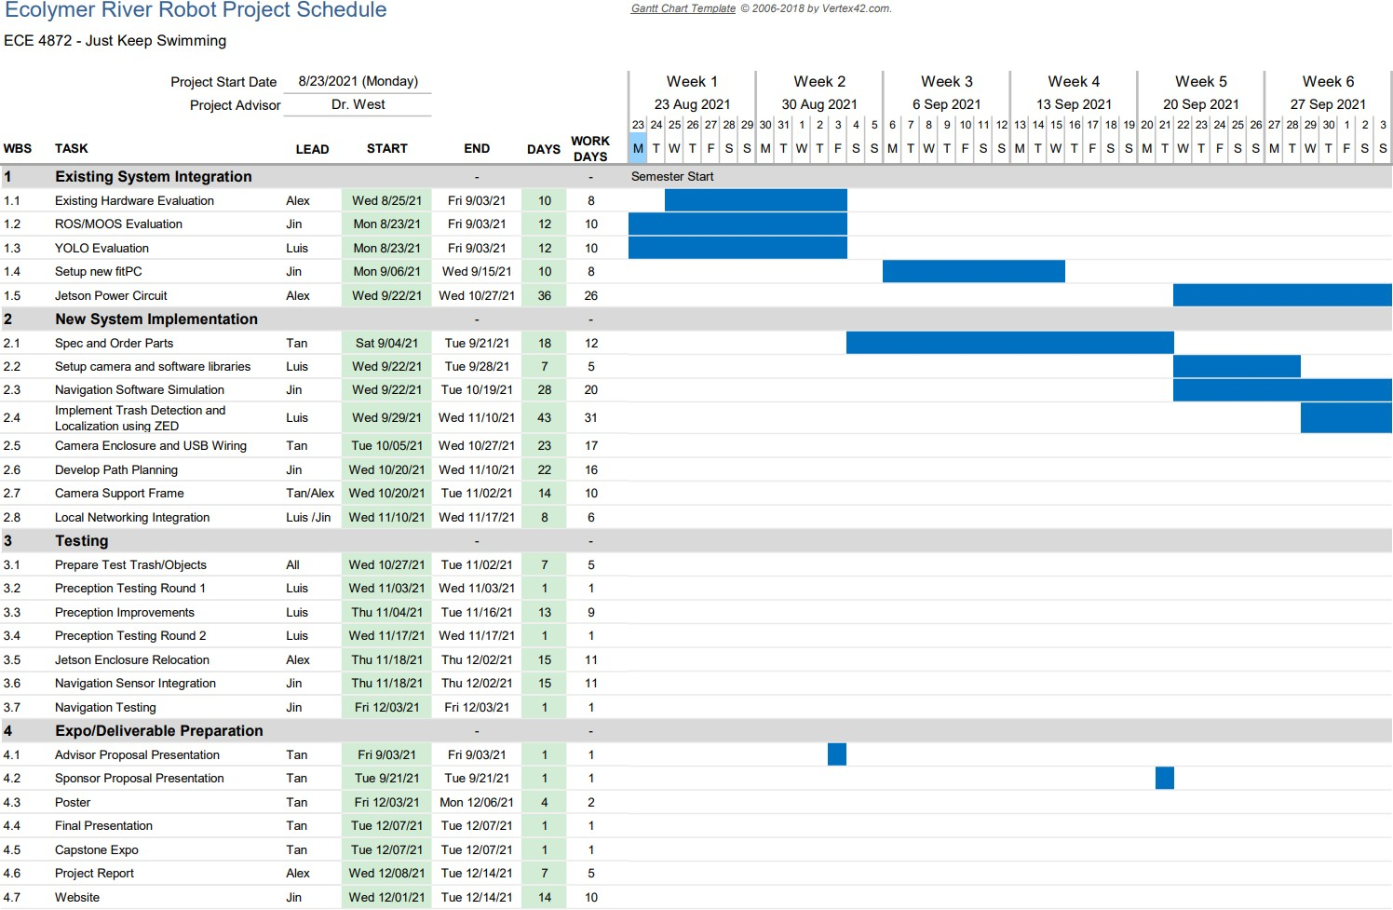

**Figure 22:** GANTT 1/3

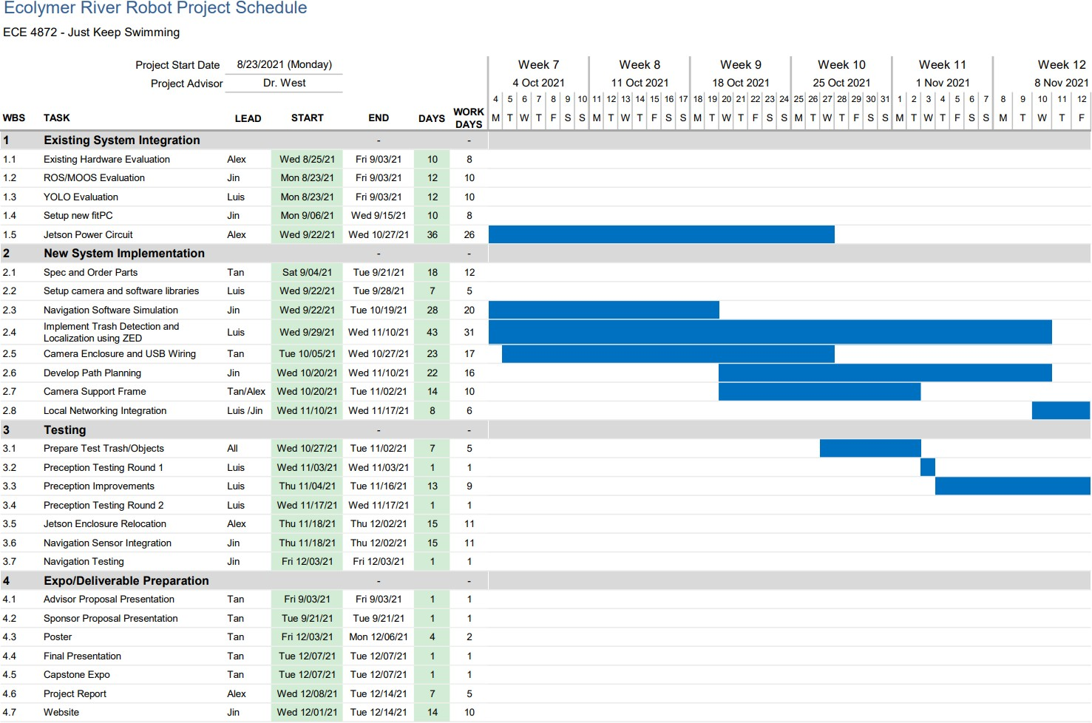

**Figure 23:** GANTT 2/3

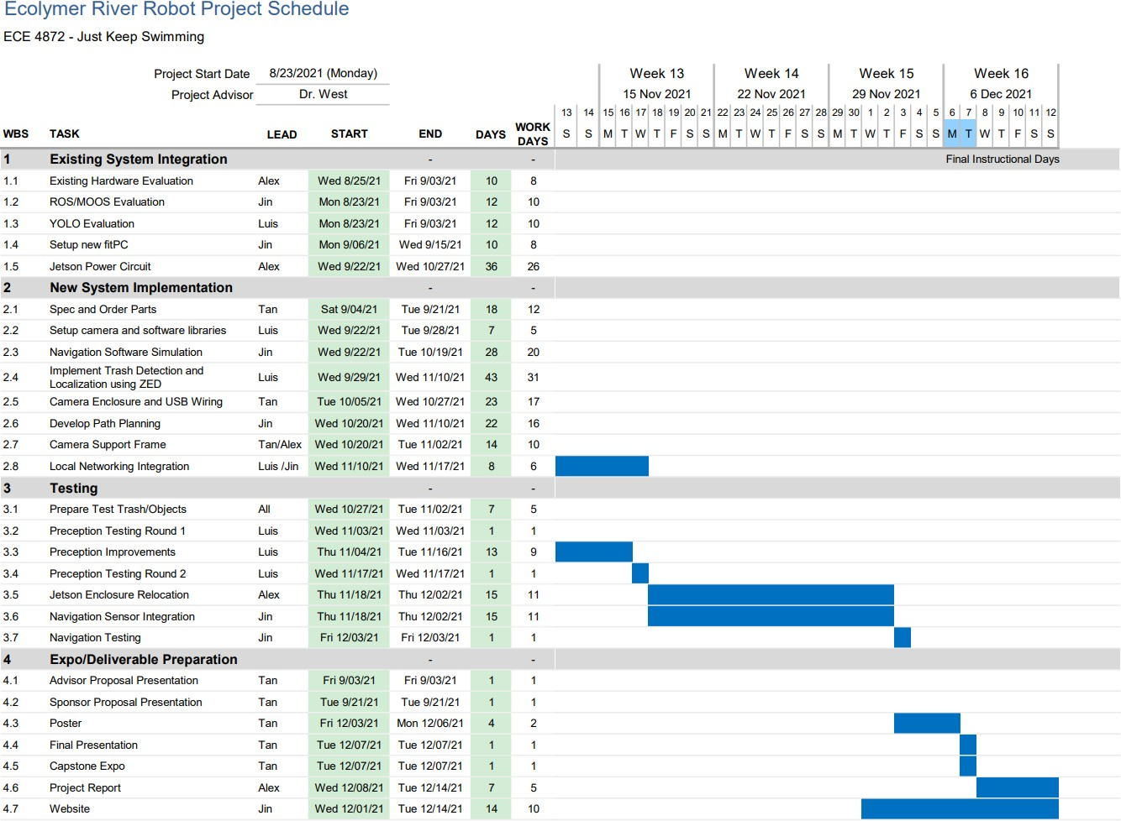

**Figure 24:** GANTT 3/3