Dia-Bot: Installation Diagnostic Robot


High-Fidelity Prototype
Fabrication Package

Bill of Materials – Electrical

Dia-Bot Electrical Bill of Materials
Name | Part Number | Cost (Per) | Quantity | Link
Raspberry Pi 4 | n/a | $ 35.00 | 1 | Buy a Raspberry Pi 4 Model B – Raspberry Pi
Raspberry Pi Spy Camea | n/a | $ 39.95 | 1 | Spy Camera for Raspberry Pi : ID 1937 : $39.95 : Adafruit Industries, Unique & fun DIY electronics and kits
6DF Accel/Gyro | MPU-6050 | $ 6.95 | 3 | Adafruit MPU-6050 6-DoF Accel and Gyro Sensor - STEMMA QT Qwiic : ID 3886 : $6.95 : Adafruit Industries, Unique & fun DIY electronics and kits
DC Motors (Drive) | AM-4230 | $ 45.00 | 2 | https://www.andymark.com/products/johnson-electric-gearmotor-and-output-shaft
Servo Motors (Camera) | SER0043 | $ 4.00 | 2 | SER0043 DFRobot | Motors, Solenoids, Driver Boards/Modules | DigiKey
H-Bridge Driver | L9110H | $ 1.50 | 2 | https://www.adafruit.com/product/4489
H-Bridge Breakout | TB6612 | $ 4.95 | 1 | https://www.adafruit.com/product/2448
Temperature sensor | MAX31820 | $ 1.95 | 1 | https://www.sparkfun.com/products/14049
Microphone (Electret) | MAX4466 | $ 6.95 | 1 | https://www.sparkfun.com/products/12758
Buck Converter: 18V-5V | MPM3610 | $ 9.95 | 1 | https://www.sparkfun.com/products/18375
Buck Converter: 18V-12V | WG8-40S1203 | $ 15.99 | 1 | Amazon.com: DC Voltage Reducer Converter DC 8V-40V to 12V 3A 36W Automatic Step Down Up Voltage Regulator Power Converter Waterproof Module Transformer for Golf Cart Club Car : Electronics
Milwaukee 18V Battery | M18 | $ 30.99 | 1 | For Milwaukee 18V Battery Replacement | M18 3.0Ah Li-Ion Battery — Vanon-Batteries-Store (vanonbatteries.com)
White LEDs | COM-11121 | $ 0.55 | 5 | Diffused LED - White 10mm - COM-11121 - SparkFun Electronics

Bill of Material – Mechanical
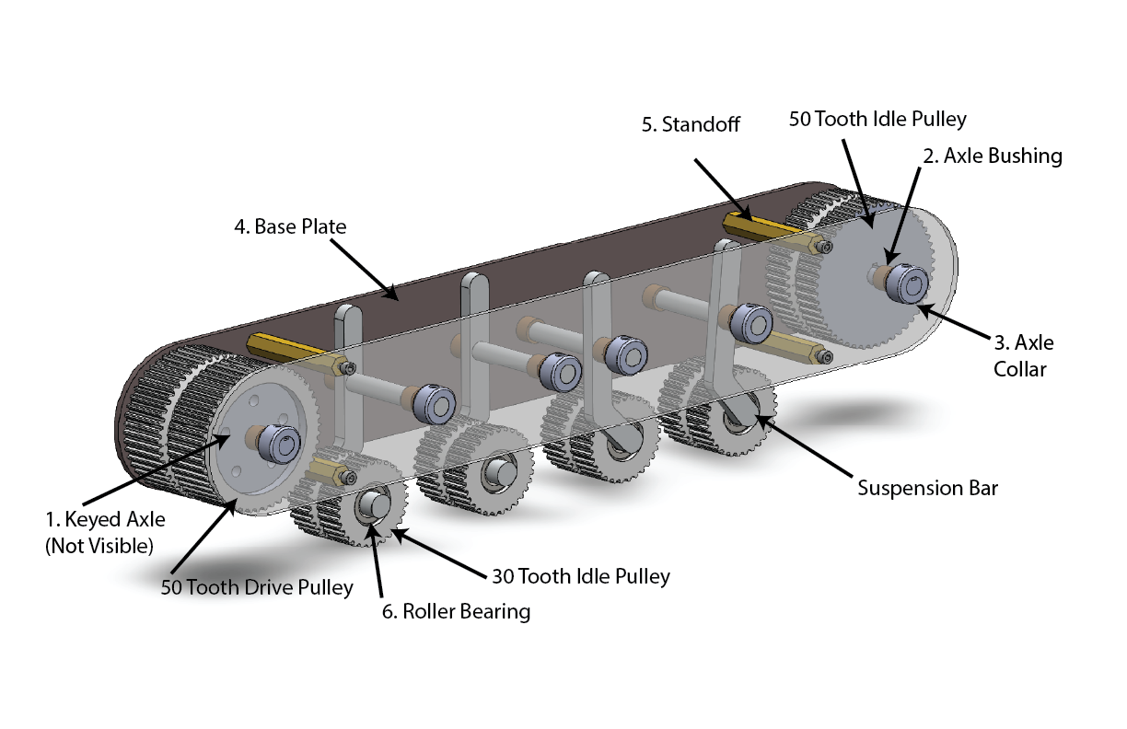
Dia-Bot Mechancial Bill of Materials
Name | ID | Part Number | Cost (Per) | Quantity | Link
1045 Carbon Steel Keyed Rotary Shaft, 10x300mm | 1 |  | $24.21 | 2 | https://www.mcmaster.com/rotary-shafts/keyed-rotary-shafts-5/system-of-measurement~metric/
  1439K311
Bronze Sleeve Bearings, 10mm | 2 | 2938T763 | $2.19 | 24 | https://www.mcmaster.com/bushings/bearings-3/high-load-oil-embedded-flanged-sleeve-bearings/system-of-measurement~metric/
Shaft Collar, 10mm | 3 | G0318906 | $2.73 | 24 | https://www.zoro.com/ruland-manufacturing-shaft-collar-set-screw-1pc-10mm-steel-msc-10-f/i/G0318906/
Thick Aluminum Composite ACM Black Sheet 24in x 72in | 4 |  | $65.67 | 1 | https://www.homedepot.com/p/Falken-Design-24-in-x-72-in-x-1-8-in-Thick-Aluminum-Composite-ACM-Black-Sheet-Falken-Design-ACM-BK-1-8-2472/308670300?MERCH=REC-_-pip_alternatives-_-308670312-_-308670300-_-N&
M4 x 60mm Female Threaded Brass Hex Standoff Pillar Spacer Nut 10pcs | 5 |  | $9.99 | 1 | https://www.amazon.com/Female-Threaded-Standoff-Pillar-Spacer/dp/B0177VG4Q8
Yeah Racing 90mm Desert Lizard Two Stage Internal Spring Shock |  | YEA-DDL-090RD | $24.99 | 4 | https://www.rcplanet.com/yeah-racing-90mm-desert-lizard-two-stage-internal-spring-shock-2-red-yea-ddl-090rd/p-tuqesxwqtm2xweue
Brecoflex Self-Tracking Timing Belt Two Pack |  | 50 TK5K6/1100 V | $188.94 | 1 | https://www.brecoflex.com/products/timing-belts/self-tracking-series/
3mmx3mm Machine Key Stock |  | 92288A715 | $4.14 | 1 | https://www.mcmaster.com/machine-keys/machine-key-stock-5/system-of-measurement~metric/
½” Roller Bearing | 6 | 25015T24 | $7.24 | 8 | https://www.mcmaster.com/bearings/wheel-axles-bearings-and-reducer-bushings/
Low-Profile Sleeve Bearing Carriage  for 27 mm Wide Rail |  | 6723K11 | 6.77 | 4 | https://www.mcmaster.com/6723K11/
27 mm Wide Guide Rail for Low-Profile Sleeve Bearing Carriage |  | 6723K2 | 17.50 | 2 | https://www.mcmaster.com/6723K2/

Engineering Drawings – Mechanical
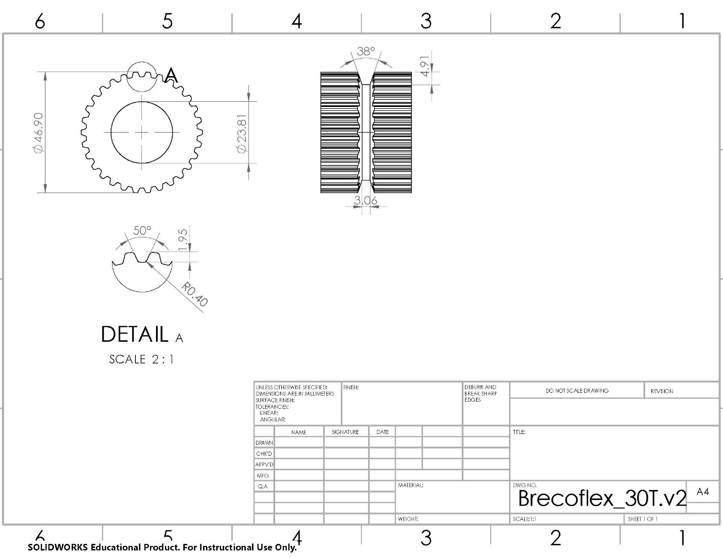
Engineering Drawing for Custom 30 Tooth Idle Pulley
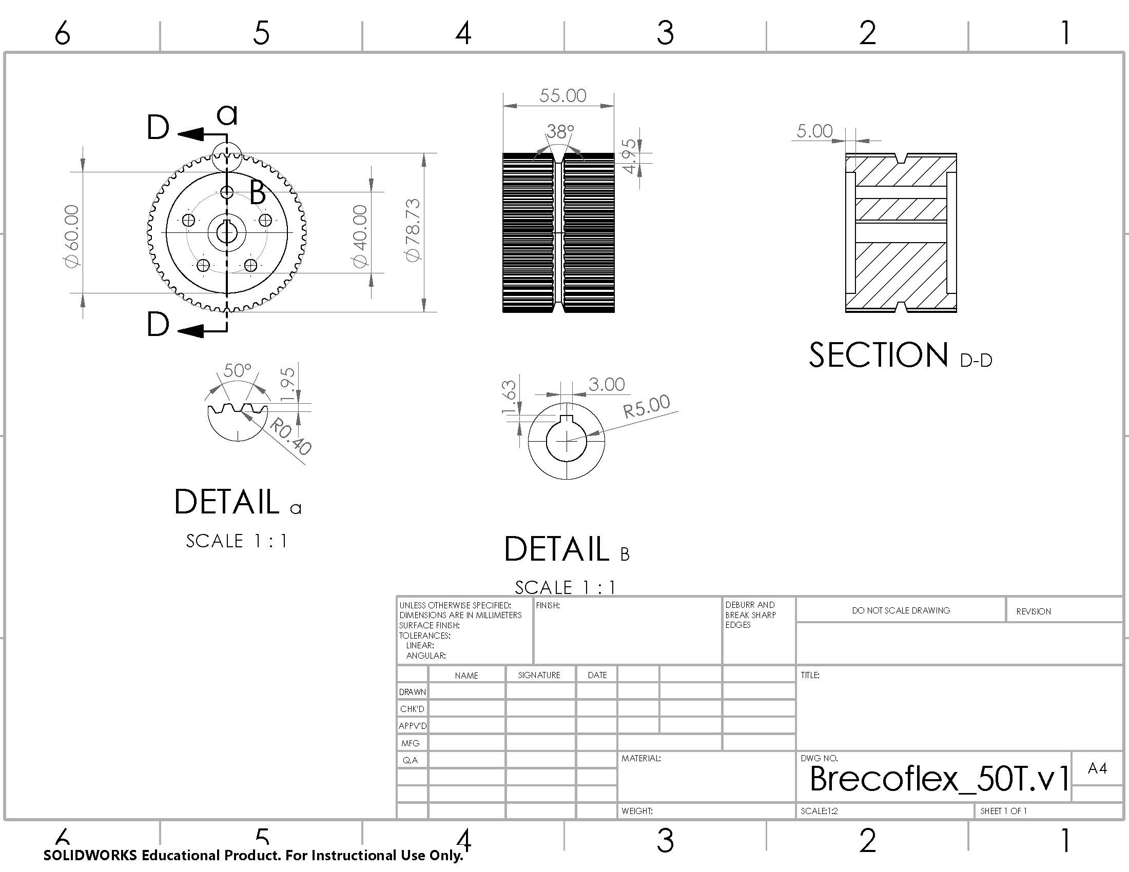
Engineering Drawing for Custom 50 Tooth Drive Pulley
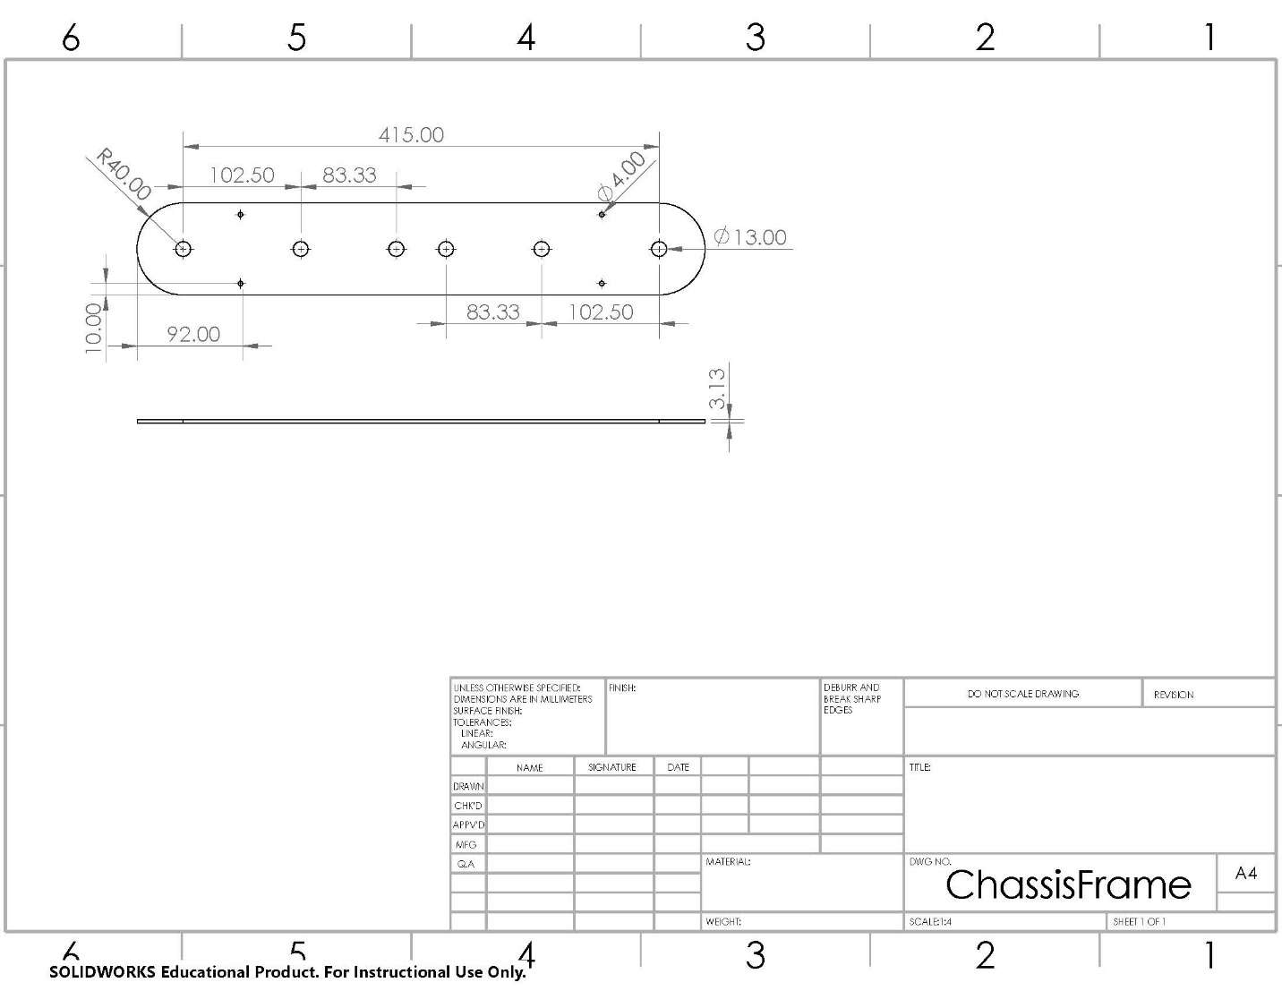
Engineering Drawing for Custom Chassis Frame
Raspberry Pi Code (Python)
Robot_test.py – main file
import sys
import tkinter as tk
from tkinter import *
from PIL import ImageTk, Image
import picamera
import time
import threading
import math
from random import *
import RPi.GPIO as GPIO
import pigpio
import DCMotor
import DualHBridge
import DataCollection

import matplotlib
matplotlib.use("TkAgg")
from matplotlib.backends.backend_tkagg import FigureCanvasTkAgg, NavigationToolbar2Tk
from matplotlib.figure import Figure

# Initialize necessary variables
camera = picamera.PiCamera()
top = tk.Tk()
top.title('Dia-Bot')
led = 11
pwmPinA = 12
motorAIn1 = 15
motorAIn2 = 16
pwmPinB = 19
motorBIn1 = 21
motorBIn2 = 22
motorEn = 18
speed = IntVar()
zoom = IntVar()
gpioMode = GPIO.BOARD
GPIO.setwarnings(False)
GPIO.setmode(gpioMode)
GPIO.setup(led, GPIO.OUT)
pi = pigpio.pi()
motors = DualHBridge.DualHBridge(pwmPinA, motorAIn1, motorAIn2, pwmPinB, motorBIn1, motorBIn2, motorEn, gpioMode)

# Threading control
graphRefreshTime = 5 # Number of seconds between graph refresh
programRunning = True
collectData = False
uiMutex = threading.Lock()
startTime = time.time_ns()

# Closes relevant processes and stops GPIO
def exit():
#camera.stop_preview()
#camera.close()
top.destroy
pwm.stop()
GPIO.output(pwm, GPIO.LOW)
GPIO.cleanup()
quit()

if not pi.connected:
print("Error: Pi Not connected")
exit()

# Debugging function - run a function and report how long it takes
def elapsedTime(func, *args):
startTime = time.time_ns()
#try:
# func(*args)
#except:
func()
elapsedTimeNs = time.time_ns() - startTime
print("ElapsedTime (" + str(func.__name__) + ") = " + str(elapsedTimeNs / 1_000_000) + " ms")

# Returns a printout of the total time since execution began
def totalElapsedTime():
global startTime
return f"(total time = {(time.time_ns()-startTime)/1_000_000_000} s)"

# Opens the camera preview on the screen
# Note: for VNC users to see the feed, the setting "Enable Direct Capture Mode" must be on
#def start_camera():
# camera.preview_fullscreen=False
# camera.preview_window=(90,100, 1280, 720)
# camera.resolution=(1280,720)
# camera.start_preview()

# -------- Define UI button functions --------

# Callback function for the zoom scroll bar
def setSpeed(var):
speed = var

def moveForwardPress(event):
print("Moving forward! Press - Speed = " + str(speed.get()))

def moveForwardRelease(event):
print("Release moving forward")

def moveForwardRightPress(event):
print("Moving forward-right! Press - Speed = " + str(speed.get()))

def moveForwardRightRelease(event):
print("Release moving forward-right")

def moveForwardLeftPress(event):
print("Moving forward-left! Press - Speed = " + str(speed.get()))

def moveForwardLeftRelease(event):
print("Release moving forward-left")

def moveBackwardPress(event):
print("Moving backward! Press - Speed = " + str(speed.get()))

def moveBackwardRelease(event):
print("Release moving backward")

def moveBackwardRightPress(event):
print("Moving backward-right! Press - Speed = " + str(speed.get()))

def moveBackwardRightRelease(event):
print("Release moving backward-right")

def moveBackwardLeftPress(event):
print("Moving backward-left! Press - Speed = " + str(speed.get()))

def moveBackwardLeftRelease(event):
print("Release moving backward-left")

def moveLeftPress(event):
print("Turn left! Press")

def moveLeftRelease(event):
print("Release moving left")

def moveRightPress(event):
print("Turn right! Press")

def moveRightRelease(event):
print("Release moving right")

def stopMovement():
print("Emergency stop!")

def lock():
print("Locking suspension")

def ledOn():
print("Turning on LED")
GPIO.output(led, True)

def ledOff():
print("Turning off LED")
GPIO.output(led, False)

# Testing purposes only - to be deprecated
def motorTurnTest():
print("Testing DC motor")
print("What goes up...")
for dc in range(0, 101, 2):
#motor.setVelo(dc)
motors.go(dc)
time.sleep(0.05)
time.sleep(1)
print("...must come down")
for dc in range(100, -1, -2):
#motor.setVelo(dc)
motors.go(dc)
time.sleep(0.05)
time.sleep(1)
print("Aaaand backwards")
for dc in range(0, -101, -2):
#motor.setVelo(dc)
motors.go(dc)
time.sleep(0.05)
print("And back")
for dc in range(-100, 1, 2):
#motor.setVelo(dc)
motors.go(dc)
time.sleep(0.05)
print("Motor turn done")

def cameraUp():
print("Camera tilt up!")

def cameraDown():
print("Camera tilt down!")

def cameraLeft():
print("Camera tilt left!")

def cameraRight():
print("Camera tilt right!")

def takePhoto():
print("Taking photo!")

def soundStatus():
print("Sound data status")

def accelerationStatus():
print("Acceleration data status")

def videoStatus():
print("Video status")

def stopGpio():
GPIO.setmode(gpioMode)
GPIO.output(motorEn, GPIO.LOW)
GPIO.output(pwmPinA, GPIO.LOW)
#pwm.stop()
GPIO.cleanup()

# -------------------------- GUI SETUP CODE --------------------------
top.resizable(width=False, height=False)
top.geometry("1600x900")

# Primary sections
controlFrame = tk.Frame(top, width=400, height=900)#, bg='orange')
dataFrame = tk.Frame(top, width=1120, height=270)#, bg='blue')
videoFrame = tk.Frame(top, width=1120, height=630)#, bg='red')

# Individual Control Frames
movementControls = tk.Frame(controlFrame, width=400, height=280)#, bg='blue')
cameraControls = tk.Frame(controlFrame, width=400, height=280)
alertControls = tk.Frame(controlFrame, width=400, height=280)

# Arrange frames
controlFrame.grid(row=1, column=1, sticky="nesw")
dataFrame.grid(row=1, column=2)
videoFrame.grid(row=2, column=2)

# ------------------ Controls Pane -----------------------
# Controls top text
controlsLabel = tk.Label(controlFrame, text="Controls", font="none 18 bold")
controlsLabel.grid(row=1, column=1, columnspan=8)
controlsLabel.config(anchor=CENTER)
controlFrame.grid_rowconfigure(1, minsize=60)

# ----- Movement controls -----
movementControls.grid(row=2, column=1, rowspan=2, columnspan=10)
tk.Label(movementControls, text="Movement", anchor=CENTER, font="none 14 bold").grid(row=1, column=1, columnspan=9)

tk.Label(movementControls, text="Speed", anchor=CENTER, font="bold").grid(row=2, column=2)
speedScale = tk.Scale(movementControls, from_=100, to=0, orient=tk.VERTICAL, variable = speed, length=150, showvalue=0, sliderlength=20)
speedScale.grid(row=3, column=2, rowspan=4)
speedScale.set(50)

# Directional buttons
tk.Label(movementControls, text="Direction", anchor=CENTER, font="bold").grid(row=2, column=4, columnspan=3)

moveForwardButton = tk.Button(movementControls, text="^", anchor=CENTER, font="16")
moveForwardButton.bind("<ButtonPress>", moveForwardPress)
moveForwardButton.bind("<ButtonRelease>", moveForwardRelease)
#top.bind("<KeyPress-w>", moveForwardPress)
#top.bind("<KeyRelease-w>", moveForwardRelease)
moveForwardButton.grid(row=3, column=5)

moveForwardLeftButton = tk.Button(movementControls, text="FL", anchor=CENTER, font="16")
moveForwardLeftButton.bind("<ButtonPress>", moveForwardLeftPress)
moveForwardLeftButton.bind("<ButtonRelease>", moveForwardLeftRelease)
moveForwardLeftButton.grid(row=3, column=4)

moveForwardRightButton = tk.Button(movementControls, text="FR", anchor=CENTER, font="16")
moveForwardRightButton.bind("<ButtonPress>", moveForwardRightPress)
moveForwardRightButton.bind("<ButtonRelease>", moveForwardRightRelease)
moveForwardRightButton.grid(row=3, column=6)

moveBackwardButton = tk.Button(movementControls, text="v", anchor=CENTER, font="16")
moveBackwardButton.bind("<ButtonPress>", moveBackwardPress)
moveBackwardButton.bind("<ButtonRelease>", moveBackwardRelease)
#top.bind("<KeyPress-s>", moveBackwardPress)
#top.bind("<KeyRelease-s>", moveBackwardRelease)
moveBackwardButton.grid(row=5, column=5)

moveBackwardLeftButton = tk.Button(movementControls, text="BL", anchor=CENTER, font="16")
moveBackwardLeftButton.bind("<ButtonPress>", moveBackwardLeftPress)
moveBackwardLeftButton.bind("<ButtonRelease>", moveBackwardLeftRelease)
moveBackwardLeftButton.grid(row=5, column=4)

moveBackwardRightButton = tk.Button(movementControls, text="BR", anchor=CENTER, font="16")
moveBackwardRightButton.bind("<ButtonPress>", moveBackwardRightPress)
moveBackwardRightButton.bind("<ButtonRelease>", moveBackwardRightRelease)
moveBackwardRightButton.grid(row=5, column=6)

moveLeftButton = tk.Button(movementControls, text="<", anchor=CENTER, font="16")
moveLeftButton.bind("<ButtonPress>", moveLeftPress)
moveLeftButton.bind("<ButtonRelease>", moveLeftRelease)
#top.bind("<KeyPress-a>", moveLeftPress)
#top.bind("<KeyRelease-a>", moveLeftRelease)
moveLeftButton.grid(row=4, column=4)

moveRightButton = tk.Button(movementControls, text=">", anchor=CENTER, font="16")
moveRightButton.bind("<ButtonPress>", moveRightPress)
moveRightButton.bind("<ButtonRelease>", moveRightRelease)
moveRightButton.grid(row=4, column=6)

# Stop and lock buttons
tk.Label(movementControls, text="Mode", anchor=CENTER, font="bold").grid(row=2, column=9)
tk.Button(movementControls, text="Stop", command=stopMovement, anchor=CENTER, fg="red", font="16").grid(row=3, column=9)
tk.Button(movementControls, text="Lock", command=lock, anchor=CENTER, font="16").grid(row=5, column=9)

movementControls.grid_columnconfigure(1, minsize=10)
for i in range(2,10):
movementControls.grid_columnconfigure(i, minsize=20)

# Keyboard Buttons
top.bind("<KeyPress-w>", moveForwardPress)
top.bind("<KeyRelease-w>", moveForwardRelease)
top.bind("<KeyPress-s>", moveBackwardPress)
top.bind("<KeyRelease-s>", moveBackwardRelease)
top.bind("<KeyPress-a>", moveLeftPress)
top.bind("<KeyRelease-a>", moveLeftRelease)
top.bind("<KeyPress-d>", moveRightPress)
top.bind("<KeyRelease-d>", moveRightRelease)

# ----- Camera Controls -----
cameraControls.grid(row=5, column=1, rowspan=1, columnspan=10)
tk.Label(cameraControls, text="Camera", anchor=CENTER, font="none 14 bold").grid(row=1, column=1, columnspan=9)

# Directional buttons
tk.Label(cameraControls, text="Angle", anchor=CENTER, font="bold").grid(row=2, column=2, columnspan=3)
tk.Button(cameraControls, text="^", command=cameraUp, anchor=CENTER, font="16").grid(row=3, column=3)
tk.Button(cameraControls, text="v", command=cameraDown, anchor=CENTER, font="16").grid(row=5, column=3)
tk.Button(cameraControls, text="<", command=cameraLeft, anchor=CENTER, font="16").grid(row=4, column=2)
tk.Button(cameraControls, text=">", command=cameraRight, anchor=CENTER, font="16").grid(row=4, column=4)
tk.Button(cameraControls, text="Pic", command=takePhoto, anchor=CENTER, font="16").grid(row=4, column=3)

# Stop and lock buttons
tk.Label(cameraControls, text="Light", anchor=CENTER, font="bold").grid(row=2, column=6)
tk.Button(cameraControls, text="On", command=ledOn, anchor=CENTER, font="16").grid(row=4, column=6)
tk.Button(cameraControls, text="Off", command=ledOff, anchor=CENTER, font="16").grid(row=5, column=6)

tk.Label(cameraControls, text="Zoom", anchor=CENTER, font="bold").grid(row=2, column=8)
zoomScale = tk.Scale(cameraControls, from_=100, to=0, orient=tk.VERTICAL, variable = zoom, length=150, showvalue=0, sliderlength=20)
zoomScale.grid(row=3, column=8, rowspan=4)
zoomScale.set(50)

cameraControls.grid_columnconfigure(1, minsize=10)
for i in range(2,10):
cameraControls.grid_columnconfigure(i, minsize=20)

# Alerts
alertControls.grid(row=7, column=1, rowspan=1, columnspan=10)
tk.Label(alertControls, text="Alerts", anchor=CENTER, font="none 14 bold").grid(row=1, column=1, columnspan=9)

tk.Label(alertControls, text="Active", anchor=CENTER, font="none 11").grid(row=2, column=4, columnspan=2)
tk.Label(alertControls, text="Threshold", anchor=CENTER, font="none 11").grid(row=2, column=7, columnspan=2)
tk.Label(alertControls, text="Alerts", anchor=CENTER, font="none 11").grid(row=2, column=10, columnspan=2)

nextRow = 3

# Repeated function to add new alert categories to UI
def addAlert(name, thresholdUnits):
global nextRow
#print("Adding alert row for " + name)
tk.Label(alertControls, text=name, anchor="w", justify=LEFT, font="none 11").grid(row=nextRow, column=1, columnspan=3)
tk.Checkbutton(alertControls, text="Enabled", anchor=CENTER, font="none 11").grid(row=nextRow, column=4, columnspan=2)
tk.Entry(alertControls, justify=CENTER, width=5, font="none 11").grid(row=nextRow, column=6, columnspan=2)
tk.Label(alertControls, text=thresholdUnits, anchor="w", justify=LEFT, font="none 11").grid(row=nextRow, column=8, columnspan=2)
if randint(0,1) == 1:
tk.Label(alertControls, text="Error", anchor=CENTER, font="none 11 bold", fg="red").grid(row=nextRow, column=10, columnspan=2)
else:
tk.Label(alertControls, text="None", anchor=CENTER, font="none 11", fg="black").grid(row=nextRow, column=10, columnspan=2)
nextRow = nextRow + 1

# Call above function to add alerts to UI
addAlert("Vibration", "m/s2")
addAlert("Sound", "dB")
addAlert("Temperature", "°C")

alertControls.grid_columnconfigure(1, minsize=10)
for i in range(2,10):
alertControls.grid_columnconfigure(i, minsize=20)
for i in range(2, nextRow+1):
alertControls.grid_rowconfigure(i, minsize=30)

# ----- Other -----

# Testing buttons
tk.Button(controlFrame, text="Motor", command=motorTurnTest).grid(row=14, column=2)
tk.Button(controlFrame, text="Off", command=stopGpio).grid(row=14, column=3)

def toggleData():
global collectData
collectData = not collectData
print("Setting colletData to " + str(collectData))

# ------------------ Data Pane -----------------------
tk.Label(dataFrame, text="Data", font="none 18 bold").grid(row=1, column=1, columnspan=50)
tk.Button(dataFrame, text="Toggle Data", command=toggleData).grid(row=1, column=2)

# Individual Frames
soundLevelFrame = tk.Frame(dataFrame, width=350, height=350)#, bg="red")
vibrationFrame = tk.Frame(dataFrame, width=350, height=350)#, bg="yellow")
temperatureFrame = tk.Frame(dataFrame, width=350, height=350)#, bg="orange")
positionFrame = tk.Frame(dataFrame, width=350, height=350)#, bg="green")
dataFrames = [soundLevelFrame, vibrationFrame, temperatureFrame, positionFrame]
units = ["dB", "m/s2", "C", "m"]

# Sound Level
def readSoundLevel():
num = randint(-10, 10)
#print("Reading sound level! - " + str(num))
return num
soundLevel = DataCollection.DataCollection("Sound Level", "dB", soundLevelFrame, readSoundLevel, uiMutex, startTime)
soundLevel.tkAddDataPane()
soundLevelFrame.grid(row=2, column=1, padx=10)

# Vibration
def readVibration():
num = randint(-10, 10)
#print("Reading vibration! - " + str(num))
return num
vibration = DataCollection.DataCollection("Vibration", "m/s2", vibrationFrame, readVibration, uiMutex, startTime)
vibration.tkAddDataPane()
vibrationFrame.grid(row=2, column=2, padx=10)

# Temperature
def readTemperature():
num = randint(-10, 10)
#print("Reading temperature! - " + str(num))
return num
temperature = DataCollection.DataCollection("Temperature", "°C", temperatureFrame, readTemperature, uiMutex, startTime)
temperature.tkAddDataPane()
temperatureFrame.grid(row=2, column=3, padx=10)

# Position
def readPosition():
num = randint(-10, 10)
#print("Reading position! - " + str(num))
return num
position = DataCollection.DataCollection("Position", "m", positionFrame, readPosition, uiMutex, startTime)
position.tkAddDataPane()
positionFrame.grid(row=2, column=4, padx=10)

# Group of all the data classes
dataClassList = [soundLevel, vibration, temperature, position]

def addDataPress(event):
x = max(x1) + 1
y = randint(-5, 8)
x1.append(x)
y1.append(y)
plot1.plot(x1, y1)
canvas.draw()
print("Adding data! Press - x = " + str(x) + ", y = " + str(y))

def addDataRelease(event):
x = max(x1) + 1
y = randint(-5, 8)
x1.append(x)
y1.append(y)
plot1.plot(x1, y1)
canvas.draw()
print(f"Adding data! Release - x = {x}, y = {y}")

addDataButton.bind("<ButtonPress>", addDataPress)
addDataButton.bind("<ButtonRelease>", addDataRelease)

# ------------------ Video Pane -----------------------
#tk.Button(videoFrame, text="Video", command=videoStatus).grid(row=1, column=1)
testImg = ImageTk.PhotoImage(Image.open("vanderlandeTest.png"))#.resize((1000, 500)))
imgLabel = Label(videoFrame, image=testImg)
imgLabel.grid(row=1, column=1)

def updateFrameImage():
fileName = "frame.png"
camera.capture(fileName)
img = ImageTk.PhotoImage(Image.open(fileName).resize((1000, 500)))
imgLabel = Label(videoFrame, image=img)
imgLabel.grid(row=1, column=1)

# Place the frames
controlFrame.place(relx=0.01, rely=0.01, anchor=tk.NW)
dataFrame.place(relx=0.3, rely=0.01, anchor=tk.NW)
videoFrame.place(x=400, y=300, anchor=tk.NW)

# ----- Threading functions -----

# Wrapper to other functions which loops
def loopAtFrequency(freqHz, loopFunction, *args):
global programRunning
loopTime = 1/freqHz
while programRunning:
loopStartTime = time.time()
loopFunction(*args)
loopEndTime = time.time()
loopTimeTaken = loopEndTime - loopStartTime
timeRemaining = loopTime - (loopTimeTaken)
if timeRemaining > 0:
time.sleep(timeRemaining)
else:
print(f"Thread {loopFunction.__name__} took longer to execute ({loopTimeTaken} s) than its given time({loopTimeTaken} s)! Assigning 1s sleep")
time.sleep(1)

# Every data class needs it own graph, data set, and sensor function
def updateData():
global collectData
if collectData:
for dataClass in dataClassList:
dataClass.readData()

#tk.Button(videoFrame, text="Update Image", command=updateFrameImage).grid(row=2, column=1)

def updateGraphs():
global collectData
if collectData:
try:
top.event_generate("<<graphEvent>>")
except:
print("Error in event_generate! Unable to update graphs")

def updateGraphsWrapper(event):
elapsedTime(updateGraphsHandler)

def updateGraphsHandler():
global startTime
global loopCount
for dataClass in dataClassList:
dataClass.updateGraph()
# Threading version
#threads = []
#for dataClass in dataClassList:
# print(f"Start threads: {dataClass.name} Loop #{loopCount} {totalElapsedTime()}")
# newThread = threading.Thread(target=dataClass.updateGraph, args=(loopCount,))
# newThread.start()
# threads.append(newThread)
#print(f"Started threads Loop #{loopCount} {totalElapsedTime()} ")
#print("Join threads.. " + str(threads))
#for t in threads:
# t.join()
#print("Completed joining")

top.bind("<<graphEvent>>", updateGraphsWrapper)

def printTime(*args):
print(totalElapsedTime())

def main():
global programRunning
global startTime

# Create additional threads
dataThread = threading.Thread(target=loopAtFrequency, args=(1, updateData))
graphThread = threading.Thread(target=loopAtFrequency, args=(1/graphRefreshTime, updateGraphs))

# Start threads
dataThread.start()
graphThread.start()

#totalTimeNs = time.time_ns() - startTime
#print("Start thread time: " + str((totalTimeNs/1_000_000)) + " ms")
top.mainloop()
programRunning = False # Stop extra threads

if __name__ == "__main__":
main()

DataCollection.py – Class used to support each type of data

import sys
import tkinter as tk
from tkinter import *
from PIL import ImageTk, Image
import time
import threading
import math
from random import *
import RPi.GPIO as GPIO
import pigpio
import picamera
import DCMotor
import DualHBridge

import matplotlib
matplotlib.use("TkAgg")
from matplotlib.backends.backend_tkagg import FigureCanvasTkAgg, NavigationToolbar2Tk
from matplotlib.figure import Figure

# GPIO Startup
gpioMode = GPIO.BOARD
GPIO.setwarnings(False)
GPIO.setmode(gpioMode)
pi = pigpio.pi()

class DataCollection:

def __init__(self, name, units, tkTop, readDataFunction, globalUImutex, globalStartTime):
self.name = name
self.units = units
self.tkTop = tkTop
self.readDataFunction = readDataFunction
self.data = []
self.dataMutex = threading.Lock()
self.globalUImutex = globalUImutex
self.globalStartTime = globalStartTime
# Create Random Graph
self.t = list(range(10))
self.data = [randint(-5, 8) for i in range(10)]
self.fig = Figure(figsize=(3,2.5), dpi=80)
self.fig.patch.set_facecolor("#DBDBDB")
self.plot1 = self.fig.add_subplot(111)
self.plot1.plot(self.t, self.data)
self.plot1.set_ylabel(self.units)

def tkAddDataPane(self):
# Top label
tk.Label(self.tkTop, text=self.name, font="none 12 bold").grid(row=1, column=1, columnspan=5)
# Add random graph
self.canvas = FigureCanvasTkAgg(self.fig, master=self.tkTop)
self.canvas.draw()
self.canvas.get_tk_widget().grid(row=2, column=1, rowspan=3, columnspan=4)

def readData(self):
self.dataMutex.acquire()
self.t.append(self.t[-1]+1)
self.data.append(self.readDataFunction())
self.dataMutex.release()

def updateGraph(self):
start = 0
end = self.t[-1]
if end > 20:
start = end-20
self.plot1.cla() # Find way to update graphs without it taking too long!!
print(f"Update {self.name} graph: indices ({start}..{end})")
# Update plot
self.dataMutex.acquire()
self.plot1.plot(self.t[start:end], self.data[start:end])
self.dataMutex.release()
# Update canvas on UI
#self.globalUImutex.acquire()
self.canvas.draw()
print(f"Graph done: {self.name} Loop #{loopCount} (total time = {(time.time_ns()-self.globalStartTime)/1_000_000_000} s)")
#self.globalUImutex.release()

DualHBridge.py – Class to interface with a Dual H-Bridge breakout controlling two motors

import time
import math
import RPi.GPIO as GPIO
import pigpio
import DCMotor

class DualHBridge:

def __init__(self, pwmA, in1A, in2A, pwmB, in1B, in2B, en, gpioMode = GPIO.BOARD):
self.gpioMode = gpioMode
self.motorA = DCMotor.DCMotor(pwmA, in1A, in2A, en, gpioMode)
self.motorB = DCMotor.DCMotor(pwmB, in1B, in2B, en, gpioMode)

def brake(self):
self.motorA.brake()
self.motorB.brake()

def go(self, velo):
self.motorA.setVelo(velo)
self.motorB.setVelo(velo)

def stop(self):
self.motorA.stop()
self.motorB.stop()

DCMotor.py – class to control individual DC motors

import time
import math
import RPi.GPIO as GPIO
import pigpio

class DCMotor:

def __init__(self, pwmPin, in1, in2, en, gpioMode = GPIO.BOARD):
# Initialize variables
self.pwmPin = pwmPin
self.in1 = in1
self.in2 = in2
self.en = en
self.gpioMode = gpioMode
# Initialize GPIO pins
self.gpioStart()
GPIO.output(pwmPin, GPIO.LOW)
self.pwm = GPIO.PWM(pwmPin, 1000) # Frequency=1KHz
self.pwm.start(0)

def gpioStart(self):
# Initialize GPIO pins
GPIO.setwarnings(False)
GPIO.setmode(self.gpioMode)
GPIO.setup(self.in1, GPIO.OUT)
GPIO.setup(self.in2, GPIO.OUT)
GPIO.setup(self.en, GPIO.OUT)
GPIO.setup(self.pwmPin, GPIO.OUT)

def brake(self):
self.gpioStart()
GPIO.setmode(self.gpioMode)
GPIO.output(self.pwmPin, GPIO.LOW)
self.pwm.ChangeDutyCycle(0)
GPIO.output(self.in1, GPIO.HIGH)
GPIO.output(self.in2, GPIO.HIGH)

def stop(self):
self.gpioStart()
GPIO.setmode(self.gpioMode)
GPIO.output(self.en, GPIO.LOW)
GPIO.output(self.pwmPin, GPIO.LOW)
self.pwm.stop()
GPIO.cleanup()

# Velo [-100, 100]
def setVelo(self, velo):
self.gpioStart()
GPIO.setmode(self.gpioMode)
# Sets relative motor speed and direction
if (velo == 1000):
# Brake if the speed is zero
self.brake()
else:
GPIO.output(self.en, GPIO.HIGH)
speed = abs(velo) # NOTE: relative speed is capped at 100
if (speed > 100):
speed = 100
# Set direction
if (velo > 0):
# Forwards
GPIO.output(self.in1, GPIO.HIGH)
GPIO.output(self.in2, GPIO.LOW)
else:
# Backwards
GPIO.output(self.in1, GPIO.LOW)
GPIO.output(self.in2, GPIO.HIGH)
self.pwm.ChangeDutyCycle(speed)
#ssself.stop()

