Dia-Bot: Installation Diagnostic Robot


Interdisciplinary Capstone Design Report #2
Course Numbers: ME 4182-A, ECE 4723-A
Instructor: Dr. Amit Jariwala
Advisors: Jianxin Jiao (ME), Vijay Madisetti (ECE)

Georgia Institute of Technology
Atlanta, Georgia

Sponsor: Vanderlande Industries
Marietta, GA; Veghel, NL
Arlo.Bromley@vanderlande.com
+1 470 541 2998

Team: Operation Omega
Members: Andrew Galant, Catherine Kasper, Jason Piotter, Hunter Present, Connor Truono, Doug Walker

Primary Editor: Connor Truono

Table of Contents
Executive Summary i
Nomenclature iii
Glossary iii
Main Body 1
1. Introduction & Background 1
2. Existing Products, Prior Art, & Applicable Patents 2
3. Codes & Standards 3
4. Customer Requirements & Engineering Design Specifications 4
5. Design Concept Ideation 9
6. Concept Selection & Justification 12
7. Industrial Design 22
8. Engineering Analyses and Experiments 22
9. Societal, Environmental, and Sustainability Considerations 23
10. Team Member Contributions 23
11. Conclusions: Project Deliverables & Future Work 24
References / Citations 27
Appendices 28

Executive Summary
Vanderlande produces logistic process automation for warehouses, parcels, and airports, focusing on shuttle and conveyor systems. However, when installing such large systems, the process for verifying their structure, components, and throughput can take many hours to complete manually. Because of this, Vanderlande desires a more powerful tool by which they can apply more automated and manual solutions: specifically, a diagnostic robot which moves through their setups to assist in problem detection and quality assurance.
To meet Vanderlande’s needs for installation verification, the team is designing such a diagnostic robot, called the “Dia-Bot”. This robot will aid Vanderlande by providing appropriate sensors and data collection, multiple transportation modes, and effective communication and user interface strategies to detect and flag common installation problems. This solution requires solving a wide range of technical problems in mechanical, electrical, and software engineering disciplines. These include building a robust and reliable mechanical enclosure, creating a retractable self-propelled movement system that can effectively traverse the obstacles of a conveyor systems, interfacing with various types of sensors, intelligently processing the sensor data, establishing real-time wireless communication channels, and exposing a proper user interface.
The overall objective of this Dia-Bot is to aid Vanderlande operators in identifying potential problems during a phase of their system installation. The Dia-Bot should collect various data points which may be indicative of issues: most notably visuals, acceleration, and sound, as well as a mechanism to report robot position within a given system. Real-time bot controls and sensor updates would allow operators to find and fix errors more efficiently. This goal, properly achieved, will also allow Vanderlande to collect more real data on their systems to both verify existing simulations and create more accurate ones in the future.
Multiple design and ideation strategies were used to help determine the project scope and evaluate proper engineering methods. A function tree identified the primary features of the Dia-Bot and broke them down into smaller parts, and a house of quality helped evaluate the priority and importance of each requirement. From there, the team identified the best implementations for those function using a morphological chart. A Gantt chart helped the team plan out and follow a schedule of required tasks and keep the project on track.
The final design decided by the team will provide proper movement via continuous tracks, or tank treads, driven by DC motors, and a flexible suspension system. These treads can be removed to expose a flat bottom surface for ride-along mode when self-propelled movement is not desired. Between the two tracks, a dampened central roll cage will host and protect the delicate sensors and electrical parts while providing stability with a low center of gravity. An embedded processor will interface with the sensors and motors to handle input and output signals as well as expose a real-time user interface over the web to receive robot control while sending a live data feed and alerts for any detected problems.
While there are some existing products which contain some similar functionality to those described here, none of those fit the necessary criteria for collecting the right data with robust movement systems at the proper price point. Most modified RC cars would be unable to move through Vanderlande’s conveyor systems, while more advanced industrial bots are overengineered for this purpose and are therefore overly expensive. The Dia-Bot aims for the middle ground price point while providing custom hardware and software features specific for Vanderlande’s use cases.
The solution will be functional once a robot is built which can traverse Vanderlande’s conveyor systems, properly retract its treads to expose a flat bottom surface, collect relevant data (vibration, sound, temperature, position, etc.) for problem detection, interface with a proper GUI for real-time operator control and data feed, and alert users about potential problems. Key performance indicators include control response time, problem alert accuracy, positional detection accuracy, movement range and battery life, and overall ease of use. Overall, the Dia-Bot should reduce the time and improve the quality of Vanderlande’s installation verification inspections.
Now that the team has narrowed the project scope and created a design direction, the team has gone through protyping and initial development steps. The mechanical team has been creating models of the Dia-Bot using CAD tools and running appropriate tests. The electrical team is putting together a prototype embedded system with many of the necessary sensors and motors. And the software team has been creating a user interface to allow for control of prototype systems. These build steps are crucial in determining the implementation of the final engineering design.

Nomenclature
- Autonomous: Referring to that which is capable of operation without direct human control
- Dia-Bot: Title of the design project, short for “diagnostic robot”.
- Operator: Vanderlande Industries technician who controls the Dia-Bot in real time through the system
- Vanderlande Industries: Developer of complex package transportation solutions for warehousing, parcel, and airport industries; Corporate sponsor of the Dia-Bot design project

Glossary
- ASTM: American Society for Testing and Materials
- CAD: Computer – Aided Design
- GUI: Graphical User Interface
- HoQ: House of Quality
- IMU: Inertial Measurement Unit
- MATLAB: Matrix Laboratory
- NIOSH: National Institute for Occupational Safety & Health
- OSHA: Occupation Safety & Health Administration
- POC: Point of Contact
  - Vanderlande POCs are Arlo Bromley and Dr. Patrick Opdenbosch
- RC: Remote-Controlled
- UI: User Interface

Main Body

1. Introduction & Background
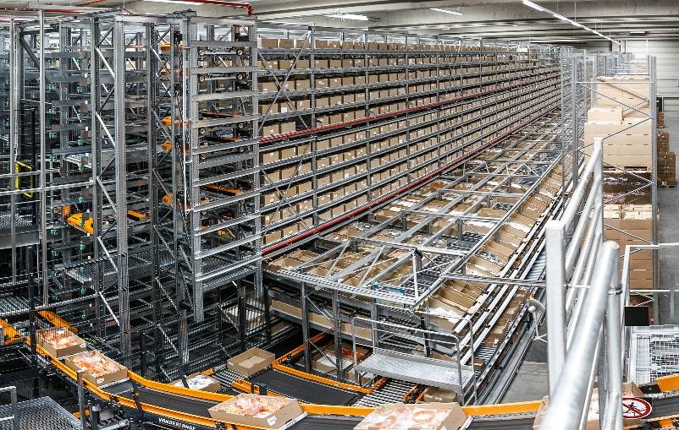
Vanderlande produces automated warehousing solutions of custom sizes for various companies, focusing on efficiently storing, transporting, and retrieving immense amounts of items via shuttle and conveyor systems [1]. One of their systems can be seen in Figure 1. During the installation of these large racking systems, there are a number of potential issues which may be found.
Figure 1: A Vanderlande automated warehouse
The most prevalent installation error pertains to incorrect assembly of the support profiles for an individual rack. An example of a correct as well as two common incorrect support profile installations can be seen in Figure 2 below. Vanderlande estimates that in any given racking installation, 0.5-1.0% of individual racks will have incorrectly installed support profiles. Each warehouse can easily have over 100,000 racks, and each error in racking installation can take around 5 minutes to locate and fix. This results in the potential for upwards of two weeks’ worth of work to identify and correct these erroneous support profile installations. This maintenance and repair time increases the overall commissioning time for each warehouse. 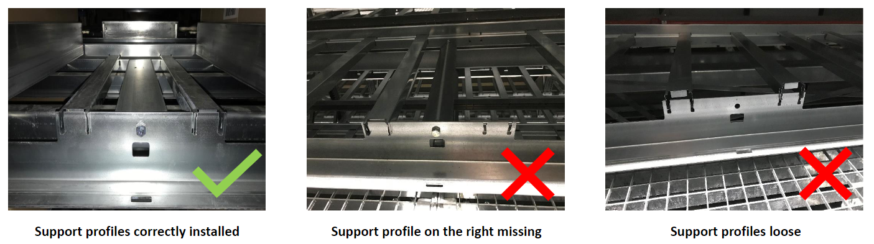
Figure 2: Examples of correctly and incorrectly installed support profiles
In an effort to reduce commissioning time for a warehouse, Vanderlande desires a diagnostic robot, or Dia-Bot, that can identify errors in the installation of their automated warehouses. The robot will be controlled to transverse around the racking systems either or its own power or riding along on the system’s conveyors and shuttles and uses a kit of sensors to detect any errors in the system. Examples of such error detection include a camera system used to identify incorrect installment of support profiles, an accelerometer to detect abnormal vibrations a package would experience on the conveyors or shuttles, and a microphone used to identify abnormal decibel levels of operation. Overall, the Dia-Bot is beneficial for giving visibility to areas of the warehouse system that may otherwise be difficult or dangerous to view or reach, identify potential material handling issues before system commission, validate the speeds and throughputs of the system, and decrease commissioning time for each warehouse system which benefits both Vanderlande and their clients.
The following sections will dive deeper into similar existing products and related codes, more detailed specifications, various ideation and decision-making modes, selected design choices and solutions, and next project steps.

2. Existing Products, Prior Art, & Applicable Patents
The world of robotics is a vastly growing frontier in today’s market. There are thousands of designs for various tasks ranging from recreational use to commercial industries. Automation robotics has seen a heavy impact on the supply chain industry, with robotic arms and carts being able to assemble and transport products more efficiently and accurately. The team has been aware since beginning this project that there would be a robust amount of ideology and inspiration from the market. While this aided solution brainstorming, it could also complicate the patent process.
Fortunately, Vanderlande is not looking to produce the Dia-Bot for this crowded market. They are aiming to design a solution fully for in-house use. This takes the pressure of patenting of the team's shoulders. As stated, the specific market for sensor packed transverse robots is widespread. The bookends consist of cheap toy like designs as depicted below by a generic framed RC car with exposed sensors, motors, and wiring. This design is very low cost with the typical price point falling between $50 and $250 dollars. This is juxtaposed by the top-of-the-line type constructed of high end protected sensors with advanced processors and materials as depicted by the ROSbot [2]. This top of the line can vary greatly in size and application which increases the price range. Robots of this stature can be anywhere from $2,000 to $45,000 dollars. Examples of these products can be seen in Figure 3 below.
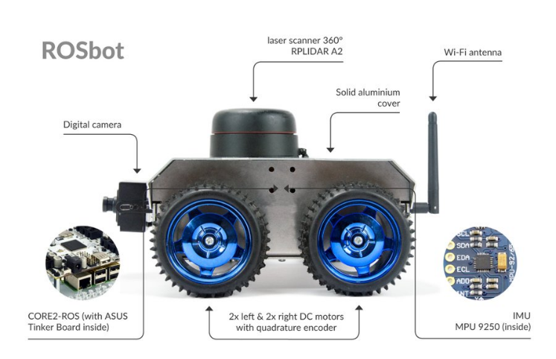
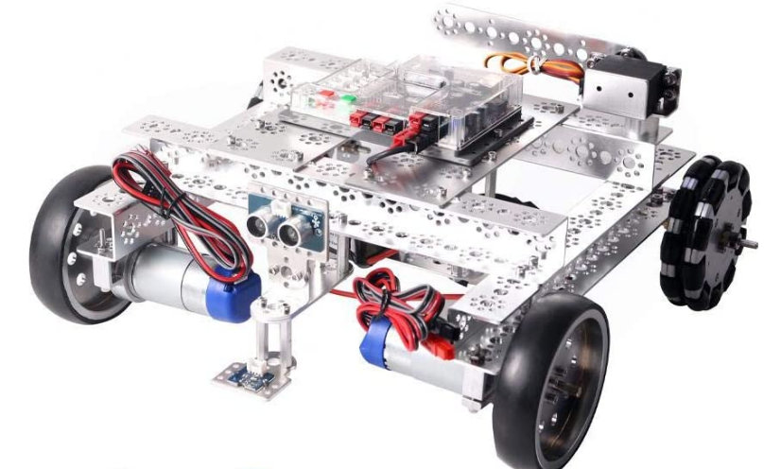
Figure 3: Examples of existing products similar in function to the Dia-Bot
Low-end market High-end market

3. Codes & Standards
Given that this robot must be picked up to be placed onto the warehousing system it will operate within, it is important to consider the lifting requirements. While the Occupational Safety and Health Administration (OSHA) does not have set regulations for acceptable weight to be lifting by a single person, or any other similar set regulations, it has worked with the National Institute for Occupational Safety & Health (NIOSH) to create a lifting equation. This NIOSH lifting equation gives a risk factor based on considerations of the lifting activity such as objects horizontal distance from the body, vertical location of the object to the floor, distance the object needs to be moved vertically, asymmetry angle or twisting requirement of the lift, frequency and duration of lifting activity, and the quality of the coupling or grip to the object.
While not directly within the industry of the Dia-Bot, the American Society for Testing and Materials (ASTM) have standards for the testing of response robots that fall near to some of the functionalities necessary for the Dia-Bot. ASTM standard E2566 gives a testing procedure to ascertain the visual acuity of a response robot to perform their given visual sensing task a counted number of times over a set period of time [3]. ASTM standard E2802 gives a testing procedure to determine how well a response robot is able to overcome vertical obstacles [4]. ASTM standards E2854 gives a testing procedure to measure the maximum range of wireless communication to complete tasks in line-of-sight [5]. While these tests are not required for our Dia-Bot, they are helpful testing procedures for the validation and testing of the Dia-Bot.

4. Customer Requirements & Engineering Design Specifications
A. Stakeholders
Table 1 provides a detailed analysis of the stakeholder interest in the Dia-Bot. Figure 4 shows an overview of the stakeholder analysis in a stakeholder 2x2 chart.
Table 1: Stakeholder Analysis
Stakeholder | Interests | Impact  /Effect | Importance | Influence Scope
Georgia Tech | Documentation, expo demonstration, creativity, innovation, problem definition, analysis, and design validation | Low | 2 | Timeline, documentation, course requirements
Primary Advisor (Dr. Jiao) | Documentation, creativity, innovation, problem definition, analysis, and design verification | Medium | 2 | Feedback based on knowledge and experience, and resources
Secondary/ECE Advisor (Dr. Madisetti) | Creativity, innovation, problem definition, analysis, and design verification | Low | 1 | Feedback based on knowledge and experience, and resources
Vanderlande Industries | Business interests, talent, ideas (i.e. support to team’s mechanical engineer) and final detail design | High | 2 | Feedback for usability, customer needs, feasibility, and stakeholder satisfaction
Vanderlande Industries Installation Engineers (User) | Reliability, ease to use, provides meaningful information, and quickens installation verification | Low | 1 | Performance, analytics, feasibly, and stakeholder satisfaction
Vanderlande Industries (technical POC) | Technical Knowledge and ideas, talent, analytical approaches, prototype validation, and deliverables | High | 3 | Technical knowledge for feedback and feasibility, performance, and customer needs analysis
Future Design and Engineering Teams | Technical knowledge and ideas, analytical approaches, deliverables, prototype, and documentation | Low | 1 | Problem scope, documentation, and feasibility
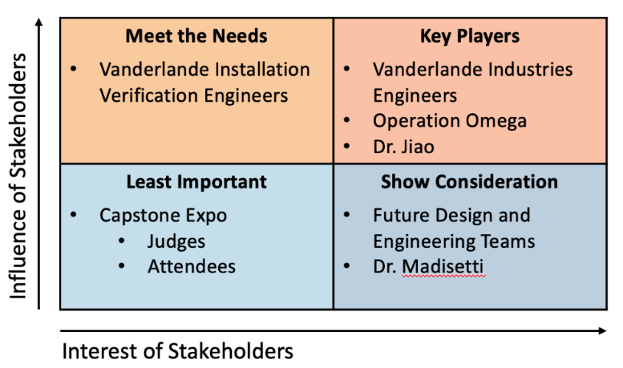
Figure 4: Stakeholder 2x2 Chart
B. Customer Requirements
Based on the team’s interaction with key stakeholders, customer requirements for the Dia-Bot have been identified and divided into eight (8) categories, as shown in Table 2 below.
Table 2: Customer Requirements
Category | Customer Requirements (Explicit and Implicit)
- Function | - Collects environment data
- Function | - Recognize robot’s location
- Function | - Moves through system
- Size | - Fit in System:  620mm x 400mm footprint, 300mm tall
- Weight | - Be under 35 kg
- Cost | - Less than $750
- Use | - Easy to control
- Power | - Self-sustained (Battery Powered)
- Power | - Lasts through system navigation
- Speed | - Navigates faster than human verification
- Navigation | - Easily moved over rollers, conveyer belts, and all other surfaces

C. Evaluating Key Functions
In reference to Table 2, the first category, function, is the most important category here because the main goal of the robot it to report the location of errors within the large racking system. The robot needs to be more effective than the human means of verification to be worth using over the current validation techniques. The robot should be able to fit and go through the racking system (for the size and weight requirements). Additionally, the Dia-Bot must be easy to control and cordless, therefore needing self-sustaining power and wireless communication. The robot needs to be able to navigate over all the different surfaces it may encounter such as rollers, conveyer belts curves, diverts, shuttles, inclines, declines, merges, and diverges. Lastly the Dia-Bot must be cost effective. While Vanderlande Industries will not need a large quantity of these robots, the team’s goal is to be able to produce a robot for no more than than $750.

D. Constraints
The robot has several constraints at this time. Notable the robot must fit inside of a 620mm x 400mm footprint with a maximum height of 300mm. Additionally the robot cannot exceed 35kg or the racking system will not be able to safety and effectively support the Dia-Bot’s movements. The user must be able to see fully around the robot, which requires that the robot have a camera with the ability to rotate 360° along with vertical tilting up and down for an angle of 45° (from min to max – a minimum of 10° off level in both directions). Because the Dia-Bot must relay the racking system’s environment, the robot must be accurate in its location within a foot (±12 inches).

E. Engineering Specifications
Based on the customer requirements and our constraints, Operation Omega has identified the follow important engineering requirements. The specification sheet is shown below.

Table 3: Specification Sheet
# | Spec | Date Updated | Requirements | Responsible | Source | How Validated
General
1 | Affordable for Small Scale Production | 09/26/21 | Unit cost < $750 | Design Team | Sponsor | Manufacturing cost analysis for the entire product
Physical Characteristics
2 | Product Weight | 09/26/21 | < 35kg (or <77lbs) | Mechanical Team | Sponsor | Weight measurement of full-scale prototype
3 | Product Size | 09/28/21 | Footprint < 620mm x 400mm  Height < 300mm | Mechanical Team | Sponsor | Measurement of full-scale prototype
Performance
4 | Movement Speed | 09/26/21 | a) Speed increments linearly | Electrical Team | Sponsor | Testing of Robot’s movement
4 | Movement Speed | 09/26/21 | b) Top speed ≥ 275m/hr (or ≥ 15 ft/min) | Mechanical Team | Design Team | Speed calculation from RPM from the motor
5 | Navigation Surfaces | 09/26/21 | a) Successfully navigates over belts, rollers, curves, and diverts | Mechanical Team | Sponsor | On site Testing (or if unavailable Simulation)
5 | Navigation Surfaces | 09/26/21 | b) Successfully navigates through inclines, declines, mergers, and diverges | Mechanical Team | Sponsor | On site Testing or test system (or if unavailable Simulation)
6 | Robustness | 09/26/21 | Withstands vibrations induced while navigating the racking system | Mechanical Team | Sponsor | Performance Assessment
7 | Visibility | 09/26/21 | Camera provides a 360° rotation with 45° vertical tilting | Electronic Team | Sponsor | Demonstration with full-scale prototype
8 | Position Tracking | 09/26/21 | Location Accuracy within a ±12 inches | Electrical Team | Sponsor | Algorithm analysis with projection supported by field testing
Electrical
9 | Power Management | 09/26/21 | Uses conventional wall plug | Electrical Team | Sponsor | Verify specifications and use appropriate battery in the final product
10 | Operating Time | 09/26/21 | > 5 hours | Electrical Team | Design Team | Verify specifications and use appropriate battery in the final product

F. Importance of Specifications
From the Customer Requirements and the Specification Requirements, the team created a House of Quality in Figure 5 to recognize the most important engineering requirements.
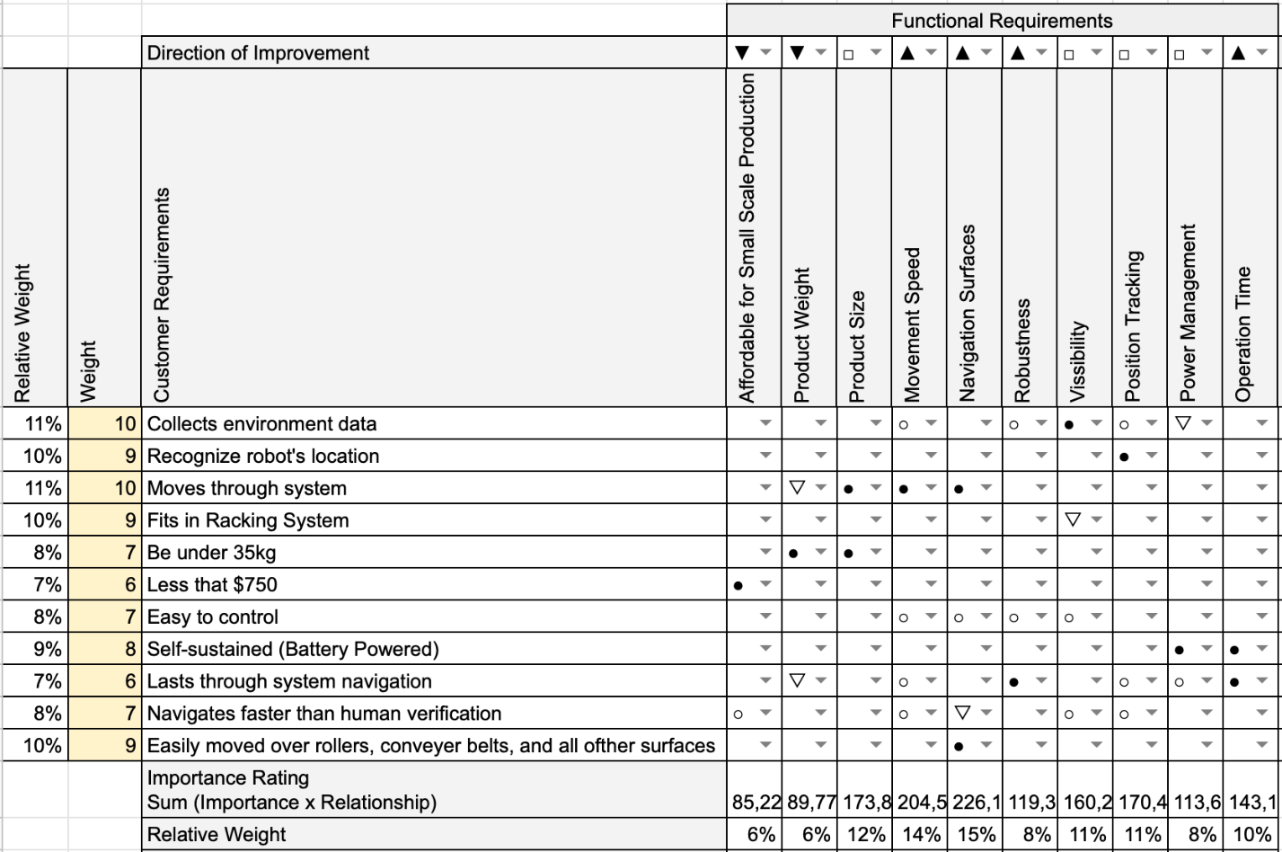
Figure 5: House of Quality
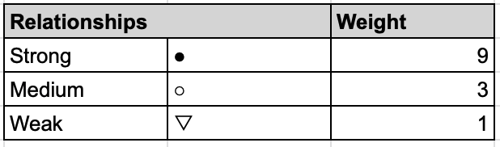
Figure 6: House of Quality Relationship Icons Weighting

The center section of the House of Quality characterizes the relationship between the customer requirements (on the left side of the table) and the functional requirements (on the top right of the table). These relationships are weighted based on their icons according to Figure 6 which, along with the weight of each customer requirement, is used to produce an importance rating along the bottom of the table. We have added a relative weight to each of these requirements to normalize our results.
The House of Quality analysis shows that the most important requirement for the bot will be the Navigation of the Dia-Bot over the myriad of surfaces that it will encounter. This places importance on the earlier design work for the special tread system. Next, the movement speed of the robot will be the second most important function, so that the Dia-Bot can make an improvement from Vanderlande Industries’ previous system of rack installation verification. Additionally, the team will need to provide Vanderlande Industries with our estimate speed of navigation over each type of surface so that we can calculate how the Dia-Bot can improve their installation verification time. Another important functionality will be the product size, and while this is an important function, the team does not foresee this constraint as a difficult technical challenge.
In the next group of important functions lies the Dia-Bot’s visibility and position tracking ability. These are vital to the robot’s facilitation of information and ability to navigate and locate problems. Next in importance there is Operation Time, Robustness, Power Management, and, finally, product weight and cost.

5. Design Concept Ideation
A. Functions
Possible functions and sub-functions necessary for an effective Dia-Bot were identified using a function tree show below in Figure 7. These functions and subfunctions were created and evaluated based on the requirements given from Vanderlande. The function tree splits the main responsibilities of the designed robot first into electrical and mechanical components. Six distinct functions stem from those: transporter and protect internal components on the mechanical side, and data collection, data analysis, signal connection, and controlling mechanical functions on the electrical side. These functions are broken down into subsections as necessary to ensure that the Dia-Bot encompasses all its requirements.
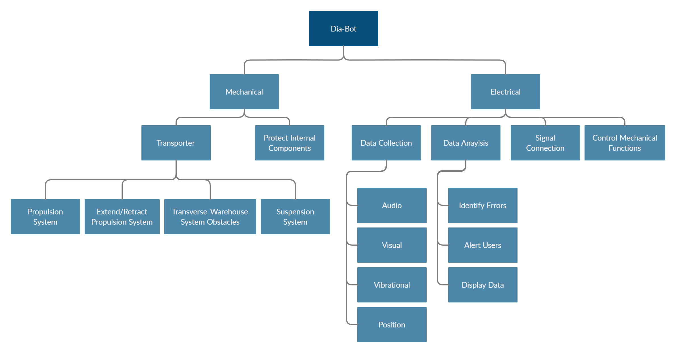
Figure 7: Dia-Bot Function Tree

Below the transporter function, the Dia-Bot must have a propulsion system that will allow it to navigate throughout its entire environment, consisting of conveyors, rollers, diverts, merges, and inclines. The Dia-Bot must also be able to retract its propulsion system to enable the ‘ride along’ functionality, allowing it to detect excessive vibrations. A suitable suspension system must also be selected to allow the Dia-Bot to detect vibrations coming from the environment rather than the bot itself.
Interactions between the Dia-Bot and the operate are possibly the most important function, as the bot would be useless if the operator cannot observe and verify the errors recognized. The operator should be able to control the movement and the error recognition sensors of the bot. The platform in which the bot and operator communicate is also an important consideration. Finally, the bot should be able to display real time sensor data, as well as log and report errors.

B. Morphological Chart
A morphological chart, as seen in Figure 8, was implemented to look more specifically at possible solutions to the subfunctions listed in the function tree. Several concepts were given for each subfunction, which allowed the team to narrow down which concepts would work best for the final design. The team plans on revisiting the morphological chart frequently once the low fidelity prototyping phase is entered to make sure the prime concept is selected.
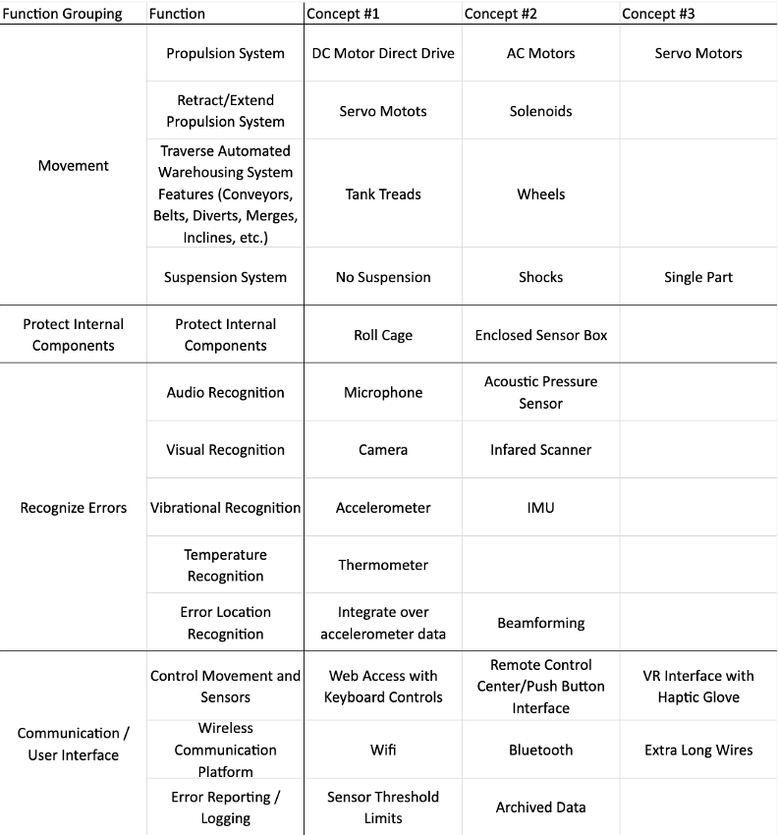
Figure 8: Dia-Bot Morphological Chart
Several different concepts were under consideration when it came to the movement of the Dia-Bot. To begin, we had to narrow down the propulsion system used, which could consist of DC motors, AC motors, or Servo Motors. In order to retract or extend the propulsion system, servo motors and solenoids were considered. The means of transportation, via tank treads or wheels, was also considered. Additionally, the type of suspension system was considered, with ideas ranging from no suspension, shock suspension, or single part suspension. For internal component part protection, two concepts were determined: a roll cage or an enclosed sensor box. In terms of being able to recognize and call out errors, the possible concept solutions can be seen in rows 6-10 in Figure 8. In order to control both the movement and sensors, three concepts were proposed: web access with keyboard controls, remote control center with push button interface, and virtual reality interface with haptic glove. For the wireless communication platform, three concepts were considered: Wi-Fi, Bluetooth, and extra-long wires. Finally, for error reporting/logging, the two concepts were setting sensor threshold limits that would report errors once the threshold was passed and archived data to be looked at once the bot had completed its run.

6. Concept Selection & Justification
A. Mechanical Design
The mechanical components of the Dia-Bot must work in concert to accomplish three general tasks: transport the camera and sensors across Vanderlande’s system, protect the delicate electrical components during transportation, and retract its propulsion system to allow the robot to lie flat on the underside of its main body.
For transportation of the camera and sensors, a continuous track design and wheels were selected as the two most realistic options. Other ideas such as a drone were considered, but dismissed for the complexity, cost, reliability, and safety concerns. Each means of transportation offers its own set of advantages and disadvantages, listed in Table 4. Given that the robot must move through a veritable maze of conveyor surfaces, rollers, and sharp turns, a continuous track design was selected over wheels. The advantage of driving over obstacles outweighs the drawbacks to speed and maneuverability.
Table 4: Comparison of a Continuous Track Design vs. Wheels [6]
 | Continuous Track | Wheels
Advantages | - Power Efficiency  - Traction  - Moving Over Rough Terrain  - Weight Distribution  - Complicated Suspension | - Lower Cost  - Speed  - Simplicity  - Lightweight  - Maneuverability
Disadvantages | - Lower Speed  - Friction | - Driving Over Obstacles
Once we selected a continuous track propulsion system, the next step was to design the chassis. The two main considerations were whether the chassis should be symmetric and whether to include a suspension system. Making the chassis symmetric offers a few advantages for the user. The most important of which is that the robot would not need to rotate 180 degrees to travel backwards. In a tight environment, turning might not be physically possible. The operator can simply reverse direction and the Dia-Bot would handle the same as if it was driving forwards. However, the drawback is that such a design would be larger and, therefore, heavier. Using a suspension system would help insulate the delicate components from jostling and vibrations as the Dia-Bot traversed its environment. Once again, the trade-off is added weight and complexity. Figure 9, Figure 10, and Figure 11 are mock-up sketches for a combination of these designs. In conversations with Vanderlande about the desired functionality of the Dia-Bot and the environment in which it would operate, they expressed a desire for the robot to be as robust and flexible as possible. To that end, we believe that a symmetric chassis with a suspension system is the strongest combination. With a finalized concept for the transportation of the camera and sensors, the next phase can begin: designing the chassis with easily sourced, off-the-shelf parts and simply custom parts.
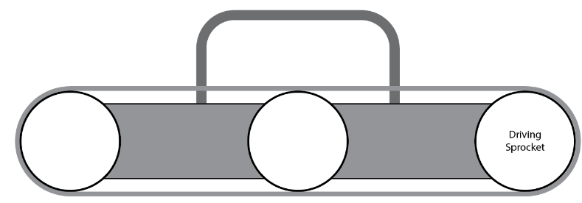
Figure 9: Symmetric Chassis Design without Suspension System
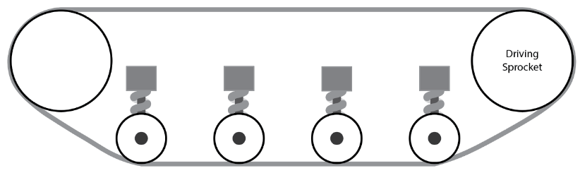
Figure 10: Symmetric Chassis Design with Suspension System
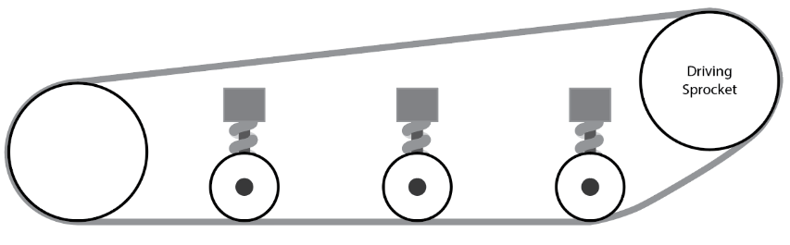
Figure 11: Asymmetric Chassis Design with Suspension
More so than any other factor, the cost of each component has had the largest influence on design. A pair of robust rubber tank treads to use for the continuous track drive can easily cost $600-$800. Two alternatives were found at a much lower price point: roller chain with flanges and timing belts. After speaking with Vanderlande, the decision was made to use the quieter timing belt. A self-centering track was sourced from Bracoflex (Figure 12) with a fixed outer perimeter of 1100mm. A sketch of the timing belt and pulleys, shown in Figure 13, was drawn up to ensure that the perimeter of the design matches the perimeter of the timing belt.
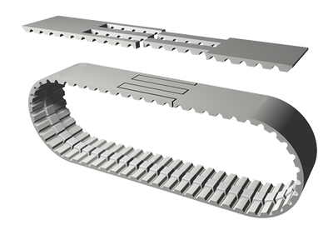
Figure 12: Self-Centering Timing Belt for Tank Tread
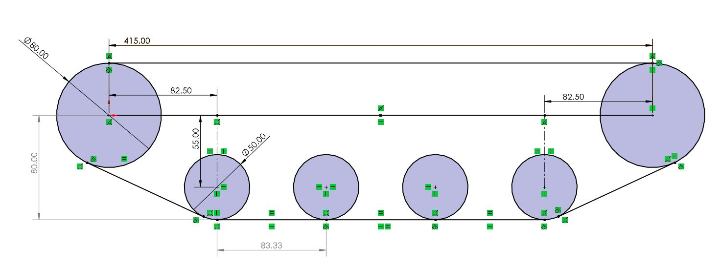
Figure 13: Layout Sketch of Chosen Chassis Design
As the Dia-Bot turns, a lateral force is applied to the track. To prevent the timing belt from slipping off its pulleys, the belt has a raised ridge running along its centerline that meshed with a channel on the pulleys (Figure 14, Figure 15). The manufacturer of the timing belt offers pulleys with a variety of customizations; however, each individual component has a price tag of a few hundred dollars. To alleviate this issue, CAD models of the pulleys were generated for SLA 3D-Printing. The Formlabs Tough 2000 Resign allows for strong and stiff parts to be printed with remarkable resolution. The 50 Tooth Custom Drive Pulley was designed such that an aluminium plate can be adhered to each side, further reinforcing the strength of the 30 printed part.
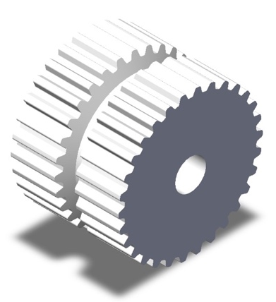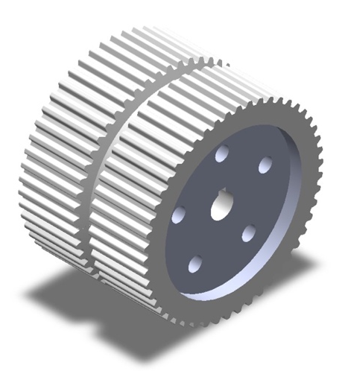
Figure 14: 30 Tooth Custom Pulley Figure 15: 50 Tooth Custom Drive Pulley
Other components necessary for the chassis such as keyed axles, hubs and bushing were sourced and then a rudimentary CAD assembly was constructed, shown in Figure 16. The baseplate of the chassis will be constructed out of an aluminiunm composite material that is lightweight and structurally sound. Rigid brass standoffs will provide extra support to prevent the chassis from warping under external loads. Once the total weight of the Dia-Bot is known, an engineering analysis can be done on the frame to determine the robustness of the design.

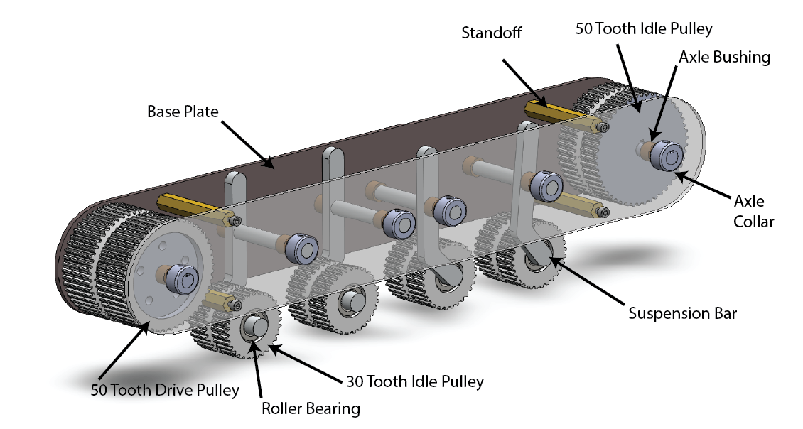
Figure 16: CAD Model of a Single Side of the Chassis Design
Designing the suspension system was a difficult task for two reasons: the system cannot extend into the cavity where the main body of the Dia-Bot will reside, and the system cannot extend up past the plane of the timing belt. Additionally, cheap components often do have their material properties listed making it difficult to perform engineering analysis for design verification before purchasing the parts. Despite the difficulties, a cheap, compact, and modular suspension system was developed. Seen in Figure 17, a 3D-printed idle pulley revolves on a suspension bar around a fixed axle, with a RC Car Spring Shock providing sufficient dampening. The suspension system without spring shock visualized is modeled in Figure 16.
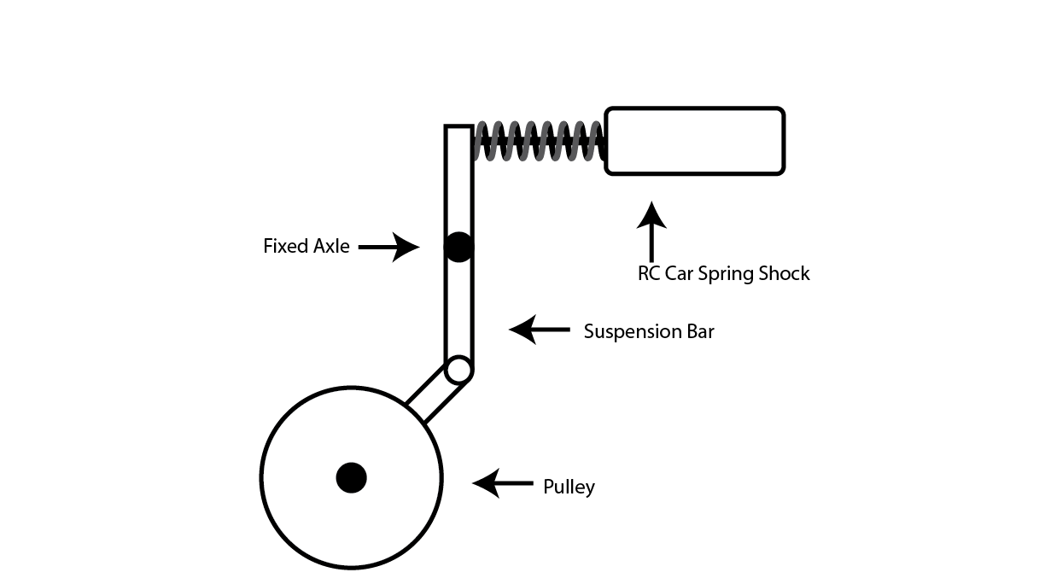
Figure 17: Suspension System Sketch
Retracting the propulsion system to allow the Dia-Bot to lie flat on a conveyor surface is a difficult task, and one that can only be reliably completed once the main body is designed. However, some concepts have been discussed. The body will be interchangeable to support the new modular system. Our design approach is to attach the chassis to the main body with a linear slide and mechanical lock as seen in Figures 18 and 19. This would allow a user to manually remove the main body from to the chassis to use as a standalone sensor apparatus or to attach a different drive module. While it is possible to automate this process with a servo, we do not believe that the convenience outweighs the added complexity. The system will use two guide rails, shown in Figure 20 with one attaching to each side of the chassis as well as four slides, shown in Figure 21, which will be integrated into the main body. Once on the rails, the body will be able to lock into position using a screw-on turn latch that will fit into a cut out slot in the chassis frame. This will inhibit motion in both the forward and backward direction while allowing for easy access for the operator.

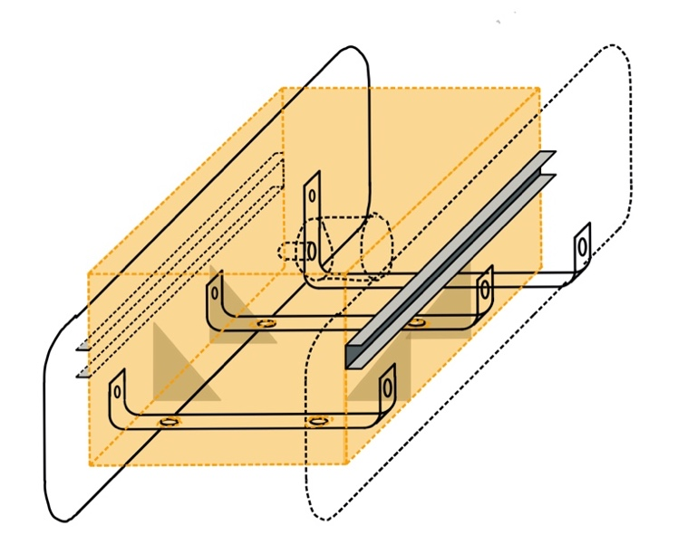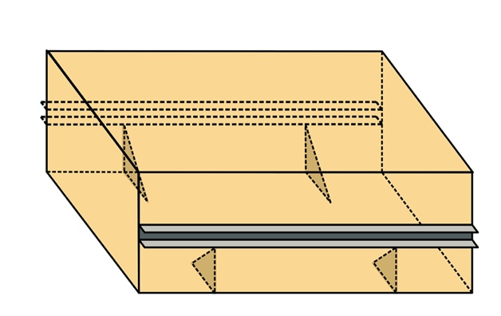
Figure 18: Modular Body Design Figure 19: Modular Body Design Side Profile
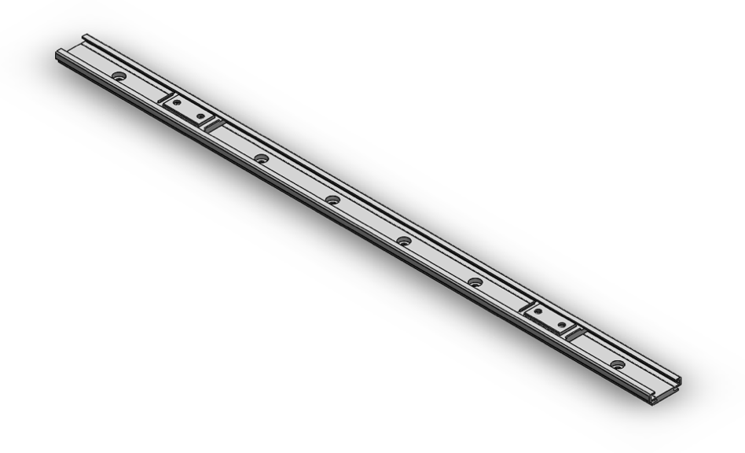
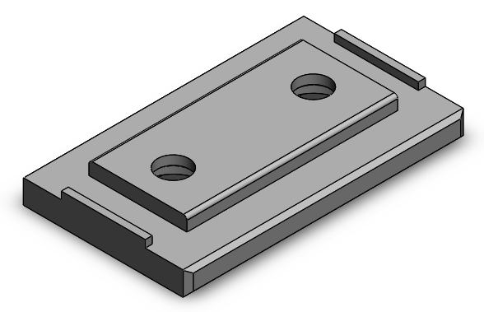
Figure 20: Chassis Guide Rail
Figure 21: Main Body Slide Attachment

B. Electrical Concept
The electrical subsystem must support the robot’s ability to move through the system, send real-time data to and receive controls from the operator, and track its position. To accomplish these functions, the team must recognize the requirements necessary such as a mobile power source, a rechargeable power source, movement generators (for the treads and camera), a light source for the camera, a user interface with the ability to control the features in real time, and an embedded processing center on the robot. As we consider the electrical subsystem’s requirements, we made an evaluation matrix for the location positioning, movement generation, processing center, power source, real-time access to Dia-Bot data, and user interface. Below are the six evaluation matrices used to formulate a design for each of these critical tasks.
Table 5: Electrical Components Evaluation Table
Mandatory Criteria | Option 1 | Option 2 | Option 3
Location Positioning | GPS | On Dia-Bot algorithm with navigation and system map | Raw position data using telemetry
Movement Generation | DC Motors  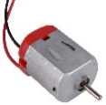 | AC Motors  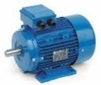 | Servo Motors  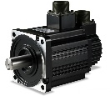
Real Time Access to Dia-Bot Data | Wi-Fi   | Bluetooth   | Extra Long Wires  
Processing Center | Arduino UNO Rev 3  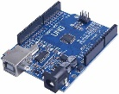 | Raspberry Pi 4  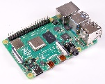 | Mbed (LPC1768 Cortex-M3)  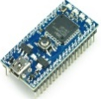
Power Source | Rechargeable: Lithium-ion battery  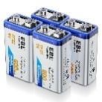 | Rechargeable: Lead Acid or SLA Batteries  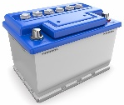 | Non-rechargeable: Alkaline Cell Batteries (PP3)  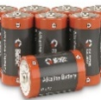
User Interface | Web Access through Computer or Tablet | Remote Control center with a fabricated push button interface | Virtual Reality Interface with Haptic Gloves

Referring to Table 5, this section discussed the options selected and why those are the best fit for the Dia-Bot. For Location Positioning, an affordable GPS unit will not yield the accurate position data necessary for the robot and from experience, raw telemetry data is known to be extremely inaccurate. As a result, the Dia-Bot will be using a positioning algorithm with navigation and a system map to determine the location. For movement generation, DC motors are light enough for the Dia-Bot’s requirements and will provide enough torque in a linear fashion. Therefore, these are the best option for our Dia-Bot. Next, Wi-Fi was chosen as the best way to access real time information from the Dia-Bot. Due to the large amount of data needing to be moved over large areas, Wi-Fi is the optimal connection technology, since Bluetooth has a very limited range of connectivity and significantly lower data throughout rates[7]. For the Dia-Bot’s processing center, the team has experience using all three microcontrollers listed and believes that the Raspberry Pi will best address the robot’s Wi-Fi requirement because these microcontrollers have an on-board W-Fi chip [8]. Vanderlande Industries has expressed that a User Interface through a computer’s web page would be most cost effective, affordable, and malleable for future work.
The team has identified the following potential risks: extra setup steps for connecting the Wi-Fi module, poor camera output quality, and inaccurate positional calculations. For initial setup of the Dia-Bot in a new location, the Raspberry Pi must be accessed directly to first connect to the local Wi-Fi network. While Raspbian OS version allows for a simple streamlined GUI to connect to Wi-Fi like any normal desktop operating system used, this connectivity process will likely require access via an external keyboard and monitor connection. If the Dia-Bot experiences poor camera output quality, interface execution will focus on capturing high quality picture data and “cut” the live feed frame rate in favor of high-quality images. If that still does not provide high quality results, the team recommends for future projects that Vanderlande Industries use special Wi-Fi module with high data transfer rates. If time allows, potential solutions could be proposed to future follow-up groups. Lastly, if the team encounters difficulty calculating the Dia-Bot’s location on the robot, some high-end GPS modules may be considered to interface with Raspberry Pi easily and provide detailed location data. However, these modules are expensive, so another algorithm would be pursued first.
A block diagram displaying electrical components has been provided (Figure 23) to ensure that all necessary components are considered for the Dia-Bot. The team has used the following updated block diagram to complete a Voltage analysis based on the load of each item on the Voltage source and the Pi. The load analysis supports our current design, and our system should be able to sustain itself without too much draw on the system or any need to achquire new parts. The updated block diagram shows all the necessary logical, voltage and ground connections for our system and will be updated within the week to be cleaner and more concise.
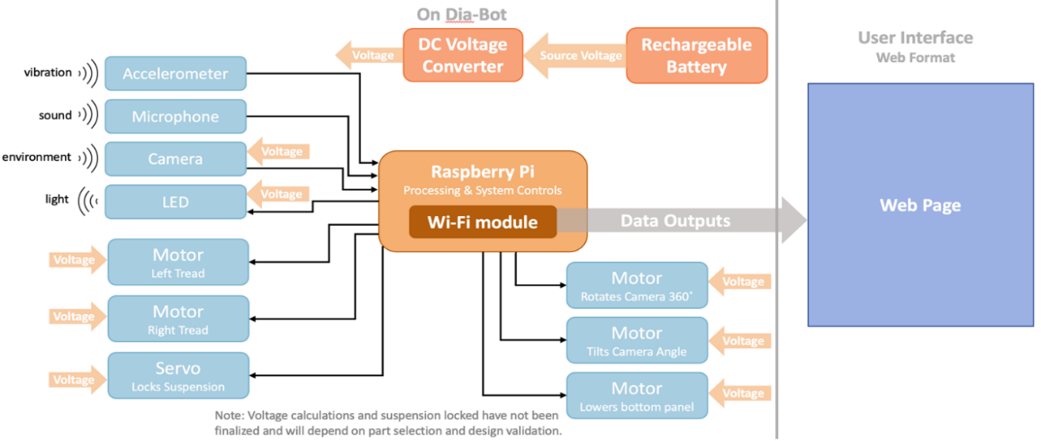
Figure 22: Preliminary Electrical Block Diagram

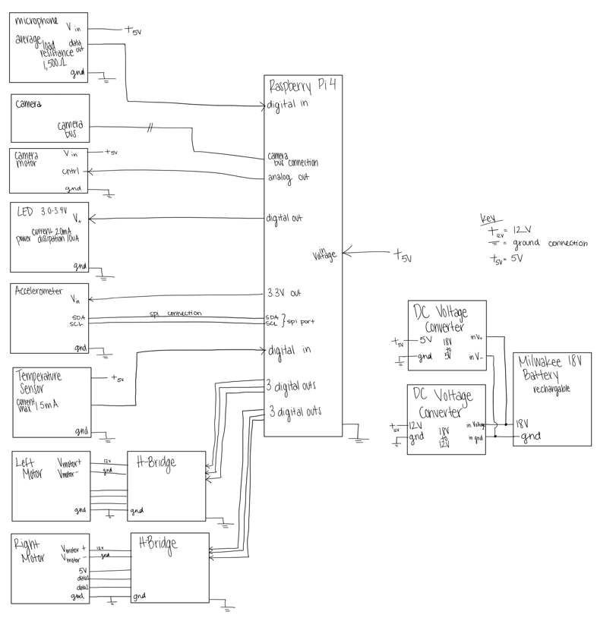
Figure 23: Updated Electrical Block Diagram
The team hosted a User Interface design workshop with the client, Vanderlande Industries, to ensure that all the data and information passed to the operator is helpful, necessary, and comprehensive. In this design session, the team presented a preliminarily mockup of the user interface (Figure 24) and talked through the user groups who may interact with each of the data points collected, the purpose of the data collected, and the ease of use for the user. This led to the Revised User Interface seen in Figure 25. This design workshop gave the electrical team members of Operation Omega the ability to see one full end of the system with the other end being the mechanical outputs of the motor, the light out of the LED, and others which are largely apart of the mechanical side of the Dia-Bot.

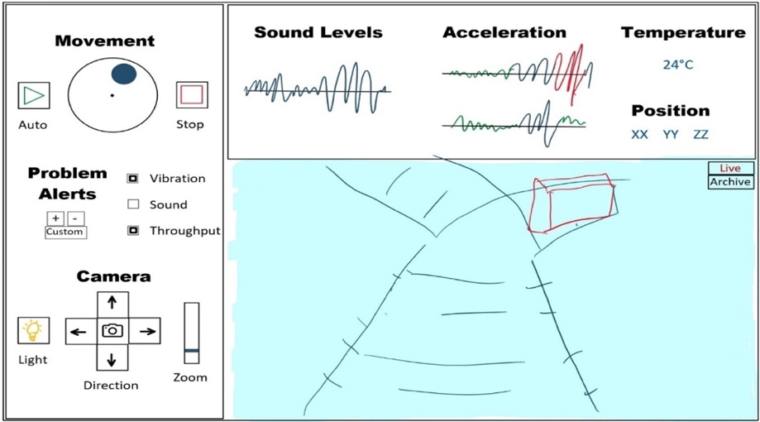
Figure 24: Preliminary User Interface Mockup
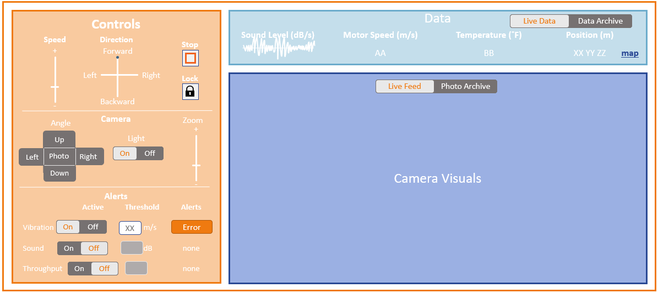
Figure 25: Revised User Interface

As building of the electrical sub-system began, the electrical team used dummy inputs (randomized generated values) to create Figure 26. In the Initial Prototype User Interface, the client can see live charts of sound levels, virbration, temperature, and position, above the real time camera visuals. On the left of the image in Figure 27 is a control panel so that the operator may control the movement of the robot, camera, light, and set alerts. This pane also displays and alerts for potential problems.

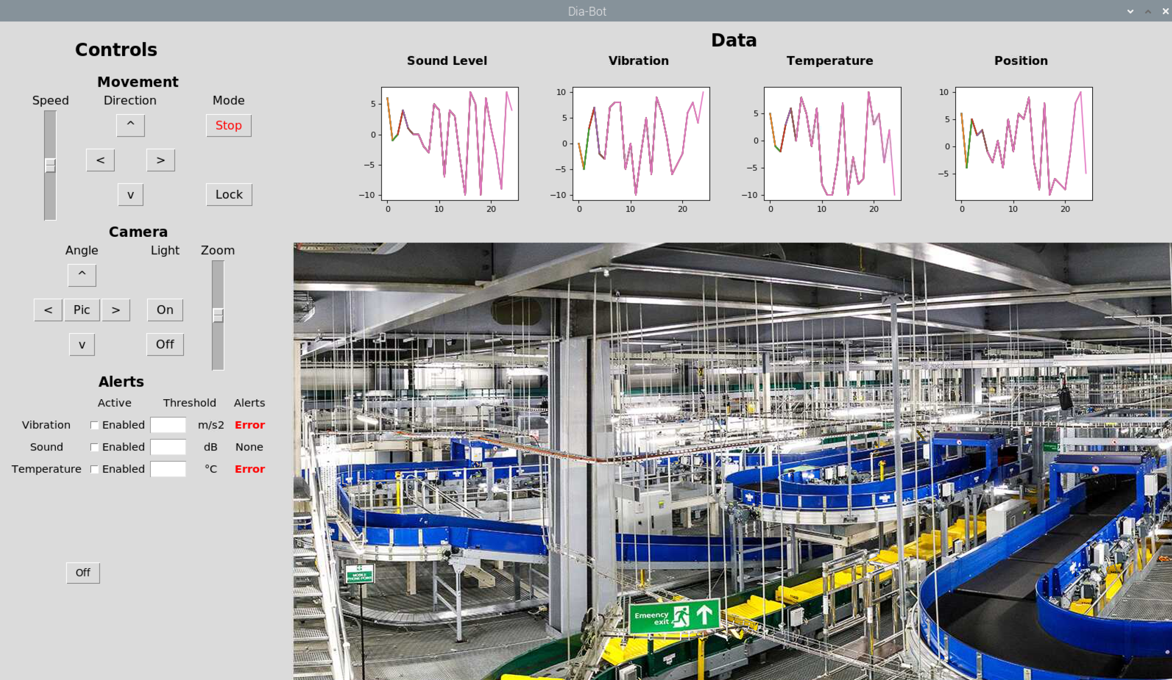
Figure 26: Initial Prototype User Interface

C. Electrical-Mechanical Interaction
As described earlier this section, the Dia-Bot moves via two treads, one on either side, each individually controlled by its own DC motor. An operator controls the movement of these two treads based on the eight-way direction buttons and speed slider exposed by the user interface. Since an operator may be controlling this robot with only a laptop, a discrete direction control scheme must be implemented to accommodate users with a keyboard and no touchscreen. Due to these constraints, the following control scheme is used to move the Dia-Bot with the eight directional buttons plus a center button for a short brake. Figure 27 shows how each of the nine control buttons maps to a different speed setting for each tread.
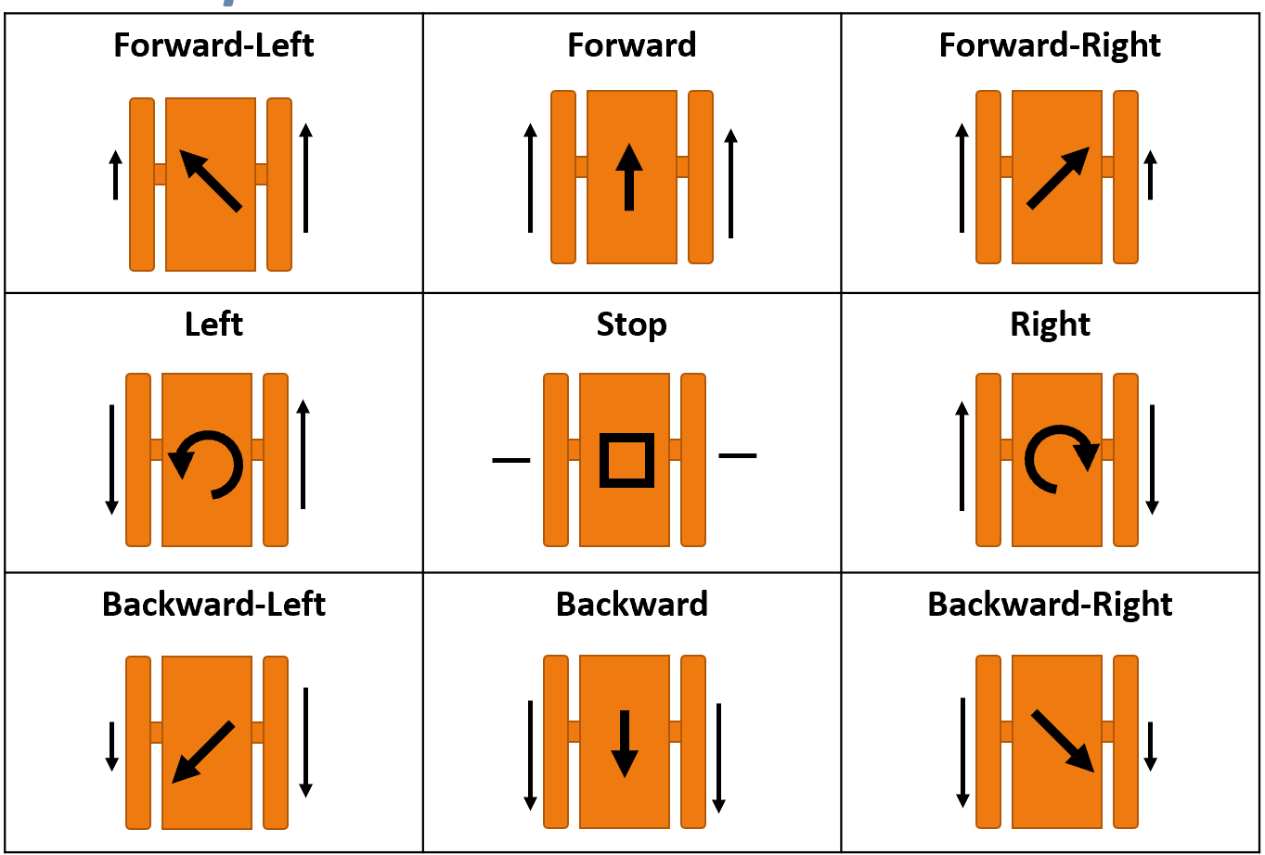
Figure 27: The nine buttons which control the Dia-Bot’s movement and their corresponding speed setting for each tread.

7. Industrial Design
Some of the main Industrial Design considerations are unity among Georgia Tech, Vanderlande Industries, and future design teams, cohesion of a final product from the user interface to the robot, ownership recognition, and practicality of the robot. To ensure unity among Georgia Tech and Vanderlande Industries, the team has been using a combination of the Vanderlande and Georgia Tech logos stacked on top of each other (Figure 28). To ensure that future groups feel a sense of ownership of this project, this combination logo in general does incorporate their identity as members of the Georgia Tech community and their growing relationship with Vanderlande Industries. This combination logo supports Vanderlande's ownership and Georgia Tech’s innovation of the final product. To create cohesion of the entire final product, the team does need to incorporate the combination logo onto the user interface and for the robot if there is reasonable exterior surface space for the logo. While the combination logo is easily recognizable, it does not help distinguish the robot from other projects done between Georgia Tech and Vanderlande.


Figure 28: Vanderlande Industries and Georgia Tech Combination Logo
Visually, the combination logo does recognize the hierarchy of Vanderlande as the owner, users, and proprietors of the robot while much of the innovation and support is provided by Georgia Tech teams. The Language of the combination logo is awkward, with two fonts stacked together, but without them the project would lose brand recognition. Because the robot will be operator and owner by Vanderlande Industries, all deliverables will use the Vanderlande Industries Color Scheme as seen in Figure 29. Using this color scheme shows respect their contributions to Georgia Tech and helps support their corporate cohesion for this custom-made robot. Lastly, target demographic research is unnecessary as the robot will be used by operators and most of the time the robot will not be visible because it will be traversing non-visible areas withing racking systems.

Figure 29: Vanderlande Industries Color Scheme

8. Engineering Analyses and Experiments
For the modular body attachment system, a static load assessment was completed during the research for design materials. With a maximum possible load of 77 lbs, the Dia-Bot needed a durable and strong attachment system to meet the team's requirements. The sourced parts for the slide and rail system have a static load maximum of 110lbs. These parts were selected based on their ability to support the maximum load as well as give the system a minimum safety factor of 1.42.
When determining the proper motor to use in the propulsion system, the main specifications that must be designed around are the torque and rotational velocity. Specifically, the stall torque requirement and desired RPM are vital specifications. There has been extensive research done into proper stall torque required for robots operating propulsion systems based on DC motors. The rule of thumb used is that the stall torque should be greater than the weight of the robot times the radius of the driving wheel [9]. The selected motor has a stall torque rating of 39.6 in/lbs. With two motors and driving sprocket diameter of 2”, these motors are able to propel a system of up to 39.6 lbs using this model. The motor produces rotation of up to 410 RPM according to its gear ratio, which equates to a top speed of 4.88 mph, which is acceptable for the use case of the Dia-Bot.

9. Societal, Environmental, and Sustainability Considerations
One aspect of societal considerations is evaluating how people’s lives are impacted by the Dia-Bot. Since the Dia-Bot is initially intended to be controlled by and send data outputs to Vanderlande operators, this will not remove any jobs from the work force. The Dia-Bot will instead accelerate and augment the operators’ decision-making process for evaluating potential installation issues. Operators will thus need to be trained to use the Dia-Bot properly and effectively. However, due to the intuitive nature desired for the user interface, this training should take minimal time. Proper instructions and debugging tips for known use case issues will be easily accessible via the user interface by leveraging existing programs on the Raspberry Pi. These considerations ensure the most positive social impact for the Dia-Bot.
Other considerations have been made when deciding on the power supply system. Vanderlande operators generally install conveyor systems using Milwaukee power tools, which use their own rechargeable 18V batteries. Due to the numerous advantages, this battery will therefore be used as the Dia-Bot’s power supply. This type of battery is already readily avaible to the client during times when the Dia-Bot would be used, simplifying power management for operators, as these will already be constantly used and recharged during work cycles. Additionally, reusing Vanderlande’s existing batteries ensures that Dia-Bot production consumes fewer materials.
To assess positive and negative impacts on society, a Social Impact Assessment (SIA) was performed for the Dia-Bot. The outlines for the assessment can be seen below in Tables 6-7, wherein Table 6 defines the goal and cope of the assessment and Table 7 performs inventory analysis.
Table 6: Goal and Scope of Social Impact Assessment
Objective of Assessment | Design Function | Functional Unit | Lifecycle Stages Considered | Associated Activities
Assess social impacts of robot | Remotely detect installation errors of Vanderlande automated warehouses | A single  Dia-Bot Unit | End of Life | Recycling, Disposal
Assess social impacts of robot |  | A single  Dia-Bot Unit | Use | Vanderlande Engineer/Operator use in warehouse
Assess social impacts of robot |  | A single  Dia-Bot Unit | Manufacturing | Material forming,  product assembly
Assess social impacts of robot |  | A single  Dia-Bot Unit | Production | Sourcing of  (raw) materials

Table 7: Inventory Analysis Section Summary of Social Impact Assessment.
Product Lifecycle Stage | Stakeholder Group | Social Impact Category | Impact Indicators
End of Life | Consumer | End of Life Responsibility | % of recyclable parts of the Dia-Bot that are successfully recycled rather than disposed
Use | Consumers | Feedback Mechanisms | Increased efficiency in installation error detection
Use | Consumers | Feedback Mechanisms | Decreased maintenance time during system validation
Use | Consumers | Technology Development | Increased Autonomy  of Dia-Bot
Manufacturing | Workers | Health and Safety | Number of OSHA violations
Manufacturing | Workers | Health and Safety | Reported Accidents
Production | Value-chain actors | Social Responsibility | Presence of explicit code of conduct

There are many possible positive impacts on human well being resulting from the Dia-Bot. Many electronic components used for the Dia-Bot require more complex assembly. This complexity drives the need for high skill labor which carries more sustainable wages. Additionally, electronic components require a vast array of raw materials which also must be processed, creating more employment opportunities. Furthermore, electronics are a global market, promoting trade across multinational value-chain actors each in their own local communities. The Dia-Bot will increase maneuverability into the warehousing systems where previously an operator may have had difficult or unsafe methods of entering. This eliminates potential safety hazards for the user.
There are also possible negative impacts on human well being as a result of the Dia-Bot. While electronic components require a vast array of raw materials and more complex production, it is not uncommon for the collection of raw materials and production to be performed in less developed areas. In these less developed areas, wages may be unsustainably low for the workers, or conditions harsh or unsafe. Some of the raw materials and natural resources used in the creation of these electronic components may be draining to the economy of less developed areas, or cause pollution in the areas where the materials are extracted in unregulated manners for profit’s sake.
With concern for poor labor practices in the supply chain of electronic components is present, it will be sensible to select vendor companies that have proven records of proper labor practices. Any vendor with potential for child labor, forced labor, environmentally hazardous, or in any other way poor labor practices should not be considered as a value-chain actor for the Dia-Bot. It will also be prudent to select materials for the Dia-Bot to be as recyclable or as reusable as possible so that there is a minized footprint of disposed materials.
The production, manufacturing, use, and end of life of the Dia-Bot were all stages of the life cycle of the Dia-Bot considered in the SIA. These four life cycle stages incorporate different stakeholder groups of which the design of the Dia-Bot will affect. As such each has the potential to impact the society around this product. Consumers were selected as stakeholders because the use case of the product is designed with the operator as the consumer in mind. Workers and value-chain actors were considered stakeholders because of the positive and negative societal impacts possible discussed above. The social impact categories and impact indicators were selected based on known working conditions in expansive warehouse systems and labor conditions in countries that produce lower cost electronic components.

10. Team Member Contributions
While team progress has consistently been made in group efforts, either the team as a whole or the mechanical or computer and electrical teams, everyone has played roles in the progress of the project. The mechanical team, consisting of Andrew, Jason, Hunter, and Douglas, has focused on the development of the movement functions and requirements of the Dia-Bot. The computer and electrical team, consisting of Catherine and Connor, worked in parallel to advance the controls, communication, and user interface portions of the Dia-Bot’s necessary functionality. A more detailed breakdown of tasks is as follows.

- Andrew conducted the research into the market’s prior art and patents. By working off of the groups brainstorming and function requirements, he was able to produce information on related robots in the field currently. This led to easier decisions for the Dia-Bot and a good baseline for the group to branch off of. He created the design for the attachment of the modular drive system by sourcing the needed materials integrating them with the main body design team.
- Catherine has worked organize the team by creating presentation (in line with Vanderlande Industries’ formatting), meeting notes, and the reports format. On a more technical note, she prepared the User Interface design workshop, the Electrical Block Diagram, the Specification Sheet, House of Quality, Customer Requirements, Industrial Design, and Stakeholder Analysis. In building the prototype, she has saudered electrical components.
- Jason worked to create a clear and detailed function tree that incorporates the entire scope of functions of the Dia-Bot as well as doing research into the codes and standards relating to the solution. Furthermore, Jason did extensive research into different types of motors and drivetrain systems to be used in the propulsion of the continuous track system. In parallel, he researched the torque and RPM requirements of the output of the motor to ensure proper power transfer and speed of the Dia-Bot. Lastly, Jason completed the social impact analysis (SIA) to investigate the potential positive and negative social repercussions of the Dia-Bot.
- Hunter has spent much of his time designing the various components of the chassis, sourcing affordable parts for each subsystem, designing custom parts when needed, and then building out the chassis in CAD Software.
- Connor primarily helped define and narrowing the Dia-Bot scope and features, most notably by providing initial drafts of the function tree and user interface design and contents. He has also helped add formatting and final editing for team reports and presentations. On the technical side, he has created the Python code for the user interface and robot control via the Raspberry Pi, as well as discovery and sourced for many electrical parts.
- Douglas worked primarily on the Design Concept Ideation portion, where he reviewed and revised both the Function Tree and Morphological Chart. He also provided an extensive evaluation of each of the Dia-Bot’s functions, as well as the concepts that led to the final design components.

11. Conclusions: Project Deliverables & Future Work
The initial steps of diagnostic robot ideation and discussion have helped the team define a proper design scope for providing a solution to the problems that Vanderlande is describing. The team’s Dia-Bot designs include proper movement modes, appropriate data collection, and an accessible software user interface which allow Vanderlande engineers to discover issues during the installation of their shuttle and conveyor systems.
In addition to defining the project scope for the Dia-Bot, the team has devised a set of potential stretch goals or further recommendations for Vanderlande, depending on the speed of initial development. While manual movement and ride-along mode are useful transportation methods for verification, another useful feature is an automatic movement mode – either by a pre-defined route or letting the bot roam on its own. To further automate installation verification, computer vision techniques could be integrated to automatically analyze the camera’s feed and identify problems visually. Additionally, establishing modes of communication between multiple Dia-Bots may allow for quicker and more advanced verification algorithms. Finally, even though the primary purpose of the Dia-Bot is to identify issues, methods may be discovered and implemented over time to fix certain problems without the need for an operator.
Depending on the timeline of Vanderlande installing systems for their clients, the team may not get a chance to test the Dia-Bot in a proper shuttle or conveyor environment. If not, Vanderlande operators would send the Dia-Bot through a new system to track the bot’s movement and detect possible problems. This would allow proper calibration for both collecting positional data and setting vibrational and sound alert thresholds. Ideally, this would be done during the semester, but the team must account for Vanderlande’s business needs first.
With the design scope and initial solutions have been defined, the team began prototyping and design simulation. The mechanical team has sourced OEM parts for the propulsion and suspension systems as well designd and will manufacture the structures of the chassis specifically used to house and protect the internal electrical components. For embedded systems engineering, the prototyping steps included breadboarding a simple setup to control simple servo and DC motors while reading IMU and camera data. The software team is creating a functional user interface on a Raspberry Pi using to control the prototype system. These initial steps to simulate a final design are crucial in ensuring the feasibility of the design solution and creating initial Dia-Bot functionality.
Figure 30 below shows the projected timeline for the project. Mechanical design simulations have been completed and predict a functional and structurally sound design. The team has been sourcing materials and is in the processs of completing production of each subsystem: movent, enclosure, power, electrical, and software, as described throught the document. Finally, the full Dia-Bot will be assembled and validated prior to the Capstone Design expo.
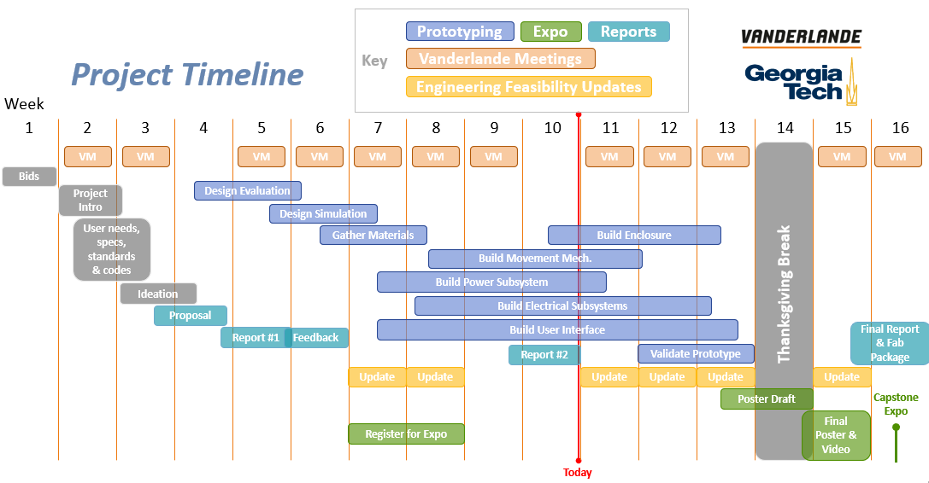
Figure 30: Project timeline, including design prototyping, feasibility updates, expo tasks, and reports.

The team has held weekly or as-needed update meetings with Arlo Bromley and Dr. Patrick Opdenbosch of Vanderlande Industries conducted via Microsoft Teams. Additional email communication for quicker and more urgent questions has been, and will continue to be, in use. Additionally, the team meets in a studio session each week with primary and ME advisor Dr. Jianxin Jiao and sends weekly update emails to check in with Dr. Whit Smith and Dr. Vijay Madisetti for ECE advising.

References / Citations
- “About Vanderlande and acquisitions - Vanderlande industries,” Vanderlande, 21-Jul-2021. [Online]. Available: https://www.vanderlande.com/about-vanderlande/. [Accessed: 26-Sep-2021].
- “Robotyka Może Być prostsza z PRODUKTAMI HUSARION,” FORBOT, 04-Aug-2017. [Online]. Available: https://forbot.pl/blog/robotyka-moze-byc-prostsza-z-produktami-husarion-id21590. [Accessed: 26-Sep-2021].
- “Standard Test Method for Evauating Response Robot Sensing: Visual Acuity,’ ASTM Compass, 01-Sep-2017 [Online]. Available: https://compass.astm.org/document/?contentcode=ASTM%7CE2566-17A%7Cen-US [Accessed: 26-Sep-2021]
- “Standard Test Method for Evauating Response Robot Mobility Using Variable Hurdle Obstacles,’ ASTM Compass, 01-Mar-2021 [Online]. Available: https://compass.astm.org/document/?contentcode=ASTM%7CE2802_E2802M-21E01%7Cen-US [Accessed: 26-Sep-2021]
- “Standard Test Method for Evaluating Response Robot Radio Communications Line-of-Sight Range,’ ASTM Compass, 01-Jan-2021 [Online]. Available: https://compass.astm.org/document/?contentcode=ASTM%7CE2854_E2854M-21%7Cen-US [Accessed: 26-Sep-2021]
- “Wheels vs tracks: Advantages and disadvantages,” Lite Trax, 01-Mar-2018. [Online]. Available: https://litetrax.com/wheels-vs-tracks-advantages-disadvantages/. [Accessed: 26-Sep-2021].
- J. Arellano, “Bluetooth vs. Wi-Fi for IOT: Which is better?,” Very Possible, 19-Jul-2021. [Online]. Available: https://www.verypossible.com/insights/bluetooth-vs.-wi-fi-for-iot-which-is-better. [Accessed: 26-Oct-2021].
- “RaspberryPi models comparison: Comparison tables,” SocialCompare, 05-Sep-2021. [Online]. Available: https://socialcompare.com/en/comparison/raspberrypi-models-comparison. [Accessed: 23-Sep-2021].
- J. Palmisano “Actuators - DC Motors Tutorial,” Society of Robots, 2014. [Online]. Available: https://www.societyofrobots.com/actuators_dcmotors.shtml. [Accessed 20-Oct-2021].

Appendices

