Dia-Bot: Installation Diagnostic Robot


Interdisciplinary Capstone Design Report #1
Course Numbers: ME 4182-A, ECE 4723-A
Instructor: Dr. Amit Jariwala
Advisors: Jianxin Jiao (ME), Vijay Madisetti (ECE)

Georgia Institute of Technology
Atlanta, Georgia

Sponsor: Vanderlande Industries
Marietta, GA; Veghel, NL
Arlo.Bromley@vanderlande.com
+1 470 541 2998

Team: Operation Omega
Members: Andrew Galant, Catherine Kasper, Jason Piotter, Hunter Present, Connor Truono, Doug Walker

Primary Editor: Connor Truono

Table of Contents
Executive Summary i
Nomenclature iii
Glossary iii
Main Body 1
1. Introduction & Background 1
2. Existing Products, Prior Art, & Applicable Patents 2
3. Codes & Standards 3
4. Customer Requirements & Engineering Design Specifications 4
5. Design Concept Ideation 9
6. Preliminary Concept Selection & Justification 12
7. Team Member Contributions 18
8. Conclusions: Project Deliverables & Future Work 19
References / Citations 22
Appendices 23

Executive Summary
Vanderlande is a multinational industry leader in logistic process automation for warehouses, parcels, and airports. They focus on efficiently storing, transporting, and retrieving immense amounts of items via shuttle and conveyor systems. However, when installing such large systems, the process for verifying their structure, components, and throughput can take many hours to complete manually. Because of this, Vanderlande desires a more powerful tool by which they can apply more automated and manual solutions: specifically, a diagnostic robot which moves through their setups to assist in problem detection and quality assurance.
To meet Vanderlande’s needs for installation verification, the team is designing such a diagnostic robot, called the “Dia-Bot”. This robot will aid Vanderlande by providing appropriate sensors and data collection, multiple transportation modes, and effective communication and user interface strategies to detect and flag common installation problems. This solution requires solving a wide range of technical problems in mechanical, electrical, and software engineering disciplines. These include building a robust and reliable mechanical enclosure, creating a retractable self-propelled movement system that can effectively traverse the obstacles of a conveyor systems, interfacing with various types of sensors, intelligently processing the sensor data, establishing real-time wireless communication channels, and exposing a proper user interface.
The overall objective of this Dia-Bot is to aid Vanderlande operators in identifying potential problems during a phase of their system installation. The Dia-Bot should collect various data points which may be indicative of issues: most notably visuals, acceleration, and sound, as well as a mechanism to report robot position within a given system. Real-time bot controls and sensor updates would allow operators to find and fix errors more efficiently. This goal, properly achieved, will also allow Vanderlande to collect more real data on their systems to both verify existing simulations and create more accurate ones in the future.
Multiple design and ideation strategies were used to help determine the project scope and evaluate proper engineering methods. A function tree identified the primary features of the Dia-Bot and broke them down into smaller parts, and a house of quality helped evaluate the priority and importance of each requirement. From there, the team identified the best implementations for those function using a morphological chart. A Gantt chart helped the team plan out and follow a schedule of required tasks and keep the project on track.
The final design decided by the team will provide proper movement via continuous tracks, or tank treads, driven by AC motors, and a flexible suspension system. These treads will retract and expose a flat bottom surface for ride-along mode when self-propelled movement is not desired. Between the two tracks, a dampened central roll cage will host and protect the delicate sensors and electrical parts while providing stability with a low center of gravity. An embedded processor will interface with the sensors and motors to handle input and output signals as well as expose a real-time user interface over the web to receive robot control while sending a live data feed and alerts for any detected problems.
While there are some existing products which contain some similar functionality to those described here, none of those fit the necessary criteria for collecting the right data with robust movement systems at the proper price point. Most modified RC cars would be unable to move through Vanderlande’s conveyor systems, while more advanced industrial bots are overengineered for this purpose and are therefore overly expensive. The Dia-Bot aims for the middle ground price point while providing custom hardware and software features specific for Vanderlande’s use cases.
The solution will be functional once a robot is built which can traverse Vanderlande’s conveyor systems, properly retract its treads to expose a flat bottom surface, collect relevant data (vibration, sound, temperature, position, etc.) for problem detection, interface with a proper GUI for real-time operator control and data feed, and alert users about potential problems. Key performance indicators include control response time, problem alert accuracy, positional detection accuracy, movement range and battery life, and overall ease of use. Overall, the Dia-Bot should reduce the time and improve the quality of Vanderlande’s installation verification inspections.
Now that the team has narrowed the project scope and created a design direction, the next steps for design simulation are as follows. The mechanical team will create models of the Dia-Bot using CAD tools and run appropriate tests. The electrical team will put together a prototype embedded system with many of the necessary sensors and motors. And the software team will explore and test various implementations of a user interface. These will be important steps in determining the direction of the final engineering design.

Nomenclature
- Autonomous: Referring to that which is capable of operation without direct human control
- Dia-Bot: Title of the design project, short for “diagnostic robot”.
- Operator: Vanderlande Industries technician who controls the Dia-Bot in real time through the system
- Vanderlande Industries: Developer of complex package transportation solutions for warehousing, parcel, and airport industries; Corporate sponsor of the Dia-Bot design project

Glossary
- ASTM: American Society for Testing and Materials
- CAD: Computer – Aided Design
- GUI: Graphical User Interface
- HoQ: House of Quality
- IMU: Inertial Measurement Unit
- MATLAB: Matrix Laboratory
- NIOSH: National Institute for Occupational Safety & Health
- OSHA: Occupation Safety & Health Administration
- POC: Point of Contact
  - Vanderlande POCs are Arlo Bromley and Dr. Patrick Opdenbosch
- RC: Remote-Controlled
- UI: User Interface

Main Body

1. Introduction & Background
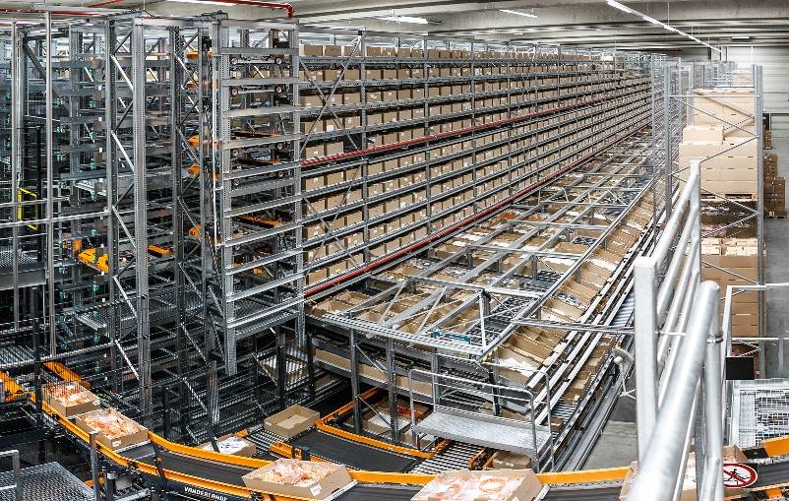
Vanderlande produces automated warehousing solutions of custom sizes for various companies, focusing on efficiently storing, transporting, and retrieving immense amounts of items via shuttle and conveyor systems [1]. One of their systems can be seen in Figure 1. During the installation of these large racking systems, there are a number of potential issues which may be found.
Figure 1: A Vanderlande automated warehouse
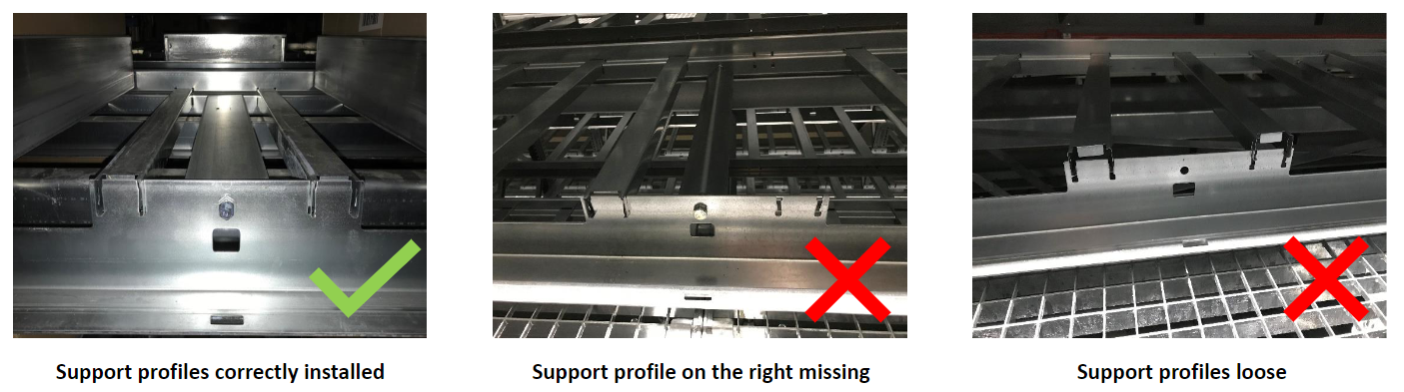
The most prevalent installation error pertains to incorrect assembly of the support profiles for an individual rack. An example of a correct as well as two common incorrect support profile installations can be seen in Figure 2 below. Vanderlande estimates that in any given racking installation, 0.5-1.0% of individual racks will have incorrectly installed support profiles. Each warehouse can easily have over 100,000 racks, and each error in racking installation can take around 5 minutes to locate and fix. This results in the potential for upwards of two weeks’ worth of work to identify and correct these erroneous support profile installations. This maintenance and repair time increases the overall commissioning time for each warehouse.
Figure 2: Examples of correctly and incorrectly installed support profiles
In an effort to reduce commissioning time for a warehouse, Vanderlande desires a diagnostic robot, or Dia-Bot, that can identify errors in the installation of their automated warehouses. The robot will be controlled to transverse around the racking systems either or its own power or riding along on the system’s conveyors and shuttles and uses a kit of sensors to detect any errors in the system. Examples of such error detection include a camera system used to identify incorrect installment of support profiles, an accelerometer to detect abnormal vibrations a package would experience on the conveyors or shuttles, and a microphone used to identify abnormal decibel levels of operation. Overall, the Dia-Bot is beneficial for giving visibility to areas of the warehouse system that may otherwise be difficult or dangerous to view or reach, identify potential material handling issues before system commission, validate the speeds and throughputs of the system, and decrease commissioning time for each warehouse system which benefits both Vanderlande and their clients.
The following sections will dive deeper into similar existing products and related codes, more detailed specifications, various ideation and decision-making modes, selected design choices and solutions, and next project steps.

2. Existing Products, Prior Art, & Applicable Patents
The world of robotics is a vastly growing frontier in today’s market. There are thousands of designs for various tasks ranging from recreational use to commercial industries. Automation robotics has seen a heavy impact on the supply chain industry, with robotic arms and carts being able to assemble and transport products more efficiently and accurately. As the team began this project, we were aware that there would be a robust amount of ideology and inspiration from the market. While this aided our solution brainstorming, we knew it would also complicate the patent process.
Fortunately, Vanderlande is not looking to produce the Dia-Bot for this crowded market. They are aiming to design a solution fully for in-house use. This takes the pressure of patenting of the team's shoulders. As stated, the specific market for sensor packed transverse robots is widespread. The bookends consist of cheap toy like designs as depicted below by a generic framed RC car with exposed sensors, motors, and wiring. This design is very low cost with the typical price point falling between $50 and $250 dollars. This is juxtaposed by the top-of-the-line type constructed of high end protected sensors with advanced processors and materials as depicted by the ROSbot [2]. This top of the line can vary greatly in size and application which increases the price range. Robots of this stature can be anywhere from $2,000 to $45,000 dollars. Examples of these products can be seen in Figure 3 below.
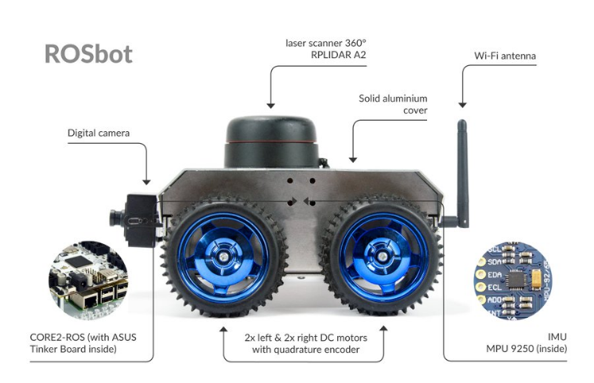
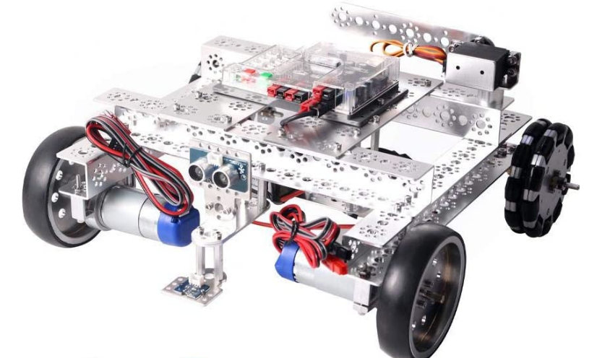
Low-end market High-end market
Figure 3: Examples of existing products similar in function to the Dia-Bot

3. Codes & Standards
Given that this robot must be picked up to be placed onto the warehousing system it will operate within, it is important to consider the lifting requirements. While the Occupational Safety and Health Administration (OSHA) does not have set regulations for acceptable weight to be lifting by a single person, or any other similar set regulations, it has worked with the National Institute for Occupational Safety & Health (NIOSH) to create a lifting equation. This NIOSH lifting equation gives a risk factor based on considerations of the lifting activity such as objects horizontal distance from the body, vertical location of the object to the floor, distance the object needs to be moved vertically, asymmetry angle or twisting requirement of the lift, frequency and duration of lifting activity, and the quality of the coupling or grip to the object.
While not directly within the industry of the Dia-Bot, the American Society for Testing and Materials (ASTM) have standards for the testing of response robots that fall near to some of the functionalities necessary for the Dia-Bot. ASTM standard E2566 gives a testing procedure to ascertain the visual acuity of a response robot to perform their given visual sensing task a counted number of times over a set period of time [3]. ASTM standard E2802 gives a testing procedure to determine how well a response robot is able to overcome vertical obstacles [4]. ASTM standards E2854 gives a testing procedure to measure the maximum range of wireless communication to complete tasks in line-of-sight [5]. While these tests are not required for our Dia-Bot, they are helpful testing procedures for the validation and testing of the Dia-Bot.

4. Customer Requirements & Engineering Design Specifications
A. Stakeholders
Table 1 provides a detailed analysis of the stakeholder interest in the Dia-Bot. Figure 4 shows an overview of the stakeholder analysis in a stakeholder 2x2 chart.
Table 1: Stakeholder Analysis
Stakeholder | Interests | Impact  /Effect | Importance | Influence Scope
Georgia Tech | Documentation, expo demonstration, creativity, innovation, problem definition, analysis, and design validation | Low | 2 | Timeline, documentation, course requirements
Primary Advisor (Dr.Jiao) | Documentation, creativity, innovation, problem definition, analysis, and design verification | Medium | 2 | Feedback based on knowledge and experience, and resources
Secondary/ECE Advisor (Dr. Madisetti) | Creativity, innovation, problem definition, analysis, and design verification | Low | 1 | Feedback based on knowledge and experience, and resources
Vanderlande Industries | Business interests, talent, ideas (i.e. support to team’s mechanical engineer) and final detail design | High | 2 | Feedback for usability, customer needs, feasibility, and stakeholder satisfaction
Vanderlande Industries Installation Engineers (User) | Reliability, ease to use, provides meaningful information, and quickens installation verification | Low | 1 | Performance, analytics, feasibly, and stakeholder satisfaction
Vanderlande Industries (technical POC) | Technical Knowledge and ideas, talent, analytical approaches, prototype validation, and deliverables | High | 3 | Technical knowledge for feedback and feasibility, performance, and customer needs analysis
Future Design and Engineering Teams | Technical knowledge and ideas, analytical approaches, deliverables, prototype, and documentation | Low | 1 | Problem scope, documentation, and feasibility
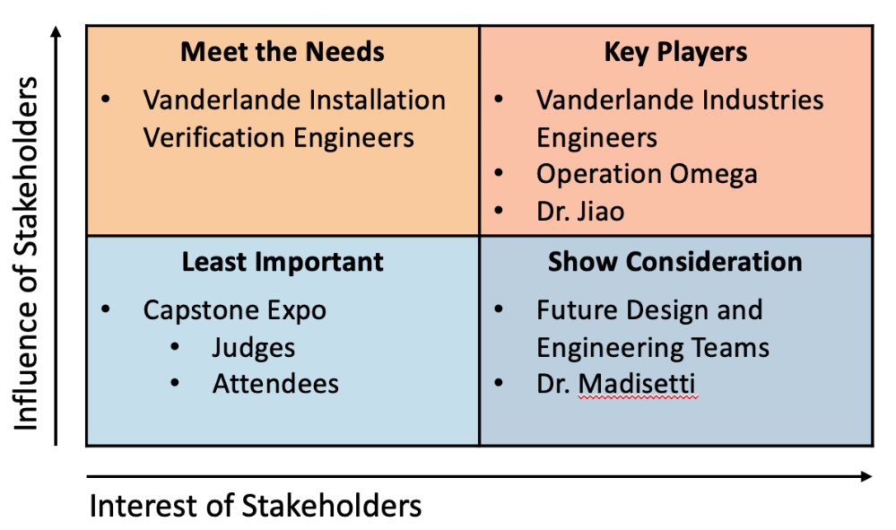
Figure 4: Stakeholder 2x2 Chart

B. Customer Requirements
Based on the team’s interaction with key stakeholders, customer requirements for the Dia-Bot have been identified and divided into eight (8) categories, as shown in Table 2 below.
Table 2: Customer Requirements
Category | Customer Requirements (Explicit and Implicit)
- Function | - Collects environment data
- Function | - Recognize robot’s location
- Function | - Moves through system
- Size | - Fit in System:  650mm x 450mm footprint, 320mm tall
- Weight | - Be under 35 kg
- Cost | - Less than $750
- Use | - Easy to control
- Power | - Self-sustained (Battery Powered)
- Power | - Lasts through system navigation
- Speed | - Navigates faster than human verification
- Navigation | - Easily moved over rollers, conveyer belts, and all other surfaces

C. Evaluating Key Functions
In reference to Table 2, the first category, function, is the most important category here because the main goal of the robot it to report the location of errors within the large racking system. The robot needs to be more effective than the human means of verification to be worth using over the current validation techniques. The robot should be able to fit and go through the racking system (for the size and weight requirements). Additionally, the Dia-Bot must be easy to control, be cordless (the need for self-sustaining power and wireless communication). The robot needs to be able to navigate over all the different surfaces it may encounter such as rollers, conveyer belts curves, diverts, shuttles, inclines, declines, merges, and diverges. Lastly the Dia-Bot must be cost effective but because Vanderlande Industries will not need a large quantity of these robots, we think that our robot should be less than $750.

D. Constraints
The robot has a number of constraints at this time. Notable the robot must fit inside of a 650mm x 450mm footprint with a maximum height of 320mm. Additionally the robot cannot exceed 35kg or the racking system will not be able to safety and effectively support the Dia-Bot’s movements. The user must be able to see fully around the robot, which requires that the robot have a camera with the ability to rotate 360° along with vertical tilting up and down for an angle of 45° (from min to max – a minimum of 10° off level in both directions). Because the Dia-Bot must relay the racking system’s environment, the robot must be accurate in its location within a foot (±12 inches).

E. Engineering Specifications
Based on the customer requirements and our constraints, Operation Omega has identified the follow important engineering requirements. The specification sheet is shown below.

Table 3: Specification Sheet
# | Spec | Date Updated | Requirements | Responsible | Source | How Validated
General
1 | Affordable for Small Scale Production | 09/26/21 | Unit cost < $750 | Design Team | Sponsor | Manufacturing cost analysis for the entire product
Physical Characteristics
2 | Product Weight | 09/26/21 | < 35kg (or <77lbs) | Mechanical Team | Sponsor | Weight measurement of full-scale prototype
3 | Product Size | 09/26/21 | Footprint < 650mm x 450mm  Height < 320mm | Mechanical Team | Sponsor | Measurement of full-scale prototype
Performance
4 | Movement Speed | 09/26/21 | a) Speed increments linearly | Electrical Team | Sponsor | Testing of Robot’s movement
4 | Movement Speed | 09/26/21 | b) Top speed ≥ 275m/hr (or ≥ 15 ft/min) | Mechanical Team | Design Team | Speed calculation from RPM from the motor
5 | Navigation Surfaces | 09/26/21 | a) Successfully navigates over belts, rollers, curves, and diverts | Mechanical Team | Sponsor | On site Testing (or if unavailable Simulation)
5 | Navigation Surfaces | 09/26/21 | b) Successfully navigates through inclines, declines, mergers, and diverges | Mechanical Team | Sponsor | On site Testing or test system (or if unavailable Simulation)
6 | Robustness | 09/26/21 | Withstands vibrations induced while navigating the racking system | Mechanical Team | Sponsor | Performance Assessment
7 | Visibility | 09/26/21 | Camera provides a 360° rotation with 45° vertical tilting | Electronic Team | Sponsor | Demonstration with full-scale prototype
8 | Position Tracking | 09/26/21 | Location Accuracy within a ±12 inches | Electrical Team | Sponsor | Algorithm analysis with projection supported by field testing
Electrical
9 | Power Management | 09/26/21 | Uses conventional wall plug | Electrical Team | Sponsor | Verify specifications and use appropriate battery in the final product
10 | Operating Time | 09/26/21 | > 5 hours | Electrical Team | Design Team | Verify specifications and use appropriate battery in the final product

F. Importance of Specifications
From the Customer Requirements and the Specification Requirements, we created a House of Quality in Figure 5 to recognize the most important engineering requirements.
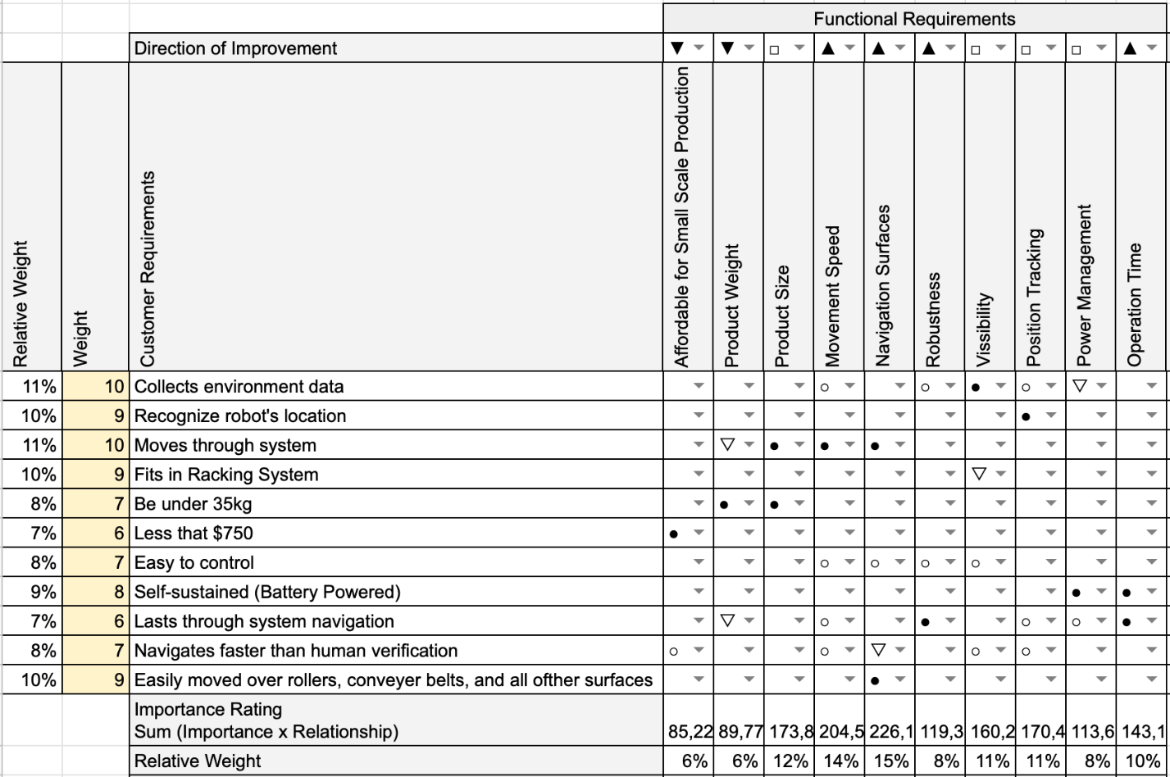
Figure 5: House of Quality

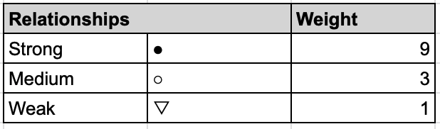
Figure 6. House of Quality Relationship Icons Weighting

The center section of the House of Quality characterizes the relationship between the customer requirements (on the left side of the table) and the functional requirements (on the top right of the table). These relationships are weighted based on their icons according to Figure 6 which, along with the weight of each customer requirement, is used to produce an importance rating along the bottom of the table. We have added a relative weight to each of these requirements to normalize our results.
The House of Quality analysis shows that the most important requirement for our bot will be the Navigation of the Dia-Bot over the myriad of surfaces that it will encounter. This places importance on our earlier design work for the special tread system. Nest we see that the movement speed of the robot will be the second most important function, so that we can make an improvement from Vanderlande Industries’ previous system of rack installation verification. Additionally, we will need to provide Vanderlande Industries with our estimate speed of navigation over each type of surface so that we can calculate how the Dia-Bot can improve their installation verification time. Another important functionality will be the product size, while this is an important function, we do not foresee this constraint as a difficult technical challenge.
In the next group of important functions lies the Dia-Bot’s visibility and position tracking ability. These are vital to the robot’s facilitation of information and ability to navigate and locate problems. Next in importance there is Operation Time, Robustness, Power Management, and, finally, product weight and cost.

5. Design Concept Ideation
A. Functions
Possible functions and sub-functions necessary for an effective Dia-Bot were identified using a function tree show below in Figure 7. These functions and subfunctions were created and evaluated based on the requirements given from Vanderlande. The function tree splits the main responsibilities of the designed robot into four distinct functions: movement, protect internal components, recognize errors, and communications/user interface. These functions are broken down into subsections to ensure that the Dia-Bot encompasses all its requirements.
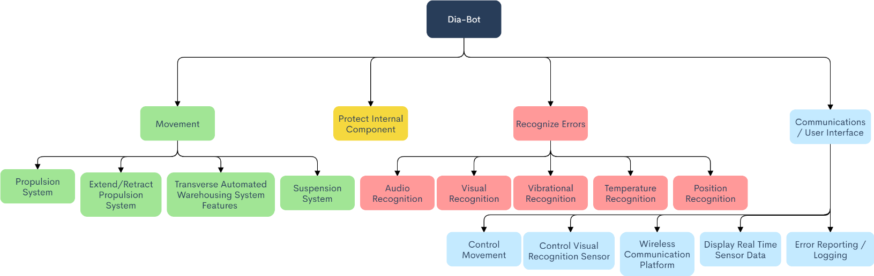
Figure 7: Dia-Bot Function Tree

Below the movement function, the Dia-Bot must have a propulsion system that will allow it to navigate throughout its entire environment, consisting of conveyors, rollers, diverts, merges, and inclines. The Dia-Bot must also be able to retract its propulsion system to enable the ‘ride along’ functionality, allowing it to detect excessive vibrations. A suitable suspension system must also be selected to allow the Dia-Bot to detect vibrations coming from the environment rather than the bot itself.
Interactions between the Dia-Bot and the operate are possibly the most important function, as the bot would be useless if the operator cannot observe and verify the errors recognized. The operator should be able to control the movement and the error recognition sensors of the bot. The platform in which the bot and operator communicate is also an important consideration. Finally, the bot should be able to display real time sensor data, as well as log and report errors.

B. Morphological Chart
A morphological chart, as seen in Figure 8, was implemented to look more specifically at possible solutions to the subfunctions listed in the function tree. Several concepts were given for each subfunction, which allowed the team to narrow down which concepts would work best for the final design. The team plans on revisiting the morphological chart frequently once the low fidelity prototyping phase is entered to make sure the prime concept is selected.

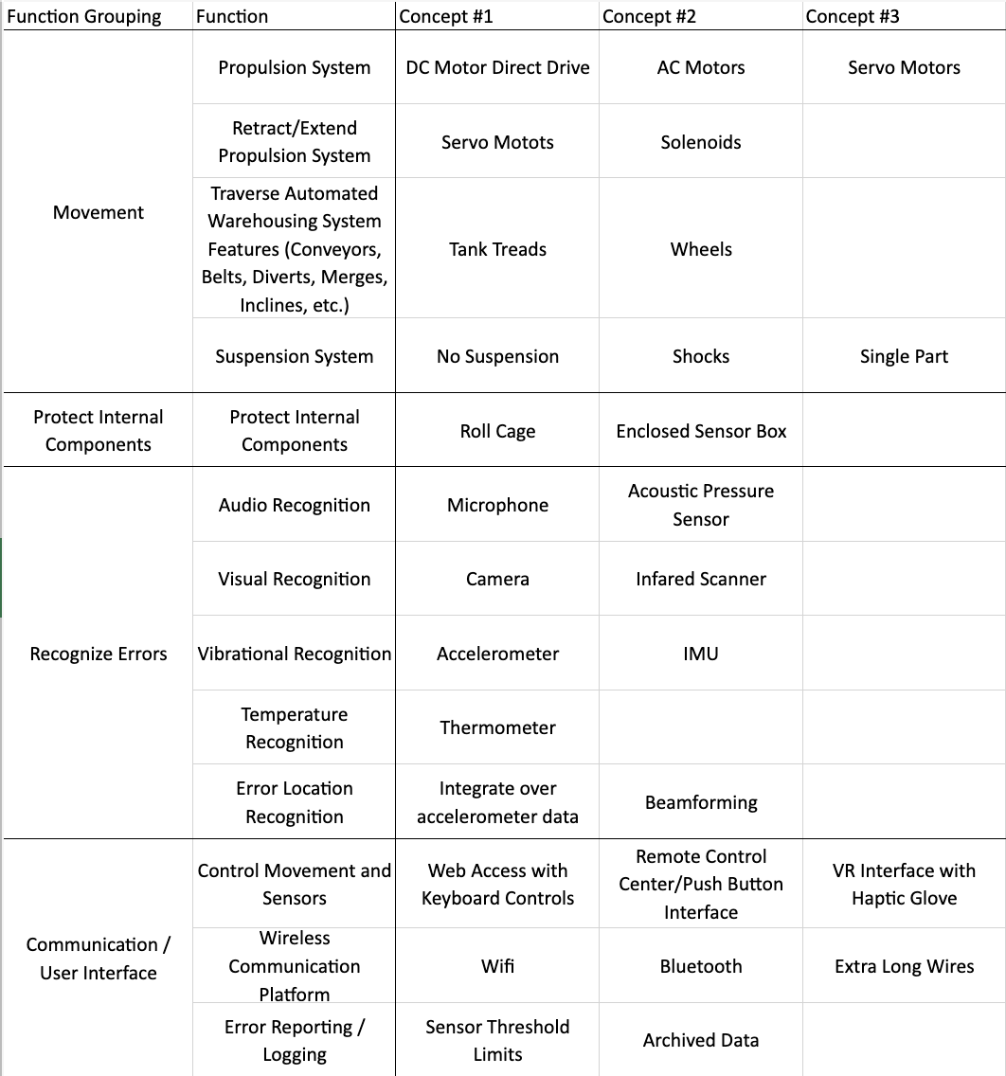
Figure 8: Dia-Bot Morphological Chart

Several different concepts were under consideration when it came to the movement of the Dia-Bot. To begin, we had to narrow down the propulsion system used, which could consist of DC motors, AC motors, or Servo Motors. In order to retract or extend the propulsion system, servo motors and solenoids were considered. The means of transportation, via tank treads or wheels, was also considered. Additionally, the type of suspension system was considered, with ideas ranging from no suspension, shock suspension, or single part suspension. For internal component part protection, two concepts were determined: a roll cage or an enclosed sensor box. In terms of being able to recognize and call out errors, the possible concept solutions can be seen in rows 6-10 in Figure 8. In order to control both the movement and sensors, three concepts were proposed: web access with keyboard controls, remote control center with push button interface, and virtual reality interface with haptic glove. For the wireless communication platform, three concepts were considered: Wi-Fi, Bluetooth, and extra-long wires. Finally, for error reporting/logging, the two concepts were setting sensor threshold limits that would report errors once the threshold was passed and archived data to be looked at once the bot had completed its run.

6. Preliminary Concept Selection & Justification
A. Mechanical Design
The mechanical components of the Dia-Bot must work in concert to accomplish three general tasks: transport the camera and sensors across Vanderlande’s system, protect the delicate electrical components during transportation, and retract its propulsion system to allow the robot to lie flat on the underside of its main body.
For transportation of the camera and sensors, a continuous track design and wheels were selected as the two most realistic options. Other ideas such as a drone were considered, but dismissed for the complexity, cost, reliability, and safety concerns. Each means of transportation offers its own set of advantages and disadvantages, listed in Table 4. Given that the robot must move through a veritable maze of conveyor surfaces, rollers, and sharp turns, a continuous track design was selected over wheels. The advantage of driving over obstacles outweighs the drawbacks to speed and maneuverability.
Table 4: Comparison of a Continuous Track Design vs. Wheels [6]
 | Continuous Track | Wheels
Advantages | - Power Efficiency  - Traction  - Moving Over Rough Terrain  - Weight Distribution  - Complicated Suspension | - Lower Cost  - Speed  - Simplicity  - Lightweight  - Maneuverability
Disadvantages | - Lower Speed  - Friction | - Driving Over Obstacles
Once we selected a continuous track propulsion system, the next step was to design the chassis. The two main considerations were whether the chassis should be symmetric and whether to include a suspension system. Making the chassis symmetric offers a few advantages for the user operator. The most important of which is that the robot would not need to rotate 180 degrees to travel backwards. In a tight environment, turning might not be physically possible. The operator can simply reverse direction and the Dia-Bot would handle the same as if it was driving forwards. However, the drawback is that such a design would be larger and, therefore, heavier. Using a suspension system would help insulate the delicate components from jostling and vibrations as the Dia-Bot traversed its environment. Once again, the trade-off is added weight and complexity. Figure 9, Figure 10, and Figure 11 are mock-up sketches for a combination of these designs. In conversations with Vanderlande about the desired functionality of the Dia-Bot and the environment in which it would operate, they expressed a desire for the robot to be as robust and flexible as possible. To that end, we believe that a symmetric chassis with a suspension system is the strongest combination.
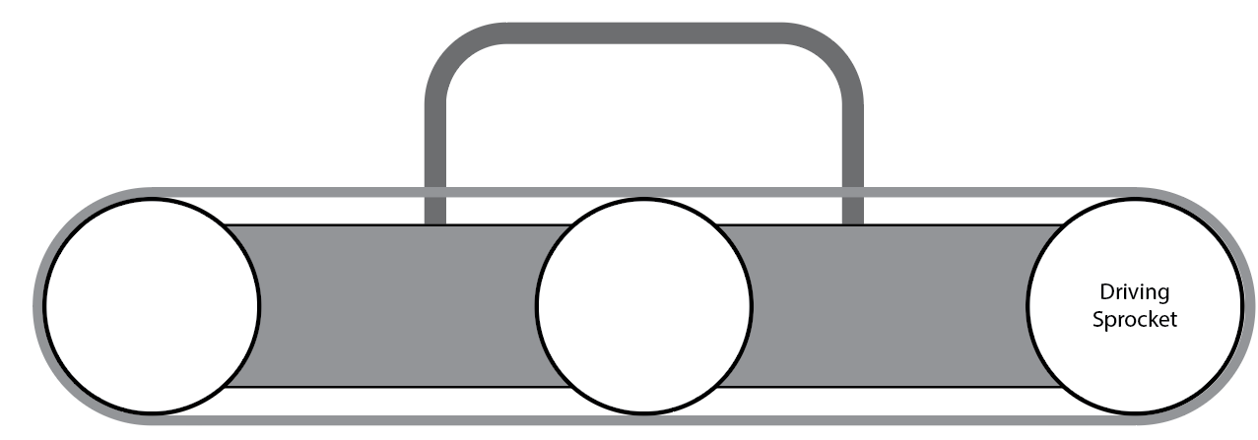
Figure 9: Symmetric Chassis Design Without Suspension System
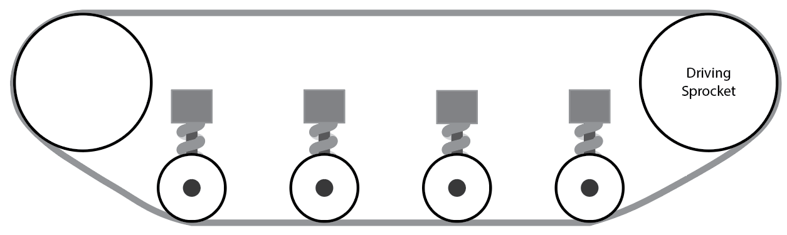
Figure 10: Symmetric Chassis Design with Suspension System
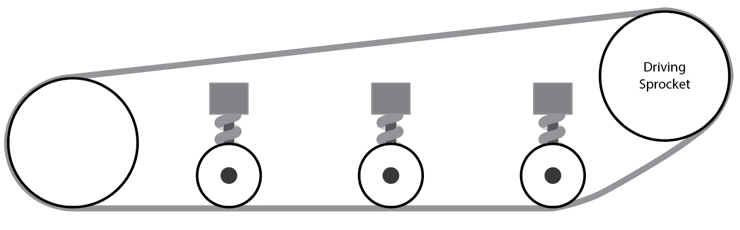
Figure 11: Asymmetric Chassis Design with Suspension
With the general design of the chassis settled upon, the next step is to begin sourcing the parts. Working within the cost requirement of less than $750 for the entire machine, finding viable parts is difficult. For the tank treads and sprockets, the options are either cheap plastic parts used for high school robotics or exceedingly expensive professional parts. The former lacks durability and the latter costs thousands. The current idea is to use a rubber timing belt with teeth on both sides as the tread. Although, work is needed to test the validity of that design. One drawback of using a continuous track over wheels is the complexity of the suspension system. The prevailing design is visualized in Figure 12. The extension spring system has a guide wheel that rotates about a fixed shaft. The natural state of the suspension system in Position A, but it deforms to Position B under a force. The springs, pins, and guide wheels can be purchased easily, but attaching the system to the chassis will require custom pieces.
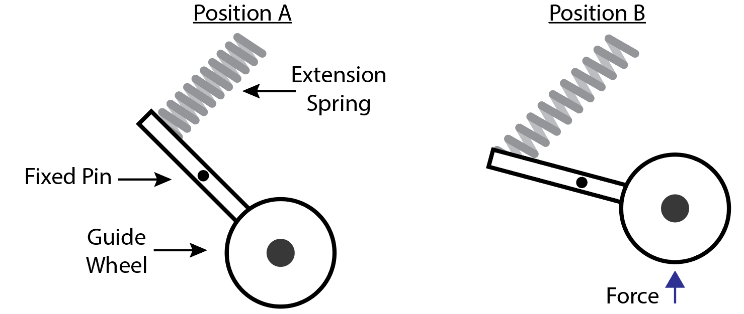Figure 12: Suspension System Sketch
Once the parts have been sourced for a reasonable price, a custom chassis will be designed and manufactured. From there, the main body of the Dia-Bot will be designed around the electrical components. Current thinking is to combine a slim body with a roll cage for the camera. Keeping the design as minimalist as possible allows us to keep the material cost and weight as low as possible. A possible stretch goal would be to achieve a rating of IP51 for ingress protection, ensuring the longevity of the Dia-Bot by protecting the electrical components against dust and water.
Retracting the propulsion system to allow the Dia-Bot to lie flat on a conveyor surface is a difficult task, and one that can only be reliably completed once the main body is designed. However, some concepts have been discussed. The leading idea is to attach the chassis to the main body with a linear slide and mechanical lock. This would allow a user to manually raise and lower the height of the main body relative to the chassis. While it is possible to automate this process with a servo, we do not believe that the convenience outweighs the added complexity.

B. Electrical Concept
The electrical subsystem must support the robot’s ability to move through the system, send real-time data to and receive controls from the operator, and track its position. To accomplish these functions, we need to recognize the requirements necessary such as a mobile power source, a rechargeable power source, movement generators (for the treads, camera, and bottom extension), a light source for the camera, a user interface with the ability to control the features in real time, and a processing center on the robot. As we consider the electrical subsystem’s requirements, we made an evaluation matrix for the location positioning, movement generation, processing center, power source, real-time access to Dia-Bot data, and user interface. Below are the six (6) evaluation matrices we used to formulate a design for each of these critical tasks.
Table 5: Electrical Components Evaluation Table
Mandatory Criteria | Option 1 | Option 2 | Option 3
Location Positioning | GPS | On Dia-Bot algorithm with navigation and system map | Raw position data using telemetry
Movement Generation | DC Motors | AC Motors | Servo Motors
Processing Center | Arduino UNO Rev 3 | Raspberry Pi 4 | Mbed (LPC1768 Cortex-M3)
Power Source | Rechargeable: Lithium-ion battery | Rechargeable: Lead Acid or SLA Batteries | Non-rechargeable: Alkaline Cell Batteries (PP3)
Real Time Access to Dia-Bot Data | Wi-Fi | Bluetooth | Extra Long Wires
User Interface | Web Access through Computer or Tablet | Remote Control center with a fabricated push button interface | Virtual Reality Interface with Haptic Gloves

Referring to Table 5, we will explore the options we selected and why those are the best fit for our robot. For Location Positioning, we believe that an affordable GPS unit will not yield the accurate position data necessary for our robot and have experience with raw telemetry data being extremely inaccurate. As a result, we will be using an algorithm on the Dia-Bot with navigation and a system map to determine the Dia-Bot’s location. For movement generation, AC motors are light enough for our Dia-Bot’s requirements and will provide enough torque in a linear fashion. Therefore, these are the best option for our Dia-Bot. Skipping over the processing center, we selected Wi-Fi as the best way to access real time information from the Dia-Bot. With the amount of data needing to be moved over large areas we believe Wi-Fi will be the most appropriate solution, since Bluetooth has a very limited range of connectivity. For the Dia-Bot’s processing center, we have experience using all three microcontrollers listed. We believe that the Raspberry Pi will best address all the robot’s requirement to use Wi-Fi because these microcontrollers have an on-board W-Fi chip [7]. For the User Interface, Vanderlande Industries has expressed that a User Interface through a computer’s web page would be most cost effective, affordable, and malleable for future work.
In our thinking we have identified the following potential risks: difficulty connecting the Wi-Fi module, poor camera output quality, and inaccurate positional calculations. To manage the difficulty connecting the Wi-Fi module, we would like to either prepare a script on the computer’s home page which launches the necessary steps to connect to the Raspberry Pi’s Wi-Fi module correctly. This option may unfortunately take too long, and we will likely have to provide the user (the engineer who will navigate the Dia-Bot) with documentation about how to properly make this connection and resources if there are issues. Depending on the OS version used, however, this connectivity process will likely be streamlined. If we run into issues with poor output quality from the camera, we first plan to focus on capturing high quality picture data and will “cut” our live feed momentarily to send the user a high-quality photo. If that still does not provide high quality results, we would recommend for future projects that Vanderlande Industries use special Wi-Fi module with high data transfer rates. (If time allows, we may attempt to find this better Wi-Fi module, but because the company has expressed interest in carrying these projects through multiple follow up groups, we will aim to provide them with ample design upgrade opportunities.) Lastly, if we have difficulty calculating the Dia-Bot’s location on the robot, we may consider using some high-end GPS modules which interface with Raspberry Pi easily to provide extremely detailed location data. These modules are expensive, and we would like to pursue our algorithm before buying these high-end parts.
To show our progress with the electrical components at this time we have created a block diagram, to ensure that we have considered all the necessary components for our Dia-Bot. Additionally, we hosted a User Interface design workshop with our client, Vanderlande Industries, to ensure that all the data and information passed to the user is helpful and necessary. In our design session, we presented a preliminarily mockup of the user interface (Figure 13) and talked through the user groups who may interact with each of the data we have collected, the purpose of the data collected, and the ease of use for the user. This led us to our Revised User Interface seen in Figure 14. This design workshop gave the electrical team members of Operation Omega the ability to see one full end of our system with the other end being the mechanical outputs of the motor, the light out of the LED, and others which are largely apart of the mechanical side of the Dia-Bot. You can see these connections in the form of our electrical block diagram in Figure 15.

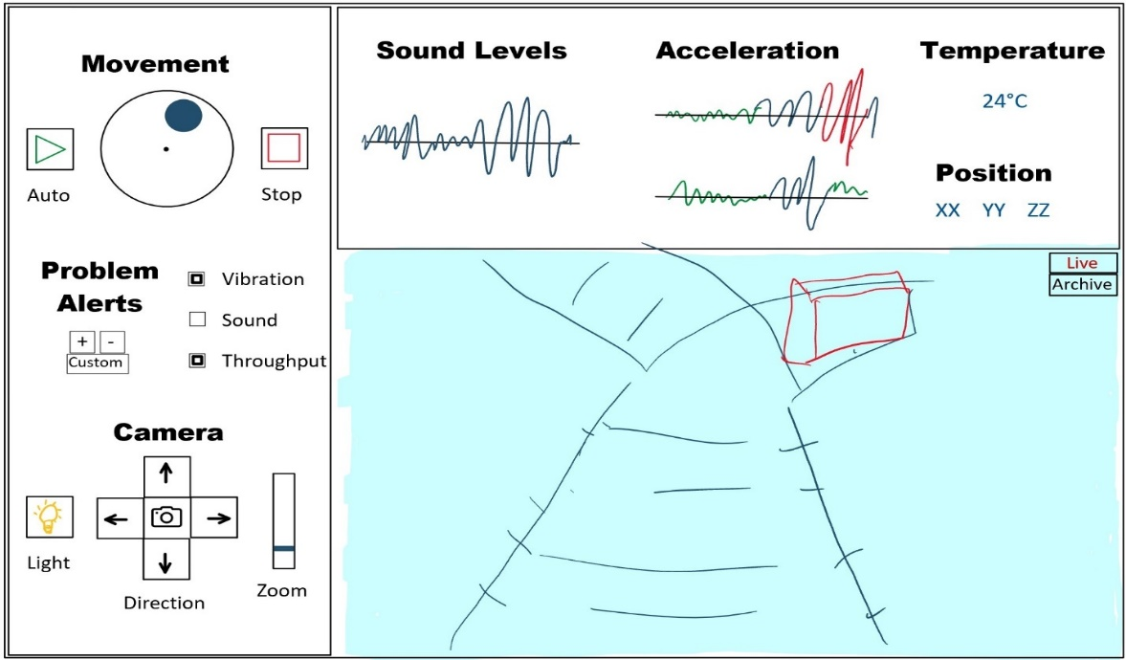
Figure 13: Preliminary User Interface Mockup

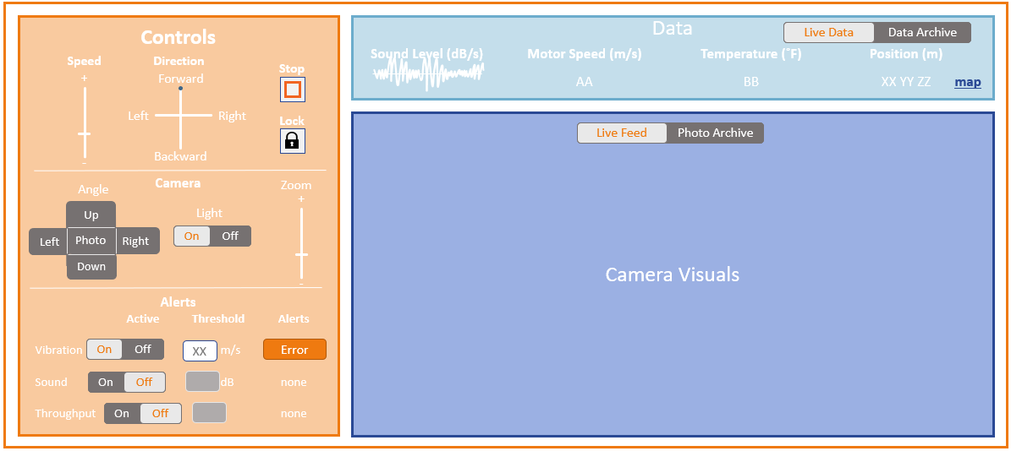Figure 14: Revised User Interface

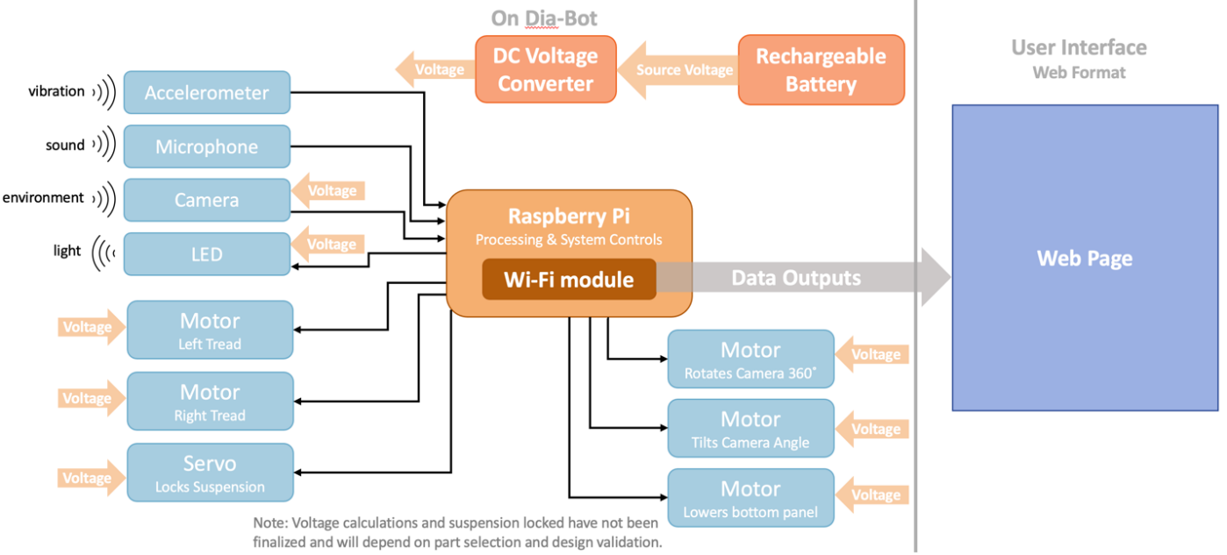Figure 15: Preliminary Electrical Block Diagram

7. Team Member Contributions
While team progress has consistently been made in group efforts, either the team as a whole or the mechanical or computer and electrical teams, everyone has played roles in the progress of the project. The mechanical team, consisting of Andrew, Jason, Hunter, and Douglas, has focused on the development of the movement functions and requirements of the Dia-Bot. The computer and electrical team, consisting of Catherine and Connor, worked in parallel to advance the controls, communication, and user interface portions of the Dia-Bot’s necessary functionality. A more detailed breakdown of tasks is as follows.

- Andrew conducted the research into the market’s prior art and patents. By working off of the groups brainstorming and function requirements, he was able to produce information on related robots in the field currently. This led to easier decisions for the Dia-Bot and a good baseline for the group to branch off of.
- Catherine has worked organize the team by creating presentation (in line with Vanderlande Industries’ formatting), meeting notes, and the reports format. On a more technical note, she prepared the User Interface design workshop, the Electrical Block Diagram, the Specification Sheet, House of Quality, Customer Requirements, and Stakeholder Analysis.
- Jason worked to create a clear and detailed function tree that incorporates the entire scope of functions of the Dia-Bot as well as doing research into the codes and standards relating to the solution.
- Hunter invested a significant amount of effort designing the chassis of the Dia-Bot, researching competition, hobbyist, and professional robots. Additionally, he has begun to source off-the-shelf parts and CAD the custom components for the chassis.
- Connor primarily helped define and narrowing the Dia-Bot scope and features, most notably by providing initial drafts of the function tree and user interface design and contents. He has also helped add formatting and final editing for team reports and presentations. On the technical side, he has begun prototyping the user interface, embedded design, and remote connection by the Raspberry Pi.
- Douglas worked primarily on the Design Concept Ideation portion, where he reviewed and revised both the Function Tree and Morphological Chart. He also provided an extensive evaluation of each of the Dia-Bot’s functions, as well as the concepts that led to the final design components.

8. Conclusions: Project Deliverables & Future Work
These initial steps of diagnostic robot ideation and discussion have helped the team define a proper design scope for providing a solution to the problems that Vanderlande is describing. The team’s proposed Dia-Bot designs include proper movement modes, appropriate data collection, and an accessible software user interface which allow Vanderlande engineers to discover issues during the installation of their shuttle and conveyor systems.
In addition to defining the project scope for the Dia-Bot, the team has devised a set of potential stretch goals or further recommendations for Vanderlande, depending on the speed of initial development. While manual movement and ride-along mode are useful transportation methods for verification, another useful feature is an automatic movement mode – either by a pre-defined route or letting the bot roam on its own. To further automate installation verification, computer vision techniques could be integrated to automatically analyze the camera’s feed and identify problems visually. Additionally, establishing modes of communication between multiple Dia-Bots may allow for quicker and more advanced verification algorithms. Finally, even though the primary purpose of the Dia-Bot is to identify issues, methods may be discovered and implemented over time to fix certain problems without the need for an operator.
Depending on the timeline of Vanderlande installing systems for their clients, the team may not get a chance to test the Dia-Bot in a proper shuttle or conveyor environment. If not, Vanderlande operators would send the Dia-Bot through a new system to track the bot’s movement and detect possible problems. This would allow proper calibration for both collecting positional data and setting vibrational and sound alert thresholds. Ideally, this would be done during the semester, but the team must account for Vanderlande’s business needs first.
Now that the design scope and initial solutions have been defined, the next steps are to begin prototyping and design simulation. The mechanical team will begin sourcing OEM parts for the propulsion and suspension systems as well design and manufacture the structures of the chassis specifically used to house and protect the internal electrical components. For embedded systems engineering, this means breadboarding a simple setup to control simple servos and DC motors while reading IMU and camera data. The software team will create a functional user interface on a Raspberry Pi using to control the prototype system. These initial steps to simulate a final design will be crucial in ensuring the feasibility of the design solution and creating initial Dia-Bot functionality.
Figure 16 below shows the projected timeline for the project. Within a few weeks, the design simulations will be completed, then the team will gather the necessary materials for building the Dia-Bot, and then move into assembly of each independent subsystem. Finally, the full Dia-Bot will be assembled and validated prior to the Capstone design expo.
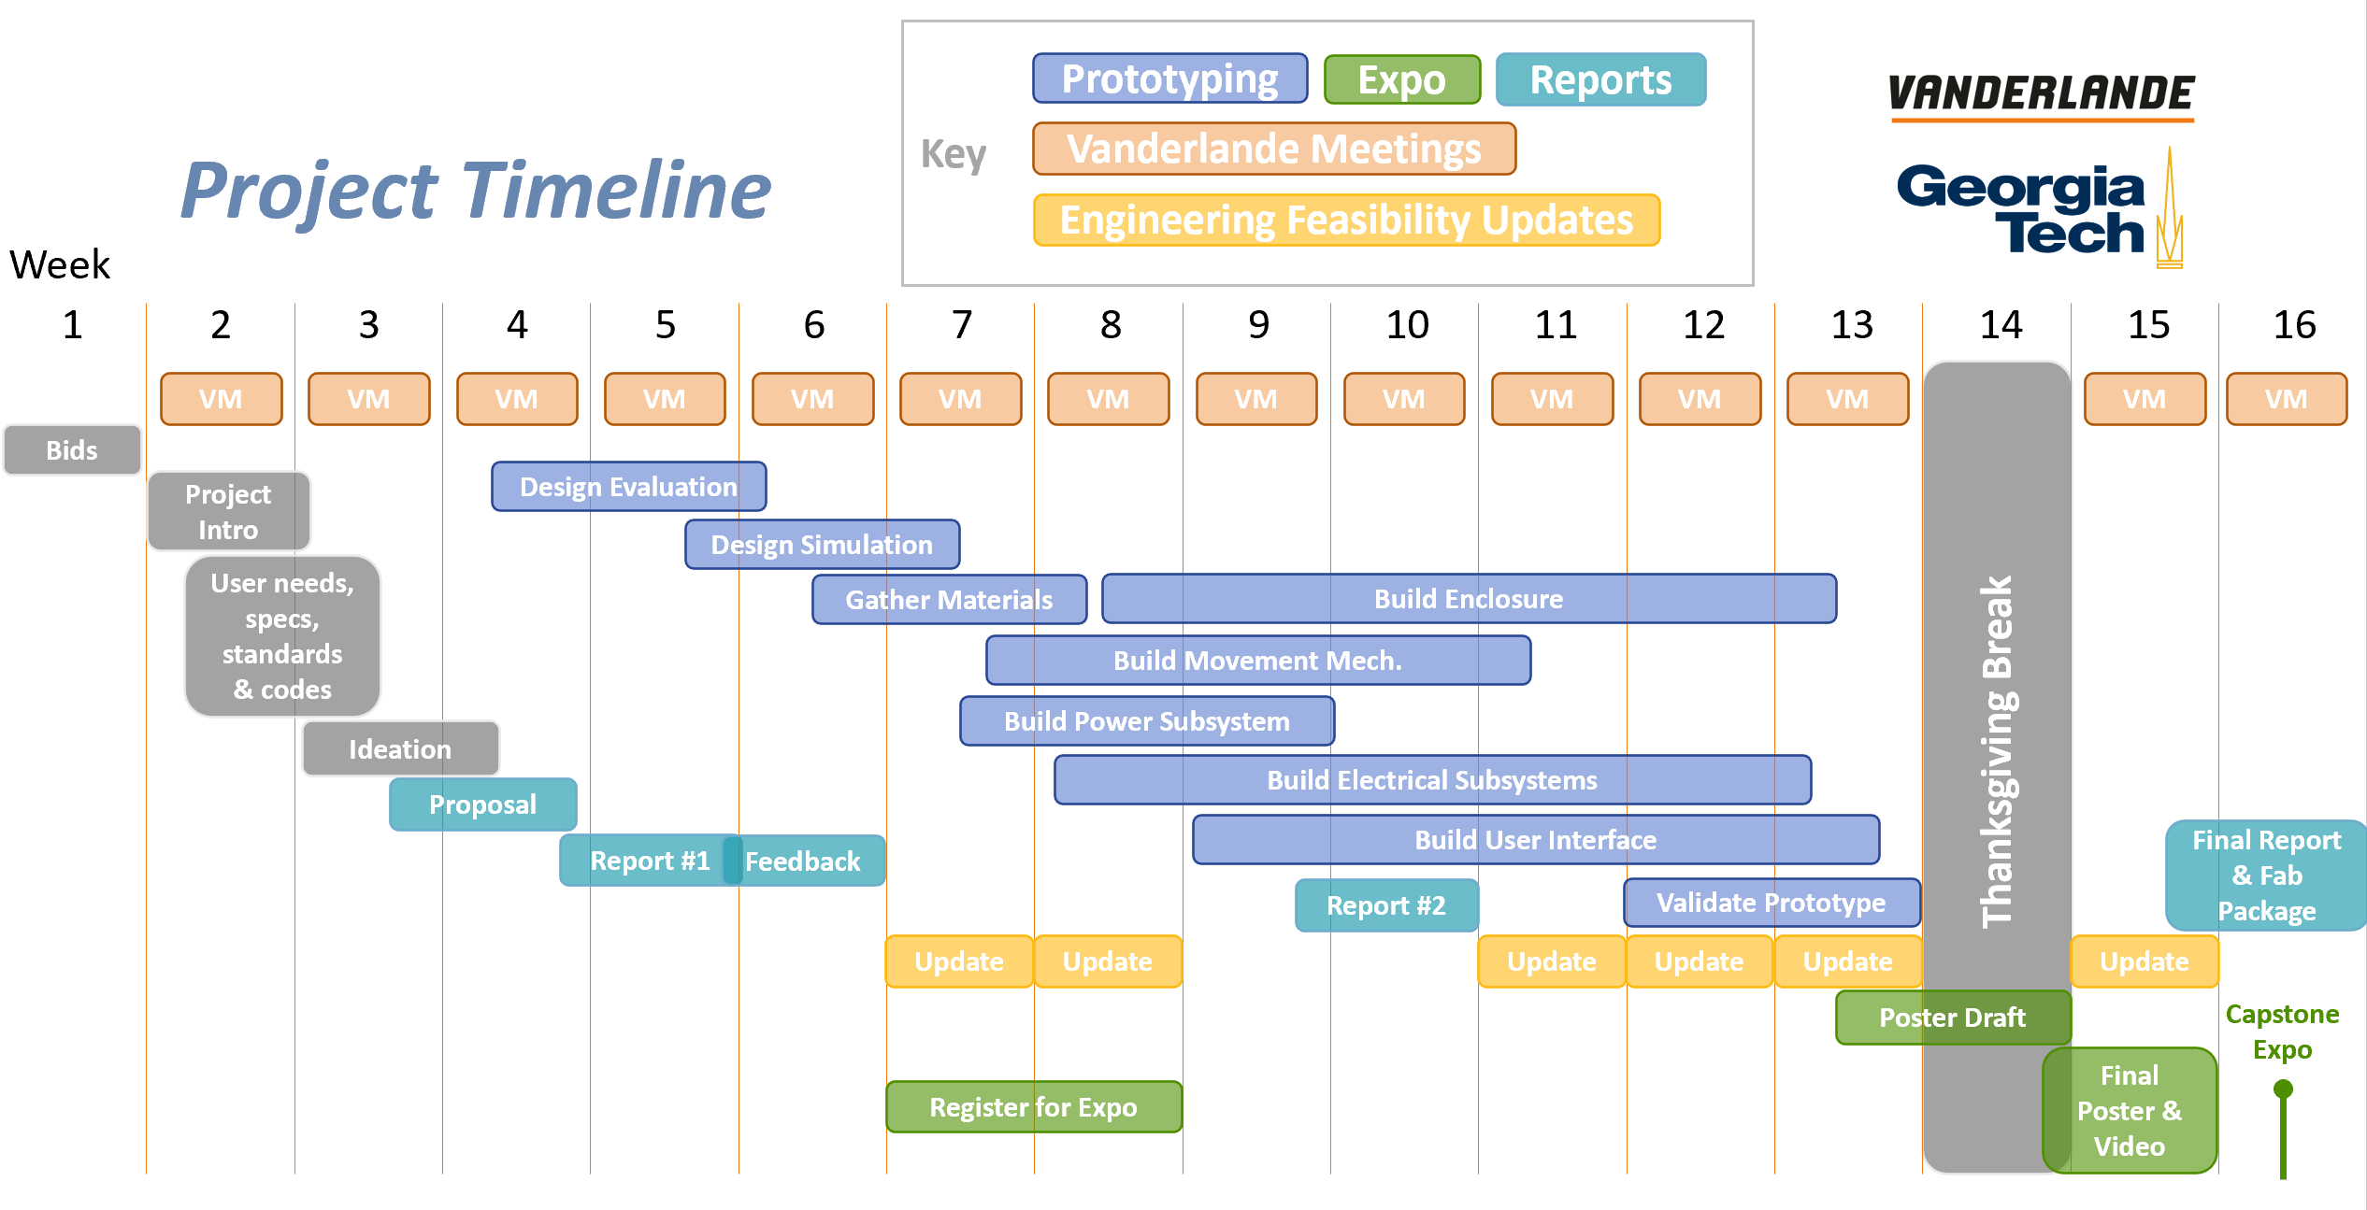
Figure 16: Project timeline, including design prototyping, feasibility updates, expo tasks, and reports

The team has set up weekly update meetings with Arlo Bromley and Dr. Patrick Opdenbosch of Vanderlande Industries conducted via Microsoft Teams. Additional email communication for quicker and more urgent questions has been, and will continue to be, in use. Additionally, the team meets in a studio session each week with primary and ME advisor Dr. Jianxin Jiao and sends weekly update emails to check in with Dr. Whit Smith and Dr. Vijay Madisetti for ECE advising.

References / Citations
- “About Vanderlande and acquisitions - Vanderlande industries,” Vanderlande, 21-Jul-2021. [Online]. Available: https://www.vanderlande.com/about-vanderlande/. [Accessed: 26-Sep-2021].
- “Robotyka Może Być prostsza z PRODUKTAMI HUSARION,” FORBOT, 04-Aug-2017. [Online]. Available: https://forbot.pl/blog/robotyka-moze-byc-prostsza-z-produktami-husarion-id21590. [Accessed: 26-Sep-2021].
- “Standard Test Method for Evauating Response Robot Sensing: Visual Acuity,’ ASTM Compass, 01-Sep-2017 [Online]. Available: https://compass.astm.org/document/?contentcode=ASTM%7CE2566-17A%7Cen-US [Accessed: 26-Sep-2021]
- “Standard Test Method for Evauating Response Robot Mobility Using Variable Hurdle Obstacles,’ ASTM Compass, 01-Mar-2021 [Online]. Available: https://compass.astm.org/document/?contentcode=ASTM%7CE2802_E2802M-21E01%7Cen-US [Accessed: 26-Sep-2021]
- “Standard Test Method for Evaluating Response Robot Radio Communications Line-of-Sight Range,’ ASTM Compass, 01-Jan-2021 [Online]. Available: https://compass.astm.org/document/?contentcode=ASTM%7CE2854_E2854M-21%7Cen-US [Accessed: 26-Sep-2021]
- “Wheels vs tracks: Advantages and disadvantages,” Lite Trax, 01-Mar-2018. [Online]. Available: https://litetrax.com/wheels-vs-tracks-advantages-disadvantages/. [Accessed: 26-Sep-2021].
- “RaspberryPi models comparison: Comparison tables,” SocialCompare, 05-Sep-2021. [Online]. Available: https://socialcompare.com/en/comparison/raspberrypi-models-comparison. [Accessed: 23-Sep-2021].

Appendices

